財團法人明日醫學基金會補助專題研究計畫
成果報告 □期中進度報告

計畫名稱：決定慢性B型肝炎嚴重急性發作預後的病毒相關因子

計畫類別： 個別型計畫 □ 整合型計畫
執行期間： 101 年 1 月 1 日起 至 101 年 12 月 31 日止

計畫主持人： 許耀峻
共同主持人：
計畫參與人員：

成果報告類型：□精簡報告 完整報告

處理方式：可公開查詢

執行單位：義大醫院一般醫學及肝膽胃腸科

中 華 民 國 102 年 2 月 12 日

Pretreatment viral DNA stratifies mortality risk in patients receiving antiviral therapy for severe acute exacerbation of chronic hepatitis B

Running head: Prognostic value of HBV DNA in acute exacerbation

Yao-Chun Hsu^{1,2},Chun-Ying Wu^{1,3,4}, Chi-Yang Chang², Chih-Min Tai², Cheng-Hao Tseng², Daw-Shyong Perng², Lein-Ray Mo²*, Jaw-Town Lin^{5, *}
¹Graduate Institute of Clinical Medicine, China Medical University, Taichung, Taiwan
²Department of Medicine, E-Da Hospital/I-Shou University, Kaohsiung, Taiwan
³School of Medicine, National Yang-Ming University, Taipei, Taiwan
⁴Division of Gastroenterology, Taichung Veterans General Hospital, Taichung, Taiwan
⁵School of Medicine, Fu Jen Catholic University, New Taipei, Taiwan

This study is accepted by Antiviral Therapy (currently Epub ahead of print).

This study was presented with the Best Poster Award at the 3rd International Forum of the 98th General Meeting of the Japanese Society of Gastroenterology on April 21, 2012, Tokyo, Japan (abstract IF-BP3-1).

ABSTRACT
Background: Prognostic factors have not been elucidated for severe acute exacerbation of chronic hepatitis B treated with antiviral therapy. This study aimed to explore the role of baseline viral load in predicting mortality.
Methods: This retrospective cohort study screened consecutive chronic hepatitis B patients (n=84) receiving antiviral therapy for severe acute exacerbation, defined as abrupt elevation of serum aminotransferase greater than 10 times the upper limit of normal along with hyperbilirubinemia. Survival pattern was evaluated by the Kaplan-Meier method and predictors for mortality determined by the Cox regression analysis.
Results: A total of 66 patients were eligible and followed up for a median of 23 (range, 0.1-75) months. Twenty (30.3%) died during the study period, with the vast majority (n=17) succumbing rapidly within 3 months. The multivariate Cox model revealed that mortality was associated with baseline viral DNA level (hazard ratio [HR], 1.49 per log copies/mL; 95% confidence interval [CI], 1.13-1.96), international normalized ratio for prothrombin time (HR, 2.68 per unit; 95% CI, 1.81-3.98), platelet count (HR, 0.87 per 10⁴/µL; 95% CI, 0.78-0.98), and age (HR, 1.10 per year; 95% CI, 1.05-1.15). A significant interaction existed between viral DNA and prolonged prothrombin time (p=0.005). Stratified analyses further demonstrated that pronounced coagulopathy heralded death irrespective of viral load whereas serum level of viral DNA stratified mortality risk among those without marked coagulopathy.
Conclusions: Pretreatment viral DNA level stratifies risk of death in patients with severe acute exacerbation of chronic hepatitis B before the manifestation of overt liver failure.

Keywords: chronic hepatitis B; severe acute exacerbation; hepatitis B viral DNA; mortality; antiviral therapy

INTRODUCTION
Chronic infection with hepatitis B virus (HBV) is a major liver disease worldwide, affecting 350 million people globally ¹. Severe acute exacerbation is a unique complication of chronic hepatitis B (CHB), resulting from massive viral reactivation and subsequent immune clearance that leads to extensive hepatic necroinflammation ²⁻⁴. Characterized clinically by abrupt elevation of serum aminotransferases along with jaundice, severe acute exacerbation of CHB is associated with substantial morbidity and mortality ^{5, 6}. Although antiviral treatment with oral nucleos(t)ide analogues may improve survival, a number of treated patients still succumb to this devastating complication ^{7, 8}.
Outcome determinants for severe acute exacerbation of CHB have not been fully elucidated. It is imperative to identify patients at risk of poor prognosis as early as possible, because acute on chronic liver failure (ACLF) may ensue rapidly and result in death in a short period of time without timely liver transplantation ^{9, 10}. Previously identified prognostic factors were parameters that represented severity of hepatic dysfunction such as serum bilirubin, albumin, prothrombin time, Child–Pugh classification, and model for end-stage liver disease (MELD) score. Factors that indicated stage of underlying chronic liver disease (e.g., cirrhosis and platelet count) might also be prognostic ^{6, 7, 11-13}. Nonetheless, not all fatal cases manifest with profound hepatic failure or have preexisting cirrhosis. It remains unknown how to further stratify risk of death among patients with relatively preserved liver function at initial presentation.
The role of baseline HBV DNA in risk stratification has not been determined in CHB patients developing severe acute exacerbation. Earlier researches did not uncover association between pretreatment viral DNA and risk of death, but methods of measurement used in prior studies were either only qualitative or insensitive ^{6, 7}. By using polymerase chain reaction (PCR) method, Jeng and colleagues were able to show that HBV DNA level predicted development of hepatic decompensation after episodes of acute exacerbation ¹⁴. Furthermore, Garg and colleagues reported in a randomized controlled trial that reduction of viral load after 2-week of antiviral therapy correlated with chance of survival in patients with ACLF due to CHB ⁸. However, the relationship between pretreatment viremic burden and risk of mortality in these vulnerable patients remains elusive. We, therefore, set to investigate the prognostic value of serum viral DNA level in CHB patients with severe acute exacerbation.

PATIENTS AND METHODS
Study population:
This retrospective cohort study was conducted in a regional teaching hospital in Taiwan (E-Da Hospital, Kaohsiung City, Taiwan). By searching the computerized database that recorded all prescribed pharmacotherapy in this hospital, we were able to identify all CHB patients who received nucleos(t)ide analogues between November, 2004 and February, 2010. We then manually reviewed their medical records to screen the eligibility. Those who met all of the following inclusion criteria were enrolled: positive serum hepatitis B surface antigen (HBsAg) or unequivocal history of hepatitis B infection for more than 6 months, severe acute exacerbation defined as both abrupt elevation of serum alanine aminotransferase (ALT) greater than 10 times the upper limit of normal (ULN) (40IU/L) and hyperbilirubinemia with serum total bilirubin level higher than 2 folds ULN (1.3mg/dL) ^{15, 16}, antiviral treatment with any nucleos(t)ide analogue, and detectable serum HBV DNA before treatment. Patients with any of the following exclusion criteria were excluded from analysis: super infection with other viral hepatitis (A, C, D, E), co-infection with human immunodeficiency virus, confirmed or suspected liver diseases from etiology other than HBV (e.g., alcohol, toxin, drug, shock, autoimmune, etc.), diagnosis of hepatocellular carcinoma, no data of pretreatment viral DNA, and previous exposure to antiviral therapy. Cirrhosis was diagnosed principally on the basis of sonographic assessment ¹⁷. Development of encephalopathy and/or ascites within 4 weeks of presentation defined the condition of ACLF ⁹. The institutional review board of E-Da Hospital approved protocol of this study (protocol ID: EMRP-100-028).
Management and follow-up
All enrolled patients received antiviral therapy with nucleos(t)ide analogues. Generally the daily dosages were 100mg for lamivudine, 0.5mg for entecavir, and 600mg for telbivudine but occasionally varied according to patients’ conditions such as renal insufficiency. During the enrolment period, tenofovir was unavailable and adefovir was only reimbursed for the indication of rescue therapy in patients developing drug resistance. Some patients might initially receive a short course of combination therapy with 2 agents at the discretion of treating physicians. Every patient continued antiviral agent for a minimum of one year unless they died, acquired drug resistance, or were lost to follow-up. Add-on adefovir (10mg per day) was administered to those who later developed drug resistance. All patients were managed with standard supportive care in addition to antiviral medication. They might receive intravenous fluid, antibiotics, lactulose, albumin, proton pump inhibitor, and parenteral nutrition per individual indication. None of the enrolled participants underwent liver transplantation in that it was unavailable during the study period in this hospital.
In general, patients were hospitalized until severe flares and hepatic dysfunction subsided. After discharge, they were followed up on a monthly basis for physical and biochemical examinations to monitor hepatic function. The interval between outpatient visits might be lengthened to 3-6 months in stabilized patients. This study cohort was followed up until September 1, 2011.
Laboratory measurement
Serological tests (HBsAg, anti-HBs, HBeAg, and anti-HBe) were determined by immunoassays (ABBOTT GmbH& Co., Wiesbaden, Germany). The upper bound in the semi-quantification of serum HBsAg was 250 IU/mL, as per the manufacturer’s protocol. All pretreatment viral loads were measured by the quantitative method of branched DNA assay (VERSANT 440 Molecular System., Siemens Healthcare Diagnostics Inc., NY, USA), since not until May 1, 2010 was the more sensitive real-time PCR method available in this hospital. The detection range was 2000 to 10⁸ copies/mL for the branched DNA assay. The expression of viral DNA was logarithmically transformed, and undetectable HBV DNA was taken as 1 copy/mL (0 log copies/mL) and enormous value beyond measurable range as 10⁸ copies /mL. Serum HBV was tested for signature mutations related to drug resistance for the administered drug in patients with confirmed virological breakthrough, which was defined as viral load rising higher than 10 folds above nadir.
Data Analysis
Primary outcome of this study was survival rate during the follow-up period. We expressed continuous variables with median and interquartile range (IQR), and categorical variables with proportion. Survival curves were estimated by the Kaplan-Meier method and compared between groups by the log-rank test. The influence of pretreatment viral load on survival was further examined in the stratified analysis according to baseline INR. Cox proportional hazard model was developed to identify predictors associated with mortality. With all probable pretreatment covariates examined, we performed the multivariate analysis using forward and backward stepwise methods and assessed goodness-of-fit of the models. The results were reported as hazard ratio (HR) with 95% confidence interval (CI). The concordance rate between predictions and outcomes in all usable subjects was estimated by calculating the Harrell's C index ¹⁸. Statistical analyses were conducted using commercially available software (Stata, version 9.1; Stata Corp, College Station, TX, USA). All tests were two-sided with significance set at p value less than 0.05

RESULTS
Baseline characteristics of enrolled patients
Among 84 CHB patients who received nucleos(t)ide analogues for severe acute exacerbation during the enrolment period, 18 patients were excluded because of hepatocellular carcinoma (n=10), no data of viral load prior to treatment (n=5), or immediate transferral to another hospital within 3 days of admission (n=3). A total of 66 patients (age range, 18-81 years) were eligible and enrolled into analysis (Table 1). These study subjects were predominantly male (n=54, 81.8%) with a median serum ALT greater than 1,000 IU/mL and MELD scores higher than 18 points. Severe acute exacerbation was spontaneous in most subjects but was preceded by triggers in 7 patients (chemotherapy for malignancy in 3, immunosuppressives for rheumatic diseases in 2, hypovolemic and septic shock in 1 respectively). A supplementary table described details of the 5 patients who received cytotoxic chemotherapy for cancers or immunosuppressant for autoimmune disorders (additional file 1). Lamivudine was the most common antiviral therapy (n=38, 57.6%), while more than one antiviral agent was administered in 7 patients: lamivudine plus entecavir in 6 and entecavir plus telbivudine in 1 patient.
Survival pattern of patients with severe acute exacerbation of chronic hepatitis B
A total of 20 patients died during a median follow-up of 23 months (range, 3 days to 75 months). Among the patients who died, the median time to death was 17 days (range, 3 days to 32 months). The survival curve was characterized by an early mortality pattern with half (n=10) of the deceased succumbing within one month, 85% (n=17) within 3 months, and 90% (n=18) within 6 months of presentation (Figure 1). Both of the two late (>6 months) mortality cases were cirrhotic at baseline. Progression to ACLF within 2 weeks preceded all deaths, illustrating the potentially fulminant course of severe acute exacerbation in patients with CHB (Figure 2).
Baseline prognostic factors for mortality
Older age, high serum level of aspartate aminotransferase, severe hyperbilirubinemia, pronounced coagulopathy, low platelet count, low haemoglobin concentration, and high MELD score were prognostic of death in the unadjusted analyses (Table 2).
After considering all variables listed in the Table 2 as potential covariates in developing the multivariate Cox proportional hazard model, we uncovered that mortality was independently associated with older age (adjusted HR, 1.10 per increment of year; 95% CI, 1.05-1.15; p<0.001), higher baseline HBV DNA level (adjusted HR, 1.49 per log copies/mL; 95% CI, 1.13-1.96; p=0.005), more severe coagulopathy denoted by higher INR (adjusted HR, 2.68 per increment of unit; 95% CI, 1.81-3.98; p<0.001), and lower platelet count (adjusted HR, 0.87 per 10⁴cell/µL higher; 95% CI, 0.78-0.98; p=0.020). The Harrell’s C index for this model was 0.932.
Since variables contributing in a multivariate model may have interrelationships unforeseen in the univariate evaluation, interactions among these cofactors were examined to address the discrepancy between univariate and multivariate analyses. We discovered that serum HBV DNA interacted with coagulopathy on the association of mortality (interaction term with both treated as continuous variables, p=0.005)
Prognostic value of pretreatment viral DNA according to severity of coagulopathy
In order to illustrate the interrelationship between baseline viral load and coagulopathy in predicting mortality, enrolled subjects were divided into having high (n=35) or low (n=31) viral load by the closet integer to the median of baseline HBV DNA levels (7 log copies/mL). Consistent with the result of univariate analysis (Table 2), the survival probability was numerically but insignificantly (p=0.076) worse in the high viral load group.
The association between pretreatment viral DNA and mortality was further explored after accounting for the strong influence of INR. Based on the receiver operating characteristic curve of INR for mortality (additional file 2), INR of 1.7 was chosen as the optimal point to distinguish outcomes. In patients manifesting with pronounced coagulopathy (INR≧1.7), the prognosis was dismal with a mortality rate of 70% (n=14/20) regardless of their viral loads (Figure 3A). However, pretreatment HBV DNA level significantly stratified risk of mortality in those with initial INR<1.7 (Figure 3B). The c statistic for baseline viral DNA in predicting mortality was 0.78 (95% CI, 0.62-0.93) among these patients without markedly prolonged prothrombin time at baseline.

DISCUSSION
This study demonstrates for the first time that baseline HBV DNA level is prognostic for mortality in patients with severe acute exacerbation of CHB. The value of viral load is modified by the severity of coagulopathy, because markedly prolonged INR (≧1.7) strongly foretells death by itself. In patients without initial manifestation of profound coagulopathy, serum level of HBV DNA significantly correlates with risk of mortality. These novel findings identify baseline HBV DNA level as a prognostic factor before disease deteriorating to overt liver failure. Our research implicated that high viremic burden may warrant more aggressive antiviral regimen among CHB patients suffering from severe acute exacerbation.
The prominent role of HBV DNA in assessing risk of long-term complications such as cirrhosis, hepatocellular carcinoma, and liver-related mortality has been well established ¹⁹⁻²¹. Nonetheless, less has been elucidated about its prognostic value for adverse outcomes in the short term. Since acute exacerbation results pathogenically from extensive hepatic necrosis as a result of vigorous immune reactions trying to clear infected hepatocytes ², the amount of virus may correlate with the magnitude of inflammatory responses and thus liver injury. Accordingly, higher viral load may stimulate more severe liver injury and hence poorer clinical outcomes. It has been shown that HBV DNA greater than 1.55 x 10⁹ copies/mL was independently associated with the development of hepatic decompensation (defined as hyperbilirubinemia plus coagulopathy) following episodes of exacerbation (defined as serum ALT > 5 folds the ULN ) ¹⁴. In addition, rapid reduction in HBV DNA greater than 2 logs at 2 weeks has been reported crucial to improve survival of CHB-related ACLF ⁸. These lines of evidence along with our results point out that viral load plays a central role in driving the pathogenic mechanism toward morbidity and mortality caused by acute HBV reactivation.
Findings of the present research are consistent with previous studies that have identified severity of hepatic dysfunction as the major outcome determinant in acute exacerbation of CHB ^{6, 7, 11-13, 22}. We found that indicators of the remaining liver reserve including serum bilirubin concentration, INR, and MELD score were all associated with mortality in the univariate analyses, and that INR was the most strong and independent predictor. INR was preferred to signify coagulopathy because measurement of prothrombin time should be calibrated by control ^{23, 24}. The Child-Pugh score, which required subjective judgement for scoring, was not incorporated into our study because the inter-observer variability could be considerable, especially in the absence of prospectively standardized appraisement ²⁵. By showing the independent association between thrombocytopenia and death, our findings concur with prior observations reporting status of underlying chronic liver disease as another essential determinant of outcome ^{11, 16, 26}. It has been demonstrated that thrombocytopenia in chronic liver disease was pathogenically attributed to hepatic fibrosis ²⁷. Furthermore, the validity of platelet count in reflecting stage of hepatic fibrosis has been replicated in CHB patients ^{28, 29}.
The survival curve of our enrolled subjects, which is characterized by early mortality pattern, illustrates the importance to identify at-risk individuals as early as possible. Our data also supports the consensus of using encephalopathy and/or ascites to define a devastating clinical entity, i.e. ACLF ⁹. The rapidly progressive course to ACLF and subsequent fatality despite antiviral treatment implies that the condition has deteriorated irreversibly beyond viral inhibition in these vulnerable patients ⁷. Therefore, the presence of serious hepatic insufficiency such as INR≧1.7, manifestation of encephalopathy, or development of ascites should prompt the evaluation of liver transplantation. On the other hand, identification of at-risk individuals before they develop overt liver failure allows greater opportunity to halt the progression toward irreversibility. Based on our results, further investigation is now warranted to explore whether more intense antiviral regimen will improve survival in highly viremic CHB patients suffering from severe acute exacerbation.
Several limitations of this study are discussed. First, patients were not managed on the basis of a standardized protocol in this retrospective analysis of “real-world” data. However, they all received potent antiviral agents and whether the choice of pharmacotherapy influenced clinical outcomes was rigorously analysed. Fatal lactate acidosis has been reported in association with entecavir among patients with severely decompensated liver diseases,³⁰ but this safety concern was not confirmed in clinical trials that prospectively monitored serum lactate ^{31,32}. It was unlikely that any specific antiviral agent was associated with particularly serious side effects in the study. Apart from antiviral therapy, the supportive care was similarly unstandardized. Second, serum concentration of HBsAg was semi-quantified and its value in assessing the outcomes of severe acute exacerbation could not be fully appreciated. Emerging evidence has established the utility of HBsAg quantification in predicting long-term prognosis ^{33, 34}, but its usefulness in evaluating outcomes of short-term complications requires more investigation. Third, although the sample size of our research is relatively large among studies focusing on severe acute exacerbation, the statistical power might be inadequate to explore the association for certain factors with lower prevalence, such as triggering event or combination therapy. Nonetheless, influence of any unaccounted variable could hardly be crucial in view of the high Harrell’s C index achieved by the multivariate model. Finally, liver transplantation was unavailable to this study cohort. Whether our findings may be extrapolated to countries where liver transplantation is routinely available warrants further research.
In summary, this research uncovers the prognostic value of pretreatment HBV DNA in patients treated with antiviral therapy for severe acute exacerbation of CHB. High serum level of HBV DNA correlates with risk of death among patients who have not progressed to overt liver failure. Our findings not only contribute to a more accurate prognostication but also shed light on how to improve survival in these vulnerable patients.

Acknowledgements:
The listed authors acknowledge contribution from all staff in the Division of Gastroenterology in E-Da Hospital. We are grateful to Ms. Jing-Ju Lee for her efficient assistance.

Financial Support: This study was supported by research grants from Taipei Institute of Pathology (No.TIP-9905) and Tomorrow Medical Foundation (No.101-3).

Disclosure statement
There are no competing interests to declare.

REFERENCES
1. Lee WM. Hepatitis B virus infection. N Engl J Med 1997;337(24):1733-45.
2. Liaw YF, Tai DI, Chu CM, Pao CC, Chen TJ. Acute exacerbation in chronic type B hepatitis: comparison between HBeAg and antibody-positive patients. Hepatology 1987;7(1):20-3.
3. Lok AS, Lai CL. Acute exacerbations in Chinese patients with chronic hepatitis B virus (HBV) infection. Incidence, predisposing factors and etiology. J Hepatol 1990;10(1):29-34.
4. Liaw YF, Chen JJ, Chen TJ. Acute exacerbation in patients with liver cirrhosis: a clinicopathological study. Liver 1990;10(3):177-84.
5. Sheen IS, Liaw YF, Tai DI, Chu CM. Hepatic decompensation associated with hepatitis B e antigen clearance in chronic type B hepatitis. Gastroenterology 1985;89(4):732-5.
6. Yuen MF, Sablon E, Hui CK, et al. Prognostic factors in severe exacerbation of chronic hepatitis B. Clin Infect Dis 2003;36(8):979-84.
7. Chien RN, Lin CH, Liaw YF. The effect of lamivudine therapy in hepatic decompensation during acute exacerbation of chronic hepatitis B. J Hepatol 2003;38(3):322-7.
8. Garg H, Sarin SK, Kumar M, Garg V, Sharma BC, Kumar A. Tenofovir improves the outcome in patients with spontaneous reactivation of hepatitis B presenting as acute-on-chronic liver failure. Hepatology 2011;53(3):774-80.
9. Sarin SK, Kumar A, Almeida JA, et al. Acute-on-chronic liver failure: consensus recommendations of the Asian Pacific Association for the study of the liver (APASL). Hepatol Int 2009;3(1):269-82.
10. Chan AC, Fan ST, Lo CM, et al. Liver transplantation for acute-on-chronic liver failure. Hepatol Int 2009;3(4):571-81.
11. Chan HL, Tsang SW, Hui Y, Leung NW, Chan FK, Sung JJ. The role of lamivudine and predictors of mortality in severe flare-up of chronic hepatitis B with jaundice. J Viral Hepat 2002;9(6):424-8.
12. Tsubota A, Arase Y, Suzuki Y, et al. Lamivudine monotherapy for spontaneous severe acute exacerbation of chronic hepatitis B. J Gastroenterol Hepatol 2005;20(3):426-32.
13. Dai CY, Yu ML, Hsieh MY, et al. Early response to lamivudine therapy in clinically non-cirrhotic chronic hepatitis B patients with decompensation. Liver international : official journal of the International Association for the Study of the Liver 2007;27(10):1364-70.
14. Jeng WJ, Sheen IS, Liaw YF. Hepatitis B virus DNA level predicts hepatic decompensation in patients with acute exacerbation of chronic hepatitis B. Clin Gastroenterol Hepatol 2010;8(6):541-5.
15. Lok AS, McMahon BJ. Chronic hepatitis B: update 2009. Hepatology 2009;50(3):661-2.
16. Wong VW, Chan HL. Severe acute exacerbation of chronic hepatitis B: a unique presentation of a common disease. J Gastroenterol Hepatol 2009;24(7):1179-86.
17. Hung CH, Lu SN, Wang JH, et al. Correlation between ultrasonographic and pathologic diagnoses of hepatitis B and C virus-related cirrhosis. J Gastroenterol 2003;38(2):153-7.
18. Harrell FE, Jr., Lee KL, Mark DB. Multivariable prognostic models: issues in developing models, evaluating assumptions and adequacy, and measuring and reducing errors. Stat Med 1996;15(4):361-87.
19. Chen CJ, Yang HI, Su J, et al. Risk of hepatocellular carcinoma across a biological gradient of serum hepatitis B virus DNA level. JAMA : the journal of the American Medical Association 2006;295(1):65-73.
20. Iloeje UH, Yang HI, Su J, Jen CL, You SL, Chen CJ. Predicting cirrhosis risk based on the level of circulating hepatitis B viral load. Gastroenterology 2006;130(3):678-86.
21. Tseng TC, Liu CJ, Chen CL, et al. Serum hepatitis B virus-DNA levels correlate with long-term adverse outcomes in spontaneous hepatitis B e antigen seroconverters. The Journal of infectious diseases 2012;205(1):54-63.
22. Wong VW, Wong GL, Yiu KK, et al. Entecavir treatment in patients with severe acute exacerbation of chronic hepatitis B. J Hepatol 2011;54(2):236-42.
23. Polson J, Lee WM. AASLD position paper: the management of acute liver failure. Hepatology 2005;41(5):1179-97.
24. Poller L. International Normalized Ratios (INR): the first 20 years. Journal of thrombosis and haemostasis : JTH 2004;2(6):849-60.
25. Malinchoc M, Kamath PS, Gordon FD, Peine CJ, Rank J, ter Borg PC. A model to predict poor survival in patients undergoing transjugular intrahepatic portosystemic shunts. Hepatology 2000;31(4):864-71.
26. Tsubota A, Arase Y, Suzuki Y, et al. Benefit of lamivudine therapy and factors associated with clinical outcome in spontaneous severe acute exacerbation of chronic hepatitis B virus infection. Intervirology 2004;47(6):335-41.
27. Adinolfi LE, Giordano MG, Andreana A, et al. Hepatic fibrosis plays a central role in the pathogenesis of thrombocytopenia in patients with chronic viral hepatitis. British journal of haematology 2001;113(3):590-5.
28. Hui AY, Chan HL, Wong VW, et al. Identification of chronic hepatitis B patients without significant liver fibrosis by a simple noninvasive predictive model. Am J Gastroenterol 2005;100(3):616-23.
29. Mohamadnejad M, Montazeri G, Fazlollahi A, et al. Noninvasive markers of liver fibrosis and inflammation in chronic hepatitis B-virus related liver disease. Am J Gastroenterol 2006;101(11):2537-45.
30. Lange CM, Bojunga J, Hofmann WP, et al. Severe lactic acidosis during treatment of chronic hepatitis B with entecavir in patients with impaired liver function. Hepatology 2009;50:2001-2006.
31. Liaw YF, Sheen IS, Lee CM, et al. Tenofovir disoproxil fumarate (TDF), emtricitabine/TDF, and entecavir in patients with decompensated chronic hepatitis B liver disease. Hepatology 2011;53:62-72.
32. Liaw YF, Raptopoulou-Gigi M, Cheinquer H, et al. Efficacy and safety of entecavir versus adefovir in chronic hepatitis B patients with hepatic decompensation: A randomized, open-label study. Hepatology 2011;54:91-100.
33. Tseng TC, Liu CJ, Su TH, et al. Serum hepatitis B surface antigen levels predict surface antigen loss in hepatitis B e antigen seroconverters. Gastroenterology 2011;141(2):517-25, 525 e1-2.
34. Tseng TC, Liu CJ, Yang HC, et al. High Levels of Hepatitis B Surface Antigen Increase Risk of Hepatocellular Carcinoma in Patients With Low HBV Load. Gastroenterology 2012;142(5):1140-1149 e3; quiz e13-4.

Table 1. Pretreatment characteristics of chronic hepatitis B patients with severe acute exacerbation
Characteristics | All patients (n=66) | Survivors (n=46) | Death (n=20)
Age, year | 47.5 [37, 57] | 45 [35, 53] | 56.5 [50, 69.5]*
Male gender, n (%) | 54 (81.8%) | 40 (87.0%) | 14 (70%)
HBeAg positive, n (%) | 22 (33.3%) | 17 (37.0%) | 5 (25%)
HBV DNA, log copies/ml | 7.12 [5.28, 8.0] | 6.76 [4.91, 8.0] | 7.71 [6.65, 8.0]
HBsAg>250 IU/ml, n(%) | 48 (72.7%) | 31 (67.4%) | 17 (85%)
AST, IU/L | 882 [462, 1436] | 869 [459, 1280] | 1041.5 [494.5, 1773.5]
ALT, IU/L | 1066.5 [760, 1747] | 1081 [820, 1750] | 968.5 [611.5, 1649.5]
Bilirubin, mg/dL | 6.0 [3.2, 12.7] | 4.6 [2.8, 10.8] | 11.7 [6.3, 15.6]*
INR | 1.44 [1.19, 1.76] | 1.26 [1.13, 1.47] | 2.07 [1.63, 3.39]*
Creatinine, mg/dL | 1 [0.9, 1.2] | 1 [0.9, 1.1] | 1 [0.9, 1.4]
Platelet, 10⁴/µL | 14 [11.4, 18.1] | 15.3 [12.2, 19.1] | 11.8 [10.7, 15.8]*
Hemoglobin, g/dL | 14.0 [12.8, 15.3] | 14.5 [13.4, 15.4] | 13.0 [10.6, 15.1]*
Leucocyte, /µL | 6160 [4710, 8385] | 5900 [4880, 8195] | 6685 [3855, 8670]
Triggering event, n (%) | 7 (10.6%) | 4 (8.7%) | 3 (15.0%)
Non-HCC cancer#, n (%) | 5 (7.6%) | 2 (4.4%) | 3 (15.0%)
Diabetes mellitus, n %) | 5 (7.6%) | 4 (8.7%) | 1 (5.0%)
Cirrhosis, n (%) | 13 [19.7%] | 6 [13.0%] | 7 [35%]*
Ascites, n (%) | 13 [19.7%] | 8 [17.4%] | 5 [25%]
MELD score | 18.1 [13.8, 23.1] | 14.8 [13.2, 19.0] | 23.5 [18.6, 32.1]*
Antiviral agent
Lamivudine, n (%) | 38 (57.6%) | 25 (54.4%) | 13 (65%)
Entecavir, n (%) | 21 (31.8%) | 15 (32.6%) | 6 (30%)
Combination,# n (%) | 7 (10.6%) | 6 (13.0%) | 1 (5%)
Data are expressed as median (interquartile range) or number (percentage).
Abbreviations: ALT, alanine aminotransferase; AST aspartate aminotransferase; HBeAg, hepatitis B e antigen; HBV, hepatitis B virus; INR, international normalized ratio; MELD, model for end-stage liver disease. * p value<0.05 between the survivors and those who died; # combination indicated use of more than one oral antiviral agents

Table 2. Pretreatment factors predictive of mortality by univariate and multivariate Cox regression analyses
 | Univariate analysis |  |  | Multivariate analysis
Variable | Crude HR | 95 % CI | P | Adjusted HR | 95% CI | p
Age, per year | 1.07 | 1.03-1.10 | <0.001 | 1.10 | 1.05-1.15 | <0.001
Male gender | 2.36 | 0.90-6.18 | 0.079
HBsAg > 250IU/ml | 2.46 | 0.72-8.41 | 0.151
HBeAg positive | 0.63 | 0.23-1.74 | 0.373
HBV DNA, per log copy/ml | 1.16 | 0.88-1.52 | 0.291 | 1.49 | 1.13-1.96 | 0.005
AST, per 100U/L | 1.05 | 1.01-1.09 | 0.024
ALT, per 100U/L | 0.99 | 0.93-1.05 | 0.717
Bilirubin, per mg/dL | 1.06 | 1.01-1.11 | 0.014
INR, per unit | 1.55 | 1.27-1.89 | <0.001 | 2.68 | 1.81-3.98 | <0.001
Creatinine, per mg/dL | 1.04 | 0.88-1.23 | 0.673
Platelet, per 10⁴ cell/µL | 0.91 | 0.84-0.99 | 0.038 | 0.87 | 0.78-0.98 | 0.020
Hemoglobin, per g/dL | 0.75 | 0.60-0.94 | 0.011
Leucocyte, per cell/µL | 0.98 | 0.91-1.06 | 0.638
Preceding trigger | 1.47 | 0.43-5.04 | 0.535
Non-HCC cancer | 2.45 | 0.71-8.42 | 0.156
Diabetes mellitus | 0.65 | 0.088-4.89 | 0.680
Cirrhosis | 2.39 | 0.95-6.01 | 0.064
Ascites | 1.37 | 0.50-3.78 | 0.541
MELD score, per point | 1.06 | 1.03-1.10 | <0.001
Initial antiviral therapy
Lamivudine monotherapy | 1
Entecavir monotherapy | 0.81 | 0.31-2.13 | 0.668
Combination therapy* | 0.40 | 0.52-3.06 | 0.378
Abbreviations: ALT, alanine aminotransferase; AST aspartate aminotransferase; CI, confidence interval; HBeAg, hepatitis B e antigen; HBV, hepatitis B virus; HCC, hepatocellular carcinoma; HR, hazard ratio; INR, international normalized ratio; MELD, model for end-stage liver disease

Figure 1

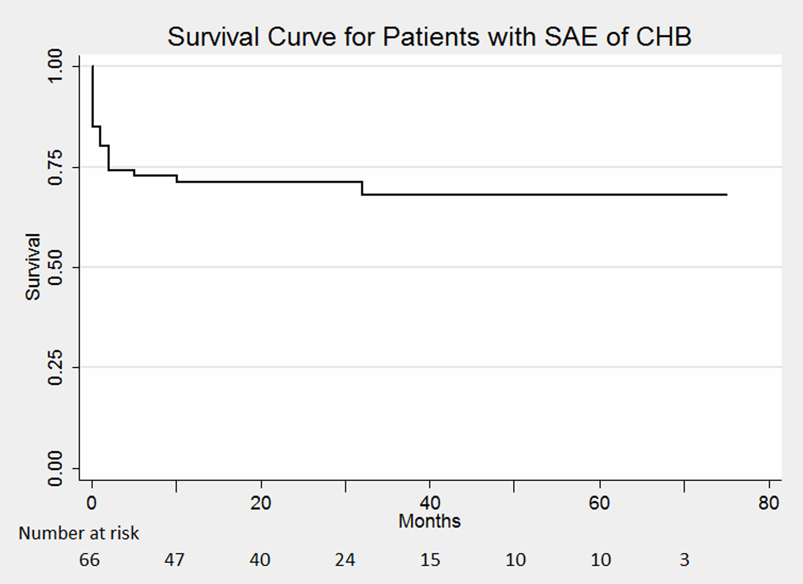

Figure 1. Survival curve for patients with severe acute exacerbation of chronic hepatitis B. The survival pattern was characterized by early mortality within 3 months of presentation. SAE, severe acute exacerbation; CHB, chronic hepatitis B.

Figure 2

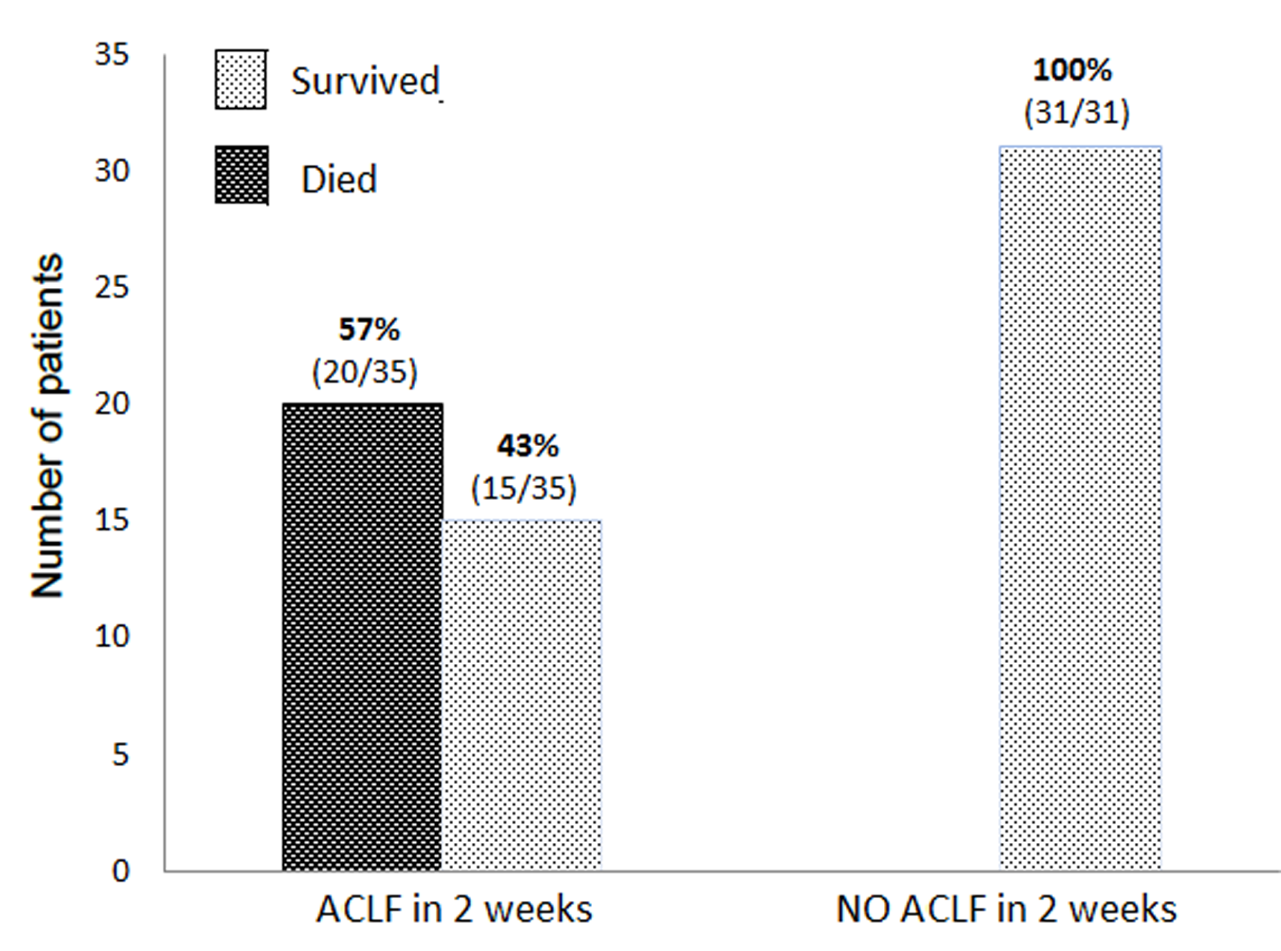
Figure 2. Progression to acute on chronic liver failure precedes mortality. All deaths occurred in patients developing acute on chronic liver failure within 2 weeks. ACLF, acute on chronic liver failure.

Figure 3

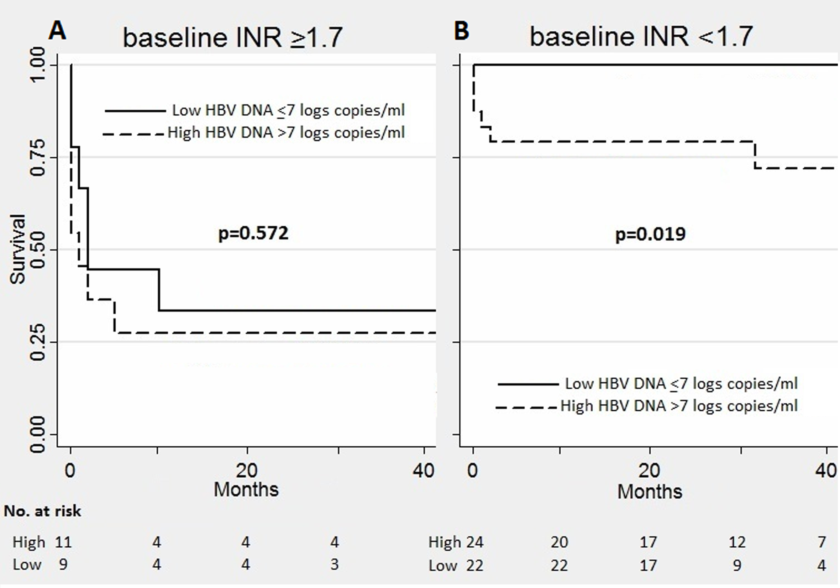
Figure 3 A. Profound coagulopathy foretells death regardless of pretreatment viral load; Figure 3B. Serum level of HBV DNA distinguishes risk of mortality in patients without initial presentation of profound coagulopathy. HBV, hepatitis B virus; INR, international normalized ration (for prothrombin time).

