Table 1 Effect of GL on serum levels of liver enzymes, triglyceride and total bilirubinin TPN-induced rats
Group | ALT U/L |  | AST (U/L) |  | TB (mg/dL) |  | TG (μg/μL)
Control | 27 | ± 4 | 123 | ± 6 | 0.10 | ± 0.1 | 5.5 | ± 0.4
TPN | 55 | ± 5* | 434 | ± 5* | 0.41 | ± 0.1* | 9.3 | ± 0.4*
GL 1 mg/kg + TPN | 38 | ± 4# | 310 | ± 16# | 0.36 | ± 0.1* | 8.1 | ± 0.4#
GL 3 mg/kg + TPN | 33 | ± 3# | 236 | ± 9# | 0.26 | ± 0.1 | 6.9 | ± 0.3#
GL 10 mg/kg + TPN | 24 | ± 3# | 146 | ± 9# | 0.20 | ± 0.4 | 6.4 | ± 0.3#
Values represent the mean±SD (n=6); *, p<0.05 (versus control group); #, p<0.05 (between TPN and GL-pretreated +TPN groups). ALT: alanine aminotransferase; AST: aspartate aminotransferase; TB: total bilirubin; TG: triglyceride

Figure 1A

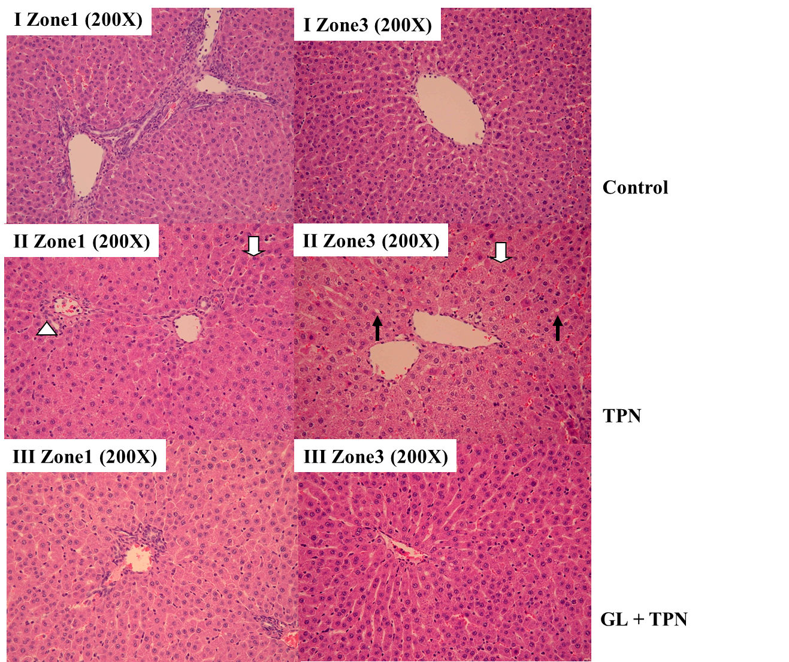
Figure 1B
Figure 2A
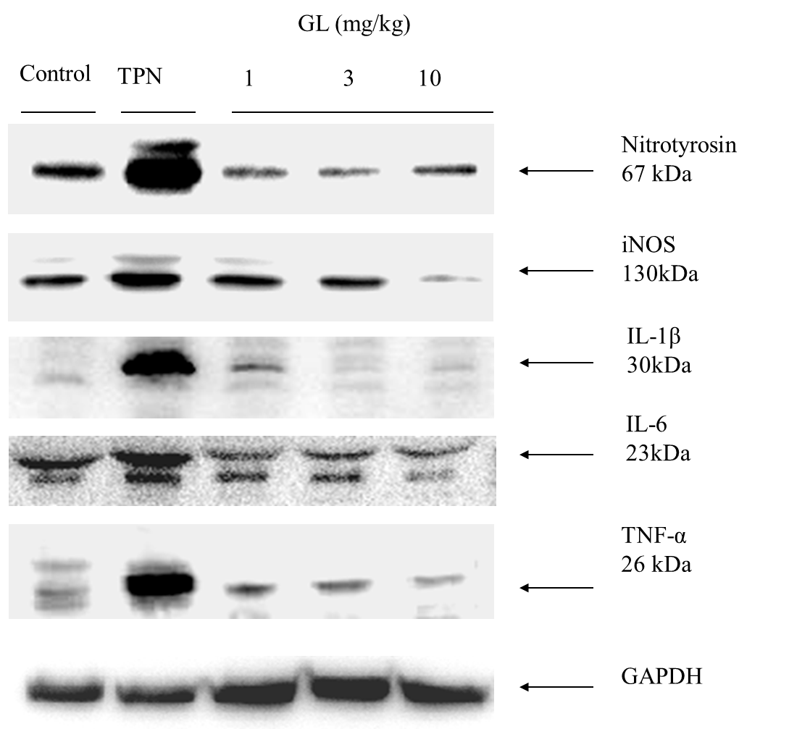
Figure 2B
Figure 3A
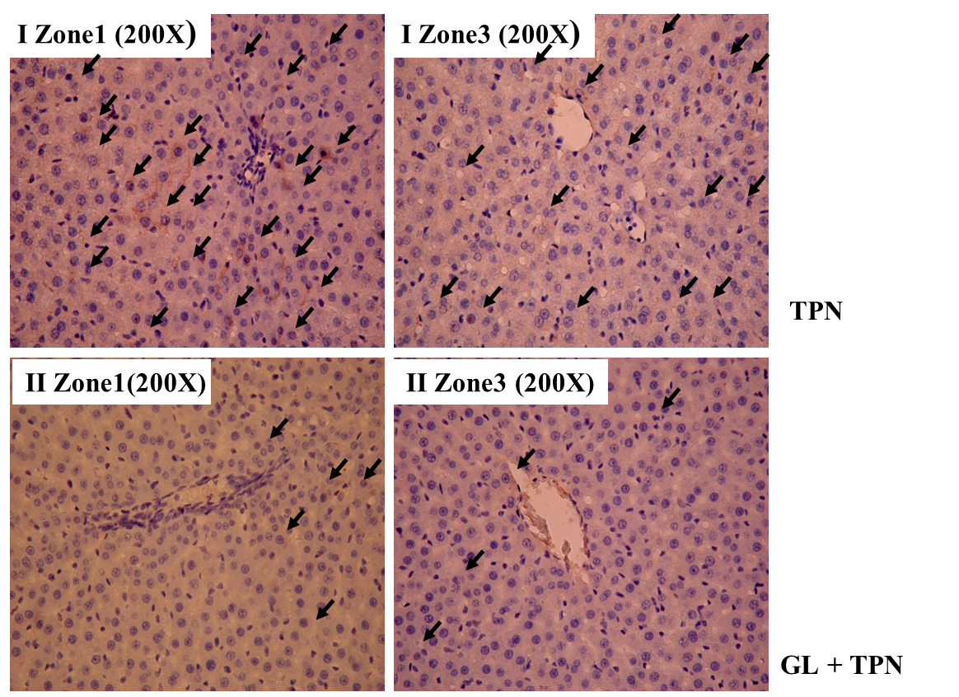
Figure 3B
Figure 4A
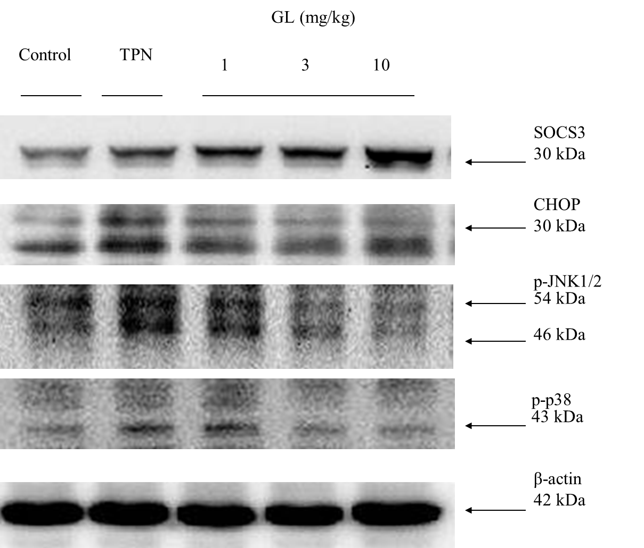
Figure 4B
Figure 5A
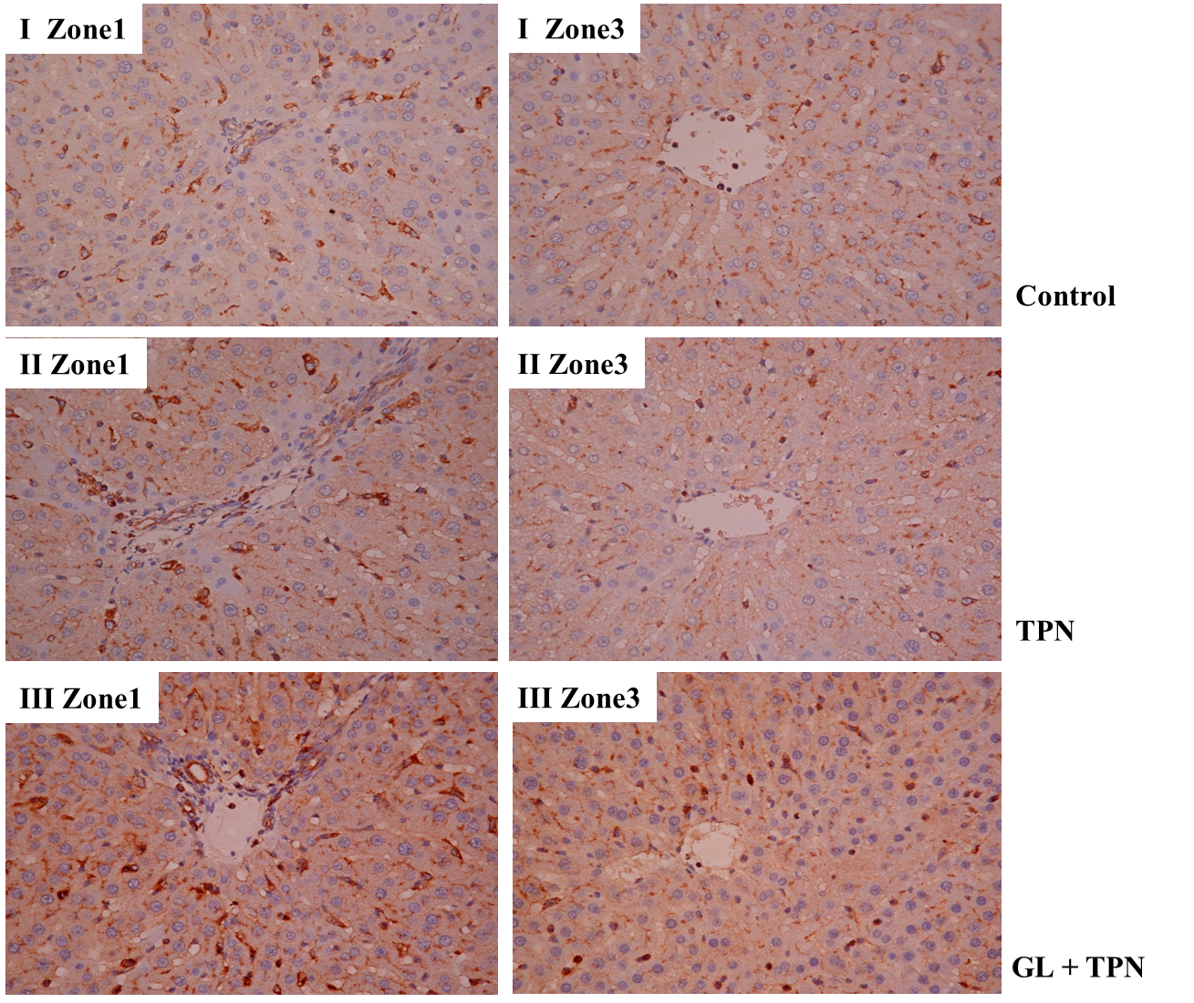

Figure 5B

Figure 6
