財團法人明日醫學基金會補助專題研究計畫
成果報告 □期中進度報告

計畫名稱：
Serum viral load at the virological relapse predicts subsequent clinical flares in chronic hepatitis B patients off entecavir therapy

計畫類別： 個別型計畫 □ 整合型計畫
執行期間： 105 年 1 月 1 日起 至 105 年 12 月 31 日止

計畫主持人： 許耀峻
共同主持人：
計畫參與人員：

成果報告類型：□精簡報告 完整報告

處理方式：可公開查詢

執行單位：義大醫院肝膽胃腸科

Serum viral load at the virological relapse predicts subsequent clinical flares in chronic hepatitis B patients off entecavir therapy
Short title: clinical hepatitis B flare off entecavir

Reported by Yao-Chun Hsu^{1,2}
¹Graduate Institute of Clinical Medicine, China Medical University, Taichung, Taiwan
²Department of Medicine, E-Da Hospital/I-Shou University, Kaohsiung, Taiwan

This study was orally presented at the United European Gastroenterology (UEG) Week 2016 (OP206) on October 18, 2016 (Vienna, Austria).

FUNDING: Tomorrow Medical Foundation (105-2), E-Da Hospital (EDAHP105019), and the Taipei Pathology Institutes (TIP105-8).

Background: Therapeutic duration of nucleos(t)ide analogues for chronic hepatitis B (CHB) is not indefinite in many parts of the world. Viral reactivation is common off therapy but the risk of subsequent clinical outcome remains unclear and unpredictable.
Aim: We aimed to quantify the incidence of and explore the predictors for clinical flare following virological relapse in CHB patients who discontinue entecavir therapy.
Methods: This multicenter cohort study prospectively monitored 133 CHB patients who were HBeAg-negative and viral DNA-undetectable when discontinuing entecavir after at least 3 years on therapy. Following virological relapse (viral DNA >2,000 IU/mL) that occurred in 92 patients, the incidences of subsequent clinical flare and persistent (unremittent for 3 months) or severe hepatitis (with jaundice or coagulopathy) were determined, and risk factors were explored. Patients did not resume antiviral therapy until occurrence of persistent or severe hepatitis.
Results: The cumulative incidence of clinical hepatitis 2 years after virological relapse was 61.0% (95% CI, 49.9-72.3%) and that of persistent or severe hepatitis was 53.0% (95% CI, 40.9-66.2%). Serum viral load at the virological relapse was associated with both clinical hepatitis (adjusted hazard ratio [HR], 1.31 per log IU/mL; 95% CI, 1.07-1.60) and persistent or severe hepatitis (adjusted HR, 1.63 per log IU/mL; 95% CI, 1.27-2.10), after adjustment for serum aminotransferase and alfa-fetoprotein levels in the multivariate analysis. Viral DNA >100,000 IU/mL predicted a nearly inevitable occurrence of clinical flare (P<0.0001).
Conclusions: A high viral load at the virological relapse predicts subsequent clinical hepatitis in CHB patients who discontinue entecavir.

Keywords: chronic hepatitis B; nucleos(t)ide analogues; hepatitis B viral DNA; off-therapy relapse; outcome research
Introduction
Nucleos(t)ide analogues (NUCs) potently inhibit replication of hepatitis B virus (HBV) and have been widely used to treat patients with chronic hepatitis B (CHB) ¹⁻³. Through sustained inhibition of the viral polymerase, long-term NUC therapy is able to ameliorate hepatitis, improve hepatic function, reverse liver fibrosis, and may reduce the risk of hepatocellular carcinoma ⁴⁻⁷. However, discontinuation of NUCs usually leads to loss of viral control ⁸⁻¹⁰. Current guidelines recommend seroclearance of hepatitis B surface antigen (HBsAg) as the indicator to discontinue NUCs ^{2, 3}, because it foresees off-therapy durability ^{11, 12}. However, this goal is remote in the vast majority of treated patients, requiring several decades on therapy ¹³, and practically unrealistic in most HBV-endemic countries ¹⁴. Besides, indefinite use raises safety concern of prolonged exposure to an agent that works on genetic transcription ¹⁵.
It remains controversial whether CHB patients can safely discontinue NUCs before HBsAg loss. How to predict durable off-therapy remission has become the focus of intense research ¹⁶. Previous studies including ours reported that therapeutic duration, age, and serum level of HBsAg were associated with risk of relapse after NUC cessation ¹⁷⁻²². We have found that HBsAg lower than 10 IU/mL at the end of therapy signifies a negligible risk of relapse, but only a small fraction of patients (less than 10%) could achieve this endpoint after 3 years of treatment ²². Most patients who attempt to stop NUCs with a higher HBsAg level still carry a substantial risk of relapse.
It is not yet clear when patients should resume antiviral therapy after discontinuing NUCs. Specifically, whether retreatment is indicated for resurge of viremia or can be deferred until occurrence of clinical flare remains debatable ²³. Much of the controversy arises from the paucity of data regarding clinical consequences subsequent to viral relapse. Also, little is known about the risk predictors. In this study, we aimed to clarify the incidence of clinical flares following virological relapse in CHB patients off entecavir therapy. Moreover, we hypothesized that serum levels of viral DNA or HBsAg could predict the risk.

METHODS and MATERIALS
Study design and setting
This is a prospective cohort study conducted in 3 teaching hospitals in Taiwan. Study protocol has been previously detailed ²². Briefly, we prospectively screened consecutive patients who were going to discontinue NUCs in the E-Da Hospital (Kaohsiung, Taiwan), the Lotung Poh-Ai Hospital (Yilan, Taiwan), and the National Taiwan University Hospital Yun-Lin Branch (Yunlin, Taiwan) between July 1, 2011 and January 31, 2016. Institutional review board in each hospital approved the protocol and subsequent data analysis (EMRP100-049, EMRP-104-131). Written informed consent was obtained from all patients.
Participants
Patients were eligible if they were 20 years or older, diagnosed with CHB for longer than 6 months, treated continuously with entecavir for a minimum of 3 years, and seronegative for both HBeAg and viral DNA at treatment cessation. Those with any of the following exclusion criteria were excluded: co-infection with hepatitis C or human immunodeficiency virus, cirrhosis, hepatic encephalopathy, variceal bleeding, malignant disease, organ transplantation, exposure to interferon alpha for one month or longer, and concurrent use of cytotoxic or immunosuppressive regimen. Cirrhosis was diagnosed either by liver biopsy or by clinical criteria, which included evaluation of liver surface, parenchyma, vascular structure, and splenic size.²⁴ In the absence of splenomegaly, varices had to be shown on upper endoscopy to ascertain a clinical diagnosis of cirrhosis.
Antiviral treatment
The National Health Insurance in Taiwan has been reimbursing Taiwanese residents with CHB for antiviral therapy since October, 2003. Details of the regulations have been documented ^{5, 6}. The regimen was generally 3 years in duration, except for special conditions such as cirrhosis, organ transplantation, and malignancy requiring cytotoxic chemotherapy. One-year consolidation following HBeAg seroconversion was granted to pretreatment HBeAg-positive patients.¹⁻³ After expiration of the reimbursement, patients who could not pay for the regimen had to stop treatment because of the strict insurance policy.
Methods of measurement
Participants were enrolled when they discontinued NUCs, and were followed up every 3 months thereafter. At enrollment, they were interviewed for demographic data, physically checked, and examined for biochemical, serological (HBsAg, HBeAg, anti-HBs, anti-HBe), and virological tests (viral DNA). At each follow-up visit, they received physical as well as laboratory examinations.
Blood samples were collected and sent to the central laboratory in the Taipei Pathology Institutes (Taipei, Taiwan) for quantification of HBsAg and viral DNA. The former was performed using the micro-particle immunoassay (Abbott Architect i2000, Abbott Park, IL, USA). If the concentration exceeded the automatic range of the machine (0.05~250 IU/mL), the sample was manually diluted without an upper limit. Viral DNA was quantified by polymerase chain reaction (COBAS TaqMan HBV Test, version 2.0, Roche Molecular Systems, Inc., USA) with a detection range from 20 to 1.7 x 10⁸ IU/mL.
Definitions of outcomes after cessation of NUCs
Virological relapse was defined by serum viral DNA >2,000 IU/mL according to the Asian-Pacific guidelines ¹. Clinical flare following virological relapse was defined by elevation of serum alanine aminotransferase (ALT) >2 folds the upper limits of normal (40 U/L). Persistent hepatitis indicated clinical hepatitis that lasted for 3 months and was defined by 2 or more measurements of serum ALT >80 U/L taken at least 3 months apart. Severe hepatitis denoted clinical flare accompanied with jaundice (serum bilirubin >2mg/dL) or coagulopathy (prolongation of prothrombin time >3 seconds).
Patients did not resume antiviral therapy for virological relapse alone or clinical hepatitis that was self-limited. Per the regulations of the national health insurance, they would be reimbursed for retreatment if clinical hepatitis persisted for 3 months or longer (i.e. persistent hepatitis) or appeared with jaundice or coagulopathy (i.e. severe hepatitis). Observation continued until resumption of antiviral therapy, the last hospital visit, or the end of this study (April 30, 2016).
Statistical analyses
Continuous variables were summarized by the number and percentage, and categorical ones by mean ± standard deviation or median with interquartile range (IQR). We applied the Kaplan Meier method to estimate the cumulative incidences of outcomes, the log rank test to analyze the difference in failure time among cohorts, and the Cox proportional hazard model to identify predictors of clinical events following virological relapse. Persistent and severe hepatitis were analysed together because they both indicated resumption of antiviral therapy that terminated observation. The multivariate-adjusted analysis examined all probable predictors with a stepwise selection to keep significant variables in the final model. The hazard ratio (HR) along with 95% confidence interval (CI) was reported. Data was managed and analyzed with a commercial software (Stata, version 13.0; Stata Corp, College Station, TX, USA). All statistical analyses were two-sided with significance set at P <0.05.

RESULTS
Characteristics of the study population
We screened a total of 284 consecutive patients who were about to discontinue NUCs, and identified 133 patients who discontinued entecavir with negative HBeAg and undetectable viral DNA in serum (Figure 1). During a mean off-therapy follow-up of 12.6 ± 8.2 months, 92 of them developed virological relapse and were enrolled into analysis (Supplementary figure 1). Table 1 summarized features of these study participants. The median duration on therapy was 36.6 (IQR, 36.3-36.9) months. All of the 25 pretreatment HBeAg-positive patients consolidated the treatment for at least one year (median 21.7 months; IQR, 12.2-25.4 months) following HBeAg seroconversion.
Clinical flares following virological relapse
None of those who did not develop virological relapse experienced clinical flare. In virological relapsers, 52 patients encountered clinical hepatitis with a cumulative incidence of 61.0% (95% CI, 49.9-72.3%) at 2 years (Figure 2A). Of note, 20 of them simultaneously experienced virological and clinical relapses. The maximum of serum ALT among at-risk participants was highest immediately following virological relapse and appeared to decline over time (supplementary figure 2). Details of the serum ALT after virological relapse were given in the appendix (supplementary table 1).
Moreover, 37 patients had persistent or severe hepatitis with a cumulative incidence of 53.0% (95% CI, 40.9-66.2%) 2 years after virological relapse (Figure 2B). Among them, 4 presented with hyperbilirubinemia and 33 patients experienced unremittent clinical hepatitis for 3 months or longer. All resumed antiviral treatment and fully recovered, without anyone deteriorating to liver failure.
HBsAg clearance was observed only in a male patient who had virological relapse. He did not experience clinical relapse, before or after HBsAg loss.
Risk factors of subsequent clinical flares
Univariate analyses showed that the risk of clinical hepatitis was associated with serum concentrations of viral DNA, ALT, and α-fetoprotein measured at the virological relapse, as well as ALT measured at treatment cessation (Table 2). The association with HBsAg was insignificant. Multivariate analysis adjusted for ALT levels affirmed that serum viral load at the virological relapse was a risk factor for clinical hepatitis (adjusted HR, 1.31 per log IU/mL; 95% CI, 1.07-1.60).
With regard to persistent or severe hepatitis, univariate analysis found that the risk was associated with serum levels of viral DNA, ALT, and α-fetoprotein at the virological relapse, as well as those of HBsAg and α-fetoprotein measured at the therapeutic end (Table 3). In the multivariate analysis, severity of viremia at the virological relapse was an independent risk factor for subsequent persistent or severe hepatitis (adjusted HR, 1.63 per log IU/mL; 95% CI, 1.27-2.10), after accounting for the effect of ALT at virological relapse and α-fetoprotein at treatment cessation.
Viral load at virological relapse stratifies risk of subsequent clinical flares
Study participants were grouped according to serum levels of viral DNA at virological relapse to illustrate how this measurement could identify patients with a high risk of clinical flares (Figure 3). The risk of clinical hepatitis (Figure 3A) and that of persistent or severe hepatitis (Figure 3B) both increased incrementally with serum viral load in a dose-response manner (P_{trend}<0.0001). Virological relapse with HBV DNA >100,000 IU/mL predicted a 2-year cumulative incidence of 89.7% (95% CI, 72.4-98.2%) for clinical hepatitis (Figure 3C), as compared with 51.3% in patients with the viremia <100,000 IU/mL (95% CI, 38.6-65.5%; P<0.0001). Similarly, whether the viral load exceeded 100,000 IU/mL significantly stratified the risk of persistent or severe hepatitis (Figure 3D; 88.0%; 95% CI, 68.7-97.9% versus 41.7%; 95% CI, 28.3-58.2%; P<0.0001).

DISCUSSION
This prospective study focuses on clinical consequences of viral reactivation after cessation of entecavir therapy in patients with CHB. We firstly quantified the substantial risk of clinical flare following virological relapse, revealing a 2-year cumulative incidence of 61.0% (95% CI, 49.9-72.3%) for clinical hepatitis and 53.0% (95% CI, 40.9-66.2%) for persistent or severe hepatitis. Furthermore, we found for the first time that serum HBV DNA level at the virological relapse was predictive of subsequent clinical hepatitis. A high viral load >100,000 IU/mL heralded persistent or severe hepatitis was nearly inevitable, and implicated an indication to resume treatment without undue delay. These findings will inform the management of CHB patients who attempt to stop NUCs before HBsAg clearance.
What off-therapy event indicates retreatment has been hotly debated. Many experts endorse viral rebound with HBV DNA greater than 2,000 IU/mL as the indication ⁸, because viremia above this level is linked to excessive risk of liver cirrhosis and cancer ^{25, 26}. Besides, early retreatment abolishes untoward immune reactions elicited by viral replication and decreases the chance of severe exacerbation. However, virological relapse is so common that it almost implies NUCs should not be discontinued at all, since more than 80% of patients will need to restart treatment ^{8, 17-19}. Furthermore, treating clinically silent viremia without biochemical hepatitis may hamper the opportunity of host immunity to control the virus ²³. Virological relapse alone, therefore, is arguably not recommended to indicate treatment resumption ¹⁶.
The major concern of stopping NUC in CHB patients is the risk of acute on chronic liver failure that may rapidly ensue after a severe bout of clinical flare. The importance of vigilant monitoring and timely retreatment cannot be overemphasized. Given the absence of liver failure in this cohort, our study suggests a follow-up interval of 3 months may suffice to avoid this dreadful complication. On the other hand, our data also demonstrated that viral replication could abruptly rebound and immediately manifest with severe clinical illness. In fact, the incidence rate of clinical flare and the severity of serum ALT elevation were all highest right after virological relapse. Therefore, it is imperative to restart treatment in those at high risk of clinical deterioration.
Based on our findings, retreatment should not be deferred in patients who relapse with a high viral load. Identification of this indicator helps to diminish the risk of persistent or severe clinical hepatitis. The predictive value of viral DNA for this scenario, which resembles similar utility in treatment-naïve patients ²⁷⁻²⁹, can be explained by the pathogenesis of liver injury resulting from the host-virus interaction. Unlike our prior work that showcased the value of HBsAg measured at the end of therapy in predicting both clinical and virological relapses ²², the present research found this biomarker was no longer an independent predictor for subsequent clinical events once virological relapse has occurred. Taken together, these findings point out complementary roles of viral DNA and HBsAg in guiding the management of CHB patients off NUCs. In addition, we also found serum levels of ALT and alfa-fetoprotein at the treatment cessation were associated with risks of clinical flare and persistent/severe hepatitis, respectively. Severity of residual liver injury at the end of therapy probably underlines this association, insomuch as these two biomarkers both are indicators of hepatocyte damage.^{30,31}.
The strict retreatment policy in Taiwan offers a unique opportunity to investigate the natural course of viral reactivation after discontinuation of NUCs. Only when the clinical hepatitis persisted for 3 months or manifested with hepatic decompensation would patients resume treatment. Furthermore, prospective selection, enrollment, and observation of consecutive patients in 3 recruiting sites minimized selection bias. The standardized protocol as well as measurement of viral DNA and HBsAg in a central laboratory controlled confounding from heterogeneity among different hospitals.
We nonetheless acknowledge the following limitations. First, our data could not address long-term outcomes such as liver cirrhosis or HCC. Tackling this issue requires a huge study sample and prolonged follow-up, given the low incidence of these late complications. Second, while we clearly showed the predictive value of viral load for subsequent clinical hepatitis, we did not intend to advocate interruption of antiviral therapy was preferred over continuous treatment. Our novel findings should be cautiously interpreted in the context of healthcare systems. Third, because this study prospectively enrolled patients at treatment cessation, we could not analyze several pretreatment factors including viral genotype and length of consolidation on therapy. It should also be noted that the study participants stopped treatment because of the insurance policy, instead of testing the APASL guidelines.³² Nevertheless, previous studies have shown a substantial risk of relapse despite fulfilling the APASL recommendation.^{8, 9} Lastly, it is beyond the scope of the present study to address HBsAg loss, given that few participants lost HBsAg off therapy.
In conclusion, our study adds to current understanding about the risk and risk stratification of clinical hepatitis subsequent to virological relapse in CHB patients who stop taking entecavir. Virological relapses was followed by persistent or severe hepatitis. Moreover, this risk is predictable by serum levels of HBV DNA at the episode of virological rebound. For patients whose viremia recurs at a gradient greater than 100,000 IU/mL, the risk is so high that retreatment should not be deferred. These novel findings may help to guide CHB management off NUC therapy and warrant independent validation and further exploration.

Acknowledgements:
The authors are indebted to Professor Grace LH Wong (The Chinese University of Hong Kong) for her careful review and comments. We also appreciate efficient assistance by Ms. Ying-Ju Lee, Ms. Hsin-Yi Tsai, and Ms. Tzu-Shan Chen. This study received grant support from the E-Da Hospital (EDAHP105019), the Tomorrow Medical Foundation (105-2), and the Taipei Pathology Institutes (TIP105-8).

REFERENCES

[1] Liaw YF, Kao JH, Piratvisuth T, et al. Asian-Pacific consensus statement on the management of chronic hepatitis B: a 2012 update. Hepatol Int. 2012; 6: 531-61.
[2] Terrault NA, Bzowej NH, Chang KM, Hwang JP, Jonas MM, Murad MH. AASLD guidelines for treatment of chronic hepatitis B. Hepatology. 2016; 63: 261-83.
[3] European Association For The Study Of The L. EASL clinical practice guidelines: Management of chronic hepatitis B virus infection. J Hepatol. 2012; 57: 167-85.
[4] Marcellin P, Gane E, Buti M, et al. Regression of cirrhosis during treatment with tenofovir disoproxil fumarate for chronic hepatitis B: a 5-year open-label follow-up study. Lancet. 2013; 381: 468-75.
[5] Chiang CJ, Yang YW, Chen JD, et al. Significant reduction in end-stage liver diseases burden through the national viral hepatitis therapy program in Taiwan. Hepatology. 2015; 61: 1154-62.
[6] Wu CY, Lin JT, Ho HJ, et al. Association of nucleos(t)ide analogue therapy with reduced risk of hepatocellular carcinoma in patients with chronic hepatitis B: a nationwide cohort study. Gastroenterology. 2014; 147: 143-51 e5.
[7] Wu CY, Chen YJ, Ho HJ, et al. Association between nucleoside analogues and risk of hepatitis B virus-related hepatocellular carcinoma recurrence following liver resection. JAMA. 2012; 308: 1906-14.
[8] Seto WK, Hui AJ, Wong VW, et al. Treatment cessation of entecavir in Asian patients with hepatitis B e antigen negative chronic hepatitis B: a multicentre prospective study. Gut. 2015; 64: 667-72.
[9] Jeng WJ, Sheen IS, Chen YC, et al. Off-therapy durability of response to entecavir therapy in hepatitis B e antigen-negative chronic hepatitis B patients. Hepatology. 2013; 58: 1888-96.
[10] Chang ML, Liaw YF, Hadziyannis SJ. Systematic review: cessation of long-term nucleos(t)ide analogue therapy in patients with hepatitis B e antigen-negative chronic hepatitis B. Aliment Pharmacol Ther. 2015; 42: 243-57.
[11] Kim GA, Lim YS, An J, et al. HBsAg seroclearance after nucleoside analogue therapy in patients with chronic hepatitis B: clinical outcomes and durability. Gut. 2014; 63: 1325-32.
[12] Chen YC, Jeng WJ, Chien RN, Chu CM, Liaw YF. Clinical outcomes after spontaneous and nucleos(t)ide analogue-treated HBsAg seroclearance in chronic HBV infection. Aliment Pharmacol Ther. 2016.
[13] Chevaliez S, Hezode C, Bahrami S, Grare M, Pawlotsky JM. Long-term hepatitis B surface antigen (HBsAg) kinetics during nucleoside/nucleotide analogue therapy: finite treatment duration unlikely. J Hepatol. 2013; 58: 676-83.
[14] Lim SG, Amarapurkar DN, Chan HL, et al. Reimbursement policies in the Asia-Pacific for chronic hepatitis B. Hepatol Int. 2015; 9: 43-51.
[15] Ridruejo E, Silva MO. Safety of long-term nucleos(t)ide treatment in chronic hepatitis B. Expert Opin Drug Saf. 2012; 11: 357-60.
[16] Lampertico P. Oral antiviral therapy for HBeAg negative chronic hepatitis B: better stop or continue? Gut. 2015; 64: 526-8.
[17] Chen CH, Lu SN, Hung CH, et al. The role of hepatitis B surface antigen quantification in predicting HBsAg loss and HBV relapse after discontinuation of lamivudine treatment. J Hepatol. 2014; 61: 515-22.
[18] Chen CH, Hung CH, Hu TH, et al. Association Between Level of Hepatitis B Surface Antigen and Relapse After Entecavir Therapy for Chronic Hepatitis B Virus Infection. Clin Gastroenterol Hepatol. 2015; 13: 1984-92 e1.
[19] Hadziyannis SJ, Sevastianos V, Rapti I, Vassilopoulos D, Hadziyannis E. Sustained responses and loss of HBsAg in HBeAg-negative patients with chronic hepatitis B who stop long-term treatment with adefovir. Gastroenterology. 2012; 143: 629-36 e1.
[20] Chan HL, Wong GL, Chim AM, Chan HY, Chu SH, Wong VW. Prediction of off-treatment response to lamivudine by serum hepatitis B surface antigen quantification in hepatitis B e antigen-negative patients. Antivir Ther. 2011; 16: 1249-57.
[21] Chi H, Hansen BE, Yim C, et al. Reduced risk of relapse after long-term nucleos(t)ide analogue consolidation therapy for chronic hepatitis B. Aliment Pharmacol Ther. 2015; 41: 867-76.
[22] Hsu YC, Mo LR, Chang CY, et al. Association Between Serum Level of Hepatitis B Surface Antigen at End of Entecavir Therapy and Risk of Relapse in E Antigen-Negative Patients. Clin Gastroenterol Hepatol. 2016; 14: 1490-8 e3.
[23] Hadziyannis S, Liaw YF. Discontinuation of long-term NA therapy in HBeAg-negative chronic hepatitis B. Gut. 2014.
[24] Hung CH, Lu SN, Wang JH, et al. Correlation between ultrasonographic and pathologic diagnoses of hepatitis B and C virus-related cirrhosis. Journal of gastroenterology. 2003; 38: 153-7.
[25] Chen CJ, Yang HI, Su J, et al. Risk of hepatocellular carcinoma across a biological gradient of serum hepatitis B virus DNA level. JAMA. 2006; 295: 65-73.
[26] Iloeje UH, Yang HI, Su J, et al. Predicting cirrhosis risk based on the level of circulating hepatitis B viral load. Gastroenterology. 2006; 130: 678-86.
[27] Brunetto MR, Oliveri F, Colombatto P, et al. Hepatitis B surface antigen serum levels help to distinguish active from inactive hepatitis B virus genotype D carriers. Gastroenterology. 2010; 139: 483-90.
[28] Jeng WJ, Sheen IS, Liaw YF. Hepatitis B virus DNA level predicts hepatic decompensation in patients with acute exacerbation of chronic hepatitis B. Clin Gastroenterol Hepatol. 2010; 8: 541-5.
[29] Hsu YC, Wu CY, Chang CY, et al. Pretreatment viral DNA stratifies mortality risk in patients receiving antiviral therapy for severe acute exacerbation of chronic hepatitis B. Antivir Ther. 2013; 18: 221-8.
[30] Goldstein NS, Blue DE, Hankin R, et al. Serum alpha-fetoprotein levels in patients with chronic hepatitis C. Relationships with serum alanine aminotransferase values, histologic activity index, and hepatocyte MIB-1 scores. Am J Clin Pathol. 1999; 111: 811-6.
[31] Jeng WJ, Chen YC, Chang ML, Liaw YF. alpha-Fetoprotein level-dependent early hepatitis B surface antigen decline during entecavir therapy in chronic hepatitis B with hepatitis flare. J Antimicrob Chemother. 2016.
[32] Sarin SK, Kumar M, Lau GK, et al. Asian-Pacific clinical practice guidelines on the management of hepatitis B: a 2015 update. Hepatol Int. 2016; 10: 1-98.

Table 1. Characteristics of CHB patients who developed virological relapse after discontinuing entecavir therapy
Characteristics | All (n =92)
Male sex, n (%) | 71 (77.2%)
Status at treatment start
HBV DNA, log IU/ml | 6.8 (4.3-8.4)
ALT, IU/mL | 158 (93-451)
α-fetoprotein, ng/mL | 4.5 (3.3-8.2)
Positive anti-HBe, n (%) | 67 (72.8%)
Positive HBeAg, n (%) | 25 (27.2%)
Status at treatment cessation
HBsAg, log IU/mL | 2.9 (2.5-3.1)
ALT, IU/mL | 22 (16-35.5)
α-fetoprotein, ng/mL | 2.6 (2.1-3.4)
Positive anti-HBe, n (%) | 87 (94.6%)
Treatment duration, months | 36.6 (36.3-36.9)
Status at virological relapse
Age, years | 50.2 (42.4-58.1)
HBV DNA, log IU/ml | 4.1 (3.6-5.0)
HBsAg, log IU/mL | 2.9 (2.5-3.3)
ALT, IU/mL | 39 (22-67.5)
α-fetoprotein, ng/mL | 2.5 (2.0-3.3)
Notes. ALT, Alanine transaminase; Anti-HBe, hepatitis B e antibody; CHB, chronic hepatitis B; HBsAg, hepatitis B surface antigen; HBV, hepatitis B virus; NUC, nucleos(t)ide analogue; VR, virological relapse

Table 2. Cox proportional hazard model for clinical hepatitis after virological relapse
Variables | Unadjusted analysis |  |  | Multivariate modelling
 | HR | 95 % CI | P | HR | 95% CI | P
Status at treatment start
Male sex | 1.40 | 0.70-2.82 | 0.34
Age, per year | 1.007 | 0.98-1.03 | 0.55
HBeAg positivity | 0.94 | 0.51-1.72 | 0.83
Anti-HBe positivity | 1.13 | 0.61-2.09 | 0.71
HBV DNA, per log IU/mL | 1.05 | 0.89-1.23 | 0.57
ALT, per U/L | 1.0 | 0.999-1.0 | 0.32
α-fetoprotein, per ng/mL | 1.0 | 1.0-1.002 | 0.13
Status at treatment cessation
Age, per year | 1.008 | 0.98-1.03 | 0.51
Anti-HBe positivity | 1.06 | 0.33-3.43 | 0.92
HBsAg, per log IU/mL | 1.50 | 0.94-2.40 | 0.09
ALT, per U/L | 1.01 | 1.004-1.016 | 0.001 | 1.008 | 1.002-1.014 | 0.005
α-fetoprotein, per ng/mL | 1.05 | 0.98-1.13 | 0.14
Regimen length, per month | 1.02 | 0.99-1.06 | 0.23
Status at virological relapse
Age, per year | 1.01 | 0.98-1.03 | 0.53
HBsAg, per log IU/mL | 1.39 | 0.93-2.06 | 0.11
HBV DNA, per log IU/mL | 1.38 | 1.15-1.66 | 0.001 | 1.31 | 1.07-1.60 | 0.008
ALT, per U/L | 1.003 | 1.001-1.004 | <0.001 | 1.002 | 1.001-1.004 | 0.002
α-fetoprotein, per ng/mL | 1.14 | 1.05-1.25 | 0.003

Table 3. Cox proportional hazard modelling for persistent/severe hepatitis following virological relapse
Variables | Unadjusted analysis |  |  | Multivariate modelling
 | HR | 95 % CI | P | HR | 95% CI | P
Status at treatment start
Male sex | 1.26 | 0.58-2.77 | 0.56
Age, per year | 1.001 | 0.98-1.03 | 0.96
HBeAg positivity | 1.44 | 0.75-2.79 | 0.28
Anti-HBe positivity | 0.73 | 0.38-1.43 | 0.36
HBV DNA, per log IU/mL | 1.16 | 0.96-1.41 | 0.12
ALT, per U/L | 1.0 | 0.999-1.001 | 0.65
α-fetoprotein, per ng/mL | 1.0 | 0.999-1.001 | 0.71
Status at treatment cessation
Age, per year | 1.001 | 0.98-1.03 | 0.91
Anti-HBe positivity | 0.60 | 0.18-1.95 | 0.39
HBsAg, per log IU/mL | 1.79 | 1.01-3.18 | 0.05
ALT, per U/L | 1.003 | 0.995-1.012 | 0.43
α-fetoprotein, per ng/mL | 1.10 | 1.03-1.2 | 0.01 | 1.09 | 1.006-1.175 | 0.034
Regimen length, per month | 1.04 | 0.99-1.08 | 0.11
Status at virological relapse
Age, per year | 1.001 | 0.98-1.03 | 0.94
HBsAg, per log IU/mL | 1.56 | 0.96-2.53 | 0.07
HBV DNA, per log IU/mL | 1.63 | 1.33-1.99 | <0.001 | 1.63 | 1.27-2.10 | <0.001
ALT, per U/L | 1.006 | 1.003-1.008 | <0.001 | 1.005 | 1.002-1.008 | 0.001
α-fetoprotein, per ng/mL | 1.16 | 1.05-1.28 | 0.003

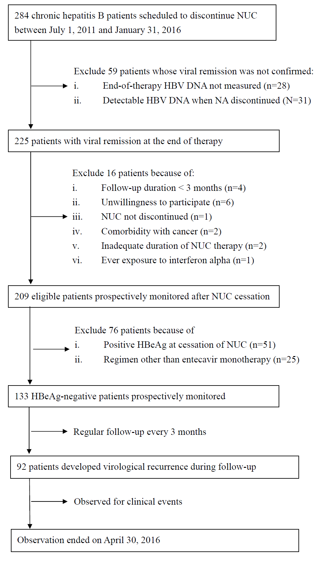
Figure 1. Study flowchart
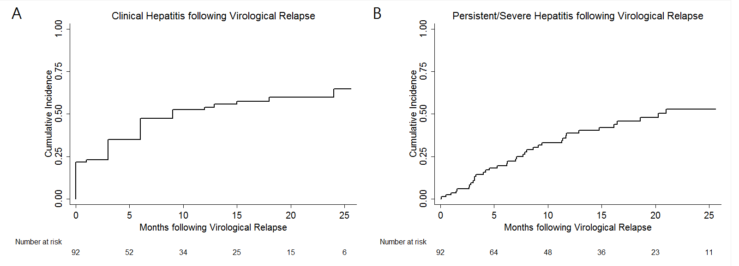
Figure 2. Cumulative incidences of clinical flares following the episode of virological relapse: clinical hepatitis (panel A), persistent or severe hepatitis (panel B)

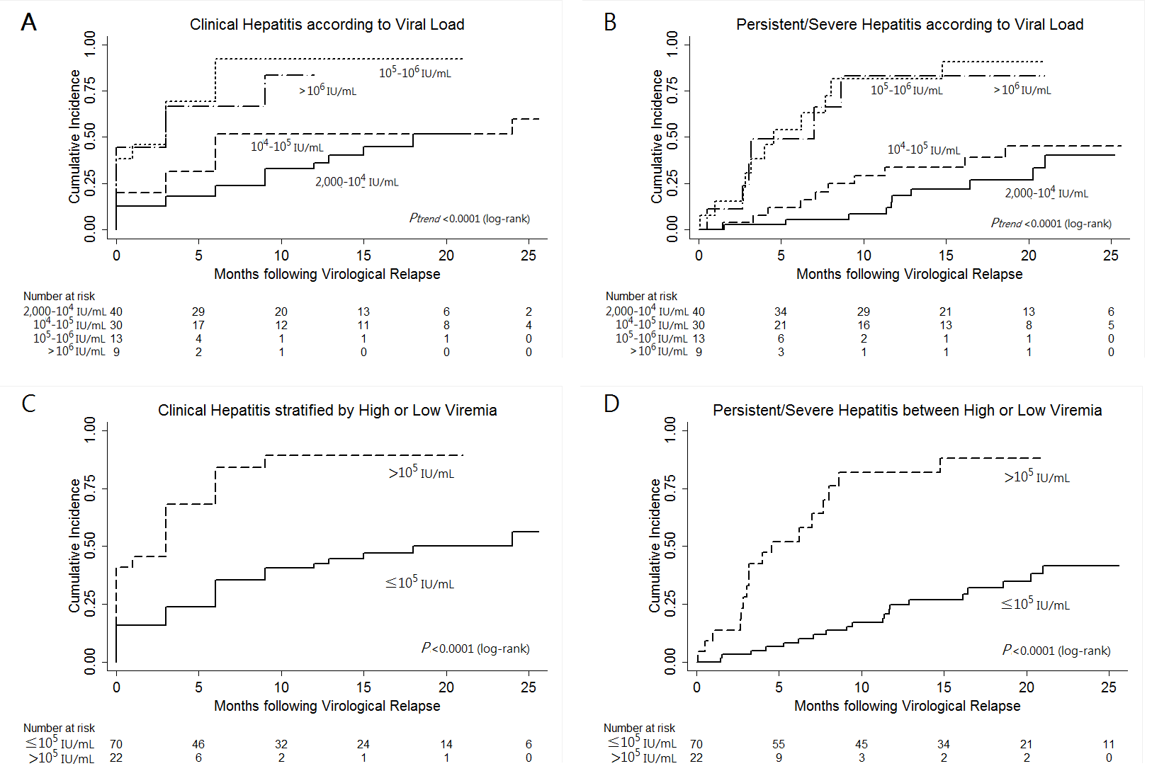
Figure 3. Serum viral load at the virological relapse stratified the risk of subsequent clinical flares: cumulative incidence of clinical hepatitis (panel A) and that of persist or severe hepatitis (panel B) according to different levels of viremia; almost all patients who relapsed with HBV DNA >100,000 IU/mL would subsequently develop clinical hepatitis (panel C) as well as persistent or severe hepatitis (panel D).

