財團法人明日醫學基金會補助專題研究計畫
成果報告 □期中進度報告

計畫名稱：
Development of a prediction model for hepatocellular carcinoma in patients with chronic hepatitis B on nucleos(t)ide analogues

計畫類別： 個別型計畫 □ 整合型計畫
執行期間： 106 年 1 月 1 日起 至 106 年 12 月 31 日止

計畫主持人： 許耀峻
共同主持人：
計畫參與人員：

成果報告類型：□精簡報告 完整報告

處理方式：可公開查詢

執行單位：輔仁大學醫學系及附設醫院肝膽胃腸科

Development of a prediction model for hepatocellular carcinoma in patients with chronic hepatitis B on nucleos(t)ide analogues

Reported by Yao-Chun Hsu^{1,2}
¹School of Medicine, Fu Jen Catholic University, New Taipei, Taiwan
²Division of Gastroenterology, Fu Jen Catholic University Hospital, New Taipei, Taiwan
³Department of Medicine, E-Da Hospital/I-Shou University, Kaohsiung, Taiwan

This study was presented at the annual meeting of American Association for the Study of Liver Diseases (the Liver Meeting® 2017), Washington DC, USA

FUNDING: Tomorrow Medical Foundation (106-2) and the Taiwan’s Ministry of Science and Technology (MOST 103-2314-B-650-002 and MOST 105-2314-B-650-001-MY2).

Background: The risk of hepatocellular carcinoma (HCC) during antiviral therapy in patients with chronic hepatitis B (CHB) is inadequately predicted by the scores built from untreated patients.
Aim: We aimed to develop and validate a risk score to predict HCC in CHB patients on entecavir or tenofovir treatment.
Methods: This study analyzed population-wide data from the healthcare databases in Taiwan and Hong Kong to identify CHB patients continuously receiving entecavir or tenofovir. The development cohort included 23,851 patients from Taiwan; 596 (2.50%) of them developed HCC with a 3-year cumulative incidence of 3.56% (95% CI, 3.26-3.86%). The multivariable Cox proportional hazard model found cirrhosis, age (cirrhosis and age interacted with each other), male sex, and diabetes mellitus were the risk determinants. These variables were weighted to develop the CAMD score ranging from 0 to 19 points. The score was externally validated in 19,321 patients from Hong Kong.
Results: The c indices for HCC in the development cohort were 0.83 (95% CI, 0.81-0.84), 0.82 (95% CI, 0.81-0.84), and 0.82 (95% CI, 0.80-0.83) at the first, second, and third year of therapy, respectively. In the validation cohort, the c indices were 0.74 (95% CI, 0.71-0.77), 0.75 (95% CI, 0.73-0.78), and 0.75 (95% CI, 0.72-0.77) during the first 3 years, and 0.76 (95% CI, 0.74-0.78) and 0.76 (95% CI, 0.74-0.77) in the extrapolated fourth and fifth years. The predicted and the observed probabilities of HCC were calibrated in both cohorts. A score <8 and >13 points identified patients at distinctly low and high risks.
Conclusions: The easily calculable CAMD score can predict HCC and may inform surveillance policy in CHB patients during oral antiviral therapy.

Keywords: hepatitis B virus infection; nucleos(t)ide analogues; risk prediction; national health insurance research database; health authority
Introduction
Hepatitis B virus (HBV) infection is the leading etiology of hepatocellular carcinoma (HCC) around the globe.[1, 2] The risk of HCC is a lifelong threat to patients with chronic hepatitis B (CHB).[3] Antiviral therapy using nucleos(t)ide analogues (NAs) inhibits HBV replication,[4-6] ameliorates hepatic inflammation,[7] reverses liver fibrosis,[8] and may attenuate hepatocellular carcinogenesis. We and others have shown that NA treatment is associated with risk reduction of HCC in CHB patients.[9-12] In addition, the incidences of HCC decreased over the years while on therapies.[13-15] However, antiviral treatment does not completely eliminate the risk of HCC.[16] Beyond viral suppression, it remains unclear how to lower the risk further.
Prior to the current era of antiviral therapy, several scoring systems such as CU-HCC, GAG-HCC, and REACH-B have been built to predict occurrence of HCC in the natural history of CHB.[17-19] Although these systems were externally validated and could attain fairly good performance in untreated patients, they do not adequately predict HCC in patients on NAs.[20-22] Because long-term suppressive treatment with potent NA currently remains the therapeutic strategy of choice, there is a need of an accurate tool to stratify patients at different risks of HCC during antiviral treatment. Such knowledge is pivotal to inform clinical practice and to direct resource allocation.
Previous studies have shown that age, cirrhosis, male sex, platelet count, liver stiffness, and diabetes mellitus (DM) are risk factors of HCC in CHB patients receiving NAs.[23-25] On the other hand, pretreatment viral load, hepatitis B e antigen (HBeAg) status, hepatitis B surface antigen (HBsAg) quantity, and aminotransferase level are not predictive for treated patients, in contrast to their roles established in untreated populations.[26-28] Recently, we analyzed the national healthcare database in Taiwan to uncover HCC risk factors in patients continuously receiving entecavir or tenofovir for CHB. The relative impact of these factors and their interaction were quantified through analysis of the population-level data.[15] On the basis of these instrumental findings, the present study aimed to develop a simple scoring tool for the risk prediction during continuous NA treatment in patients with CHB. External validation was carried out also using population-wide data extracted from the state-run healthcare database in Hong Kong.

METHODS and MATERIALS
Data source
This study analyzed the National Health Insurance Research Database (NHIRD) in Taiwan and the Hospital Authority (HA) database in Hong Kong. Both databases contained data collected from in- and outpatient services in the respective healthcare systems. Their characteristics have been detailed in prior researches.[10, 29] In brief, the NHIRD covers 99% of the 23.5 million Taiwan residents and the HA covers 70~80% of the 7.3 million Hong Kong citizens, respectively. They both applied the International Classification of Diseases, Ninth Revision, Clinical Modification (ICD-9-CM) codes, and their coding accuracy for major diseases has been validated.[30, 31] Of note, the NHIRD exclusively consists of claim data whereas the HA includes laboratory results as well. Data retrieval and analysis were approved by the research ethics committee of the National Health Research Institutes in Taiwan (EC-1030705-E) and the Joint Chinese University of Hong Kong-New Territories East Cluster Clinical Research Ethics Committee in Hong Kong (reference number 2016.595). Conduction of this study conformed to the Declaration of Helsinki.
Study populations
Data in a nationwide cohort of 23,851 adult (age >18 years) patients from Taiwan was used to construct the risk score (the development cohort). They were identified from all (N=65,426) CHB patients who received entecavir or tenofovir from August 1, 2008 through the end of 2013 (Supplementary Figure 1). Eligible patients needed to fill prescriptions of entecavir or tenofovir continuously (defined as gaps between fills <7 days) for at least 3 months. Patients were excluded if they had an existing diagnosis of any malignancy, decompensated cirrhosis, other viral hepatitis or end-stage renal failure, developed HCC or passed way within 3 months of starting antiviral treatment, or had used lamivudine, adefovir, or telbivudine for 3 months or longer.
Reimbursement for NA was tightly regulated in Taiwan.[10] Briefly, serum HBV DNA >2,000 IU/mL was mandatory in patients without hepatic decompensation, organ transplantation, or malignancy. Serum alanine aminotransferase (ALT) needed to exceed 2 folds the upper limit of the normal range (ULN) in those without cirrhosis. During the study period, the reimbursement continuously lasted for a maximum of 3 years unless a particularly serious condition was present.[32]
Through analysis of the territory-wide HA database, 19,321 Hong Kong patients were identified to serve as the validation cohort (Supplementary Figure 2). They fulfilled the same eligibility criteria except for the enrolment period starting from February 24, 2004 and ending on December 26, 2016. In Hong Kong, reimbursement for NA also required HBV DNA > 2,000 IU/mL and ALT > 2 folds ULN in those without cirrhosis and detectable HBV DNA in those with cirrhosis.
Definitions of comorbidity and potential risk factors
In principle, disease was defined based on the ICD-9-CM code in conjunction with a specific pharmacotherapy or intervention if applicable (Supplementary Table 1-3). For instance, DM was defined by the prescription of anti-diabetes agents for at least 3 months in addition to the code. Drug exposure was defined by a filled prescription of at least 3 months. Because cirrhosis was incompletely coded in the HA database,[29] we supplemented the definition by fibrosis indices based on blood tests. In the Hong Kong cohort, red blood cell distribution width to platelet ratio (RPR) >0.16,[33, 34] Fibrosis-4 (FIB-4) >3.25,[35] and aspartate transaminase to platelet ratio index (APRI) >1 also defined the presence of cirrhosis.[36] This study excluded patients with decompensated cirrhosis, defined by the related clinical complications including hepatic encephalophay, acute variceal bleeding, spontaneous bacterial peritonitis, or hepatorenal syndrome.[37]
Observation for the occurrence of HCC during antiviral therapy
Outcome observation commenced after the “wash-out” period of the initial 3 months of antiviral therapy. Patients were followed up thereafter until HCC, death, cessation of the therapy (treatment interruption for 3 months or longer), or the end of the study period; whichever occurred first. The dataset for the development cohort ended on January 1, 2014, whereas the last day was December 26, 2016 in the validation cohort.
Both in Taiwan and Hong Kong, surveillance for HCC was performed using liver sonography with or without serum alfa-fetoprotein. The interval of sonography was 6 months in general and usually shorter for those with liver cirrhosis. Our prior studies have documented the validity of HCC diagnosis in both databases. In short, accuracy of the HCC diagnosis was certified by the Registry for Catastrophic Illness Patient Database in the Taiwan cohort.[10, 30] In the Hong Kong cohort, the accuracy and completeness of data collection, including the diagnosis of HCC, have been confirmed after the implementation of the Clinical Data Framework.[31]
Data analysis and statistical tests
The incidence of HCC was estimated both by accounting for competing mortality, and by the Kaplan Meier method treating death as censoring. Given that the estimates were nearly identical between the two approaches (Supplementary Figure 3), we kept the latter. A Cox proportional hazard model was built to identify risk predictors of HCC. The process of model building has been detailed.[15] In brief, the model started with all variables available at the baseline of NA initiation. The final model was determined by the Akaike information criterion with backward elimination. We applied bootstrapping with the samples of 5,000, 10,000, 15,000, 20,000, and 25,000 patients. Each sample size was repeated for 1,000 times. We then calculated the shrinkage factor by averaging the calibration slopes of bootstrap samples in the original data to correct over-optimism in using the model selected by the whole development cohort.[38]
From a nomogram based on the regression coefficients, we developed the risk score by simplifying the assigned points to integers. The performance in discrimination was assessed by the time-varying receiver operating characteristic (ROC) curves for censored survival data.[39] The area under the ROC curve was computed to generate the Harrell's c index. For the evaluation of calibration, the expected probability as predicted by the Cox model was plotted against the observed probability as estimated by the Kaplan Meier method. We also compared our score with the well-established platelet age gender-B (PAGE-B) score in the ROC curves. The PAGE-B score was calculated according to the published scoring formula.[40]
We performed 2 steps of the “optimal cutoff approach” according to the Youden’s index to find the 2 cutoff points for risk stratification. In the first step, the entire development cohort was dichotomized by the Youden’s index. In the second step, the respective optimal cutoff point in each dichotomy was used to categorize patients into high-risk (above the upper cutoff), intermediate-risk (between the upper and lower cutoffs), and low-risk (below the lower cutoff) subgroups. The cumulative incidences of HCC among the 3 risk subgroups were compared.
The statistical tests were carried out by the SAS (version 9.4, SAS Institute., Cary, NC, USA) and the R software programs (version 3.3.3). Continuous variables were expressed by the medians and the interquartile ranges (IQRs). Categorical variables were summarized by the percentage. Point estimates were accompanied with the 95% confidence intervals (CIs). All tests were two-tailed and a p value < 0.05 defined the statistical significance.

Results
Characteristics of the study populations
The two cohorts differed in the baseline characteristics from demographics, comorbidity, to drug exposure (Table 1). The Taiwan cohort had more patients with cirrhosis while the Hong Kong cohort was older. During a median follow-up of 25.8 (IQR, 12.7-35.7) months, 596 (2.50%) patients in the Taiwan cohort developed HCC with a cumulative incidence of 3.56 (95% CI, 3.26-3.86) at 3 years (Figure 1A). The annual incidences in the first, second, and third year were 1.40%, 0.94%, and 0.72%, respectively. The validation Hong Kong cohort was followed up for a median of 33.3 (IQR, 13.4-36.0) months and 383 (1.98%) patients developed HCC within 3 years (Figure 1B). During the first 3 years, the annual incidences of HCC were 1.03%, 0.74%, and 0.64%, respectively, with a cumulative incidence of 2.66% (95% CI, 2.39-2.93%). The observation was extrapolated to 5 years in the Hong Kong cohort for external validation (Supplementary Figure 4). With a total of 478 cases, the cumulative incidence of HCC was 3.91% (95% CI, 3.54-4.28%) at 5 years.
The regression models and the risk score to predict HCC occurrence
The final Cox proportional hazard model revealed that cirrhosis, age, male sex, and DM were the independent risk factors. Besides, cirrhosis and age significantly interacted with each other in the association with HCC. These variables including the interaction between age and cirrhosis were weighted to construct the CAMD (Cirrhosis, Age, Male sex, and Diabetes mellitus) score (Table 2). The weighted scores in the original model were not amended by the results of bootstrapping given that the shrinkage factor was found to be 0.990 (Supplementary Table 4). The score ranged from 0 to 19 points.
Discrimination and calibration of the risk score
In the development cohort, the c indices of the CAMD score for HCC occurrence were 0.83 (95% CI, 0.81-0.84), 0.82 (95% CI, 0.81-0.84), and 0.82 (95% CI, 0.80-0.83) at 1, 2, and 3 years, respectively (Figure 2A). In the validation cohort, the c indices were 0.74 (95% CI, 0.71-0.77), 0.75 (95% CI, 0.73-0.78), and 0.75 (95% CI, 0.72-0.77), respectively (Figure 2B). We also extrapolated the CAMD score beyond 3 years with the c indices of 0.76 (95% CI, 0.74-0.78) and 0.76 (95% CI, 0.74-0.77) at 4 and 5 years, respectively (Figure 2B).
The calibration chart illustrated the predicted versus the observed incidences of HCC (Figure 3). It was well calibrated during the 3-year treatment period in the development cohort (Figure 3A). In the validation cohort, the calibration was illustrated during the first 3 years and could also be extrapolated to 5 years. (Figure 3B). The predicted HCC incidences according to each point of the CAMD score were detailed in the first 3 years on therapy (Table 3).
The ROC curve of the CAMD score was plotted against that of the PAGE-B score in 17,984 Hong Kong patients who had the baseline platelet data (Figure 4). In these patients, the c indices of the CAMD and PAGE-B scores were 0.74 (95% CI, 71-0.76) versus 0.73 (95% CI, 0.70-0.75) at 3 years (p=0.33; Figure 4A), and 0.75 (95% CI, 0.73-0.77) versus 0.74 (95% CI, 0.72-0.76) at 5 years (p=0.26, Figure 4B), respectively.
Application of the CAMD score for risk stratification
The 2 cutoff points were set at 8 and 13 points to stratify patients into low-, intermediate-, or high-risk subgroups (Figure 5). In the development cohort, the 3-year cumulative incidences of HCC in patients with a CAMD score <8, 8~13, and >13 points were 0.27% (95% CI, 0.12-0.42%), 2.40% (95% CI, 2.03-2.78%), and 10.75% (95% CI, 9.68-11.81%), respectively (Figure 5A). The average annual incidences among the 3 risk subgroups during the first 3 years on therapy were 0.09% (95% CI, 0.05-0.16%), 0.85% (95% CI, 0.73-0.99%), and 4.06% (95% CI, 3.69-4.47%), respectively (p<0.0001).
In the validation cohort, the 3-year cumulative incidences of HCC with a CAMD score <8, 8~13, and >13 points were 0.72% (95% CI, 0.49-0.94%), 3.35% (95% CI, 2.93-3.76%), and 9.17% (95% CI, 7.29-11.05%), respectively (Figure 5B). The corresponding average annual incidences were 0.25% (95% CI, 0.18-0.34%), 1.21% (95% CI, 1.07-1.37%), and 3.30% (95% CI, 2.66-4.08%), respectively. The CAMD score was externally validated to show the 5-year cumulative incidences of 0.91% (95% CI, 0.64-1.19%), 4.95% (95% CI, 4.37-5.52%), and 13.62% (95% CI, 11.21-16.04%) among the low-, intermediate, and high-risk subgroups, respectively (Supplementary Figure 5).

DISCUSSION
Through analysis of population-wide data from the independent healthcare systems in Taiwan and Hon Kong, we develop and validate a risk score to predict the risk of HCC in CHB patients on entecavir or tenofovir therapy. On the basis of simple information (i.e., the status of cirrhosis, age, biological sex, and DM) that is readily available in everyday practice, the developed CAMD score accurately stratifies patients into distinct risk subgroups with a scoring range from 0 to 19 points. A score lower than 8 points that predicts an average annual incidence below 0.3% may spare the patients from HCC surveillance while on therapies; this might obviate diagnostic workup that is potentially harmful and hardly cost-effective.[41] In contrast, a score higher than 13 points not only heralds the necessity of intensive surveillance to detect HCC at an early stage but also indicates the unmet need of novel strategies beyond viral suppression to reduce the risk further.[42]
Our risk score was developed using data from all eligible patients in the entire Taiwan population, and therefore mitigated the concern of sampling bias commonly seen in researches that were confined to selected samples. Furthermore, the CAMD score was externally validated in a totally independent Hong Kong population to confirm its generalizability. The two cohorts were dissimilar in the baseline demographics and comorbidities, probably reflecting differences in the population composition, healthcare policy, diagnostic definition, disease pattern, or care-seeking behavior between the two countries. Notably, the proportion of liver cirrhosis in the Hong Kong cohort (7.10%) was significantly lower than that in the Taiwan counterpart (26.45%). This might, at least in part, result from the insufficient coding of cirrhosis in the HA database.[29] Regardless, the concordance indices of 0.74-0.76 in the validation cohort confirm that the CAMD score is generalizable to different populations of previously untreated CHB patients during the NA treatment.[43]
Older age, liver cirrhosis, male sex, and DM have all been reported as the risk factors of HCC in CHB patients with or without oral antiviral therapy.[16, 21-23] Nonetheless, their relative impact was less clear. Thanks to the statistical power as a result of a large sample size, our model was able to weigh in each risk factor and quantify the interaction among them. Such quantitative knowledge is essential for an accurate prediction. In daily practice, the diagnosis of cirrhosis is usually made by typical sonographic features and may be complemented with radiographic, endoscopic, or laboratory data.[44] Pathological confirmation is seldom available. Given that our study extracted data from the real-world practice, cirrhosis was clinically defined without tissue proof in most patients. Although a clinical diagnosis could be subjective and misclassification was possible, a distinctly higher HCC risk in patients with cirrhosis defined in the study conferred additional convergent validity to the definition. In light of our results along with the existent literature,[16] a clinical diagnosis of cirrhosis remains informative for the risk prediction of HCC in the present era of antiviral therapy.
Our CAMD score is uniquely free of any specific laboratory test, as compared with other risk scores for patients with NA-treated CHB.[40, 45-48] In fact, it relies on baseline information so readily available that few patients had to be excluded because of missing data, which is a common source of bias in retrospective analyses. This may be regarded as an advantage because the score is hence applicable to literally every patient on NA treatment for CHB. In the everyday practice, not all patients were routinely tested for platelet count, serum alfa-fetoprotein, ALT levels, HBeAg status, HBsAg quantity, viral genotype, and HBV DNA at exact time points along the course of treatment. Despite lacking laboratory components, our CAMD score appeared to be similarly accurate with the well-established PAGE-B score that has been validated in Caucasian and Asian populations.[49]
The risk of HCC in patients with CHB is not static during the antiviral therapy. We and other have shown that the HCC incidence significantly decreased over the years on treatment.[13-15] However, it remains elusive whether a prolonged therapy can eventually eliminate the risk and if so, how long the regimen should be. Recently, Papatheodoridis and colleagues reported that a substantial risk of HCC still lingered after the first 5 years of entecavir or tenofovir treatment in patients with liver cirrhosis or aged above 50 years at baseline.[14] They further demonstrated that age, platelets count at baseline and year 5, and liver stiffness at year 5 were associated with HCC development in the 5-10 years of treatment. Therefore, the excessive risks predicted by old age and liver cirrhosis will probably persist throughout the first decade on therapy. Our study validated that the CAMD score could predict HCC risk in the first 5 years of therapy. Its performance for late HCC after a longer period of treatment warrants further research.
How the risk of HCC may change following NA cessation in patients with CHB is currently unknown. The risk prediction after cessation of oral antiviral therapies may differ from that during the treatment, insomuch as reactivation of viral replication almost always follows treatment discontinuation, [50, 51] and viral remission most likely underlies the mechanism through which NA therapies prevent hepatocellular carcinogenesis. [52, 53] Therefore, we explicitly censored the observation when the treatment was discontinued. Exclusion of the off-NA periods avoided an erroneous message that the risk prediction should have remained the same whether or not patients stopped the treatment. Novel knowledge is urgently needed to elucidate how cessation of NA therapies may influence the risk and risk estimation of HCC.
We recognize the following limitations in our study. First, patient management might vary among physicians or institutions. Nonetheless, the study cohorts reflect the daily practice for treated CHB patients to receive HCC surveillance in the real world. Second, the healthcare policy in Taiwan limited the observation duration in the development cohort. Extending the observation beyond 3 years in Taiwan patients would have introduced a selection bias because only those with particularly serious conditions were reimbursed for longer than 3 years of NA treatment.[32] Third, the Taiwan database did not contain laboratory results and not all Hong Kong patients had comprehensive blood tests. We cannot rule out the possibility that adding certain laboratory parameters might improve the CAMD score. Although previous studies have shown that baseline HBV features such as viral genotype, viral load, and HBeAg status were not predictive of HCC in patients on continuous NA therapy,[23, 24] whether the current scoring system may be augmented by the additional laboratory data require future research. Finally, both cohorts enrolled Asian patients with serum viral load higher than 2,000 IU/mL and ALT elevation above 2 folds of ULN or those with liver cirrhosis. Caution is needed before extrapolation to Caucasian patients or those with a milder disease.
In summary, this study analyzes the healthcare databases covering Taiwan and Hong Kong populations to develop and validate the CAMD score to predict HCC in CHB patients on continuous entecavir or tenofovir treatment. The score requires simple information that is readily available in all treated patients. By stratifying patients at different risks of HCC, the easily applicable score may inform the clinical practice and healthcare policy in the era of antiviral treatment for CHB.

Acknowledgements:
This study is funded by the Taiwan’s Ministry of Science and Technology (MOST 103-2314-B-650-002 and MOST 105-2314-B-650-001-MY2) and the Tomorrow Medical Foundation (106-2).

REFERENCES

[1] El-Serag HB. Epidemiology of viral hepatitis and hepatocellular carcinoma. Gastroenterology 2012;142:1264-1273 e1261.
[2] Singal AG, El-Serag HB. Hepatocellular Carcinoma From Epidemiology to Prevention: Translating Knowledge into Practice. Clinical gastroenterology and hepatology : the official clinical practice journal of the American Gastroenterological Association 2015;13:2140-2151.
[3] Huang YT, Jen CL, Yang HI, Lee MH, Su J, Lu SN, et al. Lifetime risk and sex difference of hepatocellular carcinoma among patients with chronic hepatitis B and C. Journal of clinical oncology : official journal of the American Society of Clinical Oncology 2011;29:3643-3650.
[4] Marcellin P, Heathcote EJ, Buti M, Gane E, de Man RA, Krastev Z, et al. Tenofovir disoproxil fumarate versus adefovir dipivoxil for chronic hepatitis B. The New England journal of medicine 2008;359:2442-2455.
[5] Chang TT, Gish RG, de Man R, Gadano A, Sollano J, Chao YC, et al. A comparison of entecavir and lamivudine for HBeAg-positive chronic hepatitis B. The New England journal of medicine 2006;354:1001-1010.
[6] Lai CL, Shouval D, Lok AS, Chang TT, Cheinquer H, Goodman Z, et al. Entecavir versus lamivudine for patients with HBeAg-negative chronic hepatitis B. The New England journal of medicine 2006;354:1011-1020.
[7] Chang TT, Liaw YF, Wu SS, Schiff E, Han KH, Lai CL, et al. Long-term entecavir therapy results in the reversal of fibrosis/cirrhosis and continued histological improvement in patients with chronic hepatitis B. Hepatology 2010;52:886-893.
[8] Marcellin P, Gane E, Buti M, Afdhal N, Sievert W, Jacobson IM, et al. Regression of cirrhosis during treatment with tenofovir disoproxil fumarate for chronic hepatitis B: a 5-year open-label follow-up study. Lancet 2013;381:468-475.
[9] Sung JJ, Tsoi KK, Wong VW, Li KC, Chan HL. Meta-analysis: Treatment of hepatitis B infection reduces risk of hepatocellular carcinoma. Alimentary pharmacology & therapeutics 2008;28:1067-1077.
[10] Wu CY, Lin JT, Ho HJ, Su CW, Lee TY, Wang SY, et al. Association of nucleos(t)ide analogue therapy with reduced risk of hepatocellular carcinoma in patients with chronic hepatitis B: a nationwide cohort study. Gastroenterology 2014;147:143-151 e145.
[11] Wong GL, Chan HL, Mak CW, Lee SK, Ip ZM, Lam AT, et al. Entecavir treatment reduces hepatic events and deaths in chronic hepatitis B patients with liver cirrhosis. Hepatology 2013;58:1537-1547.
[12] Hosaka T, Suzuki F, Kobayashi M, Seko Y, Kawamura Y, Sezaki H, et al. Long-term entecavir treatment reduces hepatocellular carcinoma incidence in patients with hepatitis B virus infection. Hepatology 2013;58:98-107.
[13] Sinn DH, Lee J, Goo J, Kim K, Gwak GY, Paik YH, et al. Hepatocellular carcinoma risk in chronic hepatitis B virus-infected compensated cirrhosis patients with low viral load. Hepatology 2015;62:694-701.
[14] Papatheodoridis GV, Idilman R, Dalekos GN, Buti M, Chi H, van Boemmel F, et al. The risk of hepatocellular carcinoma decreases after the first 5 years of entecavir or tenofovir in Caucasians with chronic hepatitis B. Hepatology 2017;66:1444-1453.
[15] Hsu YC, Ho HJ, Lee TY, Huang YT, Wu MS, Lin JT, et al. Temporal Trend and Risk Determinants of Hepatocellular Carcinoma in Chronic Hepatitis B Patients on Entecavir or Tenofovir. Journal of viral hepatitis 2017.
[16] Papatheodoridis GV, Chan HL, Hansen BE, Janssen HL, Lampertico P. Risk of hepatocellular carcinoma in chronic hepatitis B: assessment and modification with current antiviral therapy. Journal of hepatology 2015;62:956-967.
[17] Wong VW, Chan SL, Mo F, Chan TC, Loong HH, Wong GL, et al. Clinical scoring system to predict hepatocellular carcinoma in chronic hepatitis B carriers. Journal of clinical oncology : official journal of the American Society of Clinical Oncology 2010;28:1660-1665.
[18] Yuen MF, Tanaka Y, Fong DY, Fung J, Wong DK, Yuen JC, et al. Independent risk factors and predictive score for the development of hepatocellular carcinoma in chronic hepatitis B. Journal of hepatology 2009;50:80-88.
[19] Yang HI, Yuen MF, Chan HL, Han KH, Chen PJ, Kim DY, et al. Risk estimation for hepatocellular carcinoma in chronic hepatitis B (REACH-B): development and validation of a predictive score. The lancet oncology 2011;12:568-574.
[20] Kim WR, Loomba R, Berg T, Aguilar Schall RE, Yee LJ, Dinh PV, et al. Impact of long-term tenofovir disoproxil fumarate on incidence of hepatocellular carcinoma in patients with chronic hepatitis B. Cancer 2015;121:3631-3638.
[21] Ahn J, Lim JK, Lee HM, Lok AS, Nguyen M, Pan CQ, et al. Lower Observed Hepatocellular Carcinoma Incidence in Chronic Hepatitis B Patients Treated With Entecavir: Results of the ENUMERATE Study. The American journal of gastroenterology 2016;111:1297-1304.
[22] Coffin CS, Rezaeeaval M, Pang JX, Alcantara L, Klein P, Burak KW, et al. The incidence of hepatocellular carcinoma is reduced in patients with chronic hepatitis B on long-term nucleos(t)ide analogue therapy. Alimentary pharmacology & therapeutics 2014;40:1262-1269.
[23] Hsu YC, Wu CY, Lane HY, Chang CY, Tai CM, Tseng CH, et al. Determinants of hepatocellular carcinoma in cirrhotic patients treated with nucleos(t)ide analogues for chronic hepatitis B. The Journal of antimicrobial chemotherapy 2014;69:1920-1927.
[24] Papatheodoridis GV, Dalekos GN, Yurdaydin C, Buti M, Goulis J, Arends P, et al. Incidence and predictors of hepatocellular carcinoma in Caucasian chronic hepatitis B patients receiving entecavir or tenofovir. Journal of hepatology 2015;62:363-370.
[25] Raffetti E, Fattovich G, Donato F. Incidence of hepatocellular carcinoma in untreated subjects with chronic hepatitis B: a systematic review and meta-analysis. Liver international : official journal of the International Association for the Study of the Liver 2016;36:1239-1251.
[26] Chen CJ, Yang HI, Su J, Jen CL, You SL, Lu SN, et al. Risk of hepatocellular carcinoma across a biological gradient of serum hepatitis B virus DNA level. JAMA : the journal of the American Medical Association 2006;295:65-73.
[27] Yang HI, Lu SN, Liaw YF, You SL, Sun CA, Wang LY, et al. Hepatitis B e antigen and the risk of hepatocellular carcinoma. The New England journal of medicine 2002;347:168-174.
[28] Tseng TC, Liu CJ, Yang HC, Su TH, Wang CC, Chen CL, et al. High Levels of Hepatitis B Surface Antigen Increase Risk of Hepatocellular Carcinoma in Patients With Low HBV Load. Gastroenterology 2012.
[29] Wong GL, Tse YK, Wong VW, Yip TC, Tsoi KK, Chan HL. Long-term safety of oral nucleos(t)ide analogs for patients with chronic hepatitis B: A cohort study of 53,500 subjects. Hepatology 2015;62:684-693.
[30] Wu CY, Chen YJ, Ho HJ, Hsu YC, Kuo KN, Wu MS, et al. Association between nucleoside analogues and risk of hepatitis B virus-related hepatocellular carcinoma recurrence following liver resection. JAMA : the journal of the American Medical Association 2012;308:1906-1914.
[31] Cheung NT, Fung V, Chow YY, Tung Y. Structured data entry of clinical information for documentation and data collection. Stud Health Technol Inform 2001;84:609-613.
[32] Chiang CJ, Yang YW, Chen JD, You SL, Yang HI, Lee MH, et al. Significant reduction in end-stage liver diseases burden through the national viral hepatitis therapy program in Taiwan. Hepatology 2015;61:1154-1162.
[33] Chen B, Ye B, Zhang J, Ying L, Chen Y. RDW to platelet ratio: a novel noninvasive index for predicting hepatic fibrosis and cirrhosis in chronic hepatitis B. PloS one 2013;8:e68780.
[34] Lee HW, Kang W, Kim BK, Kim SU, Park JY, Kim DY, et al. Red cell volume distribution width-to-platelet ratio in assessment of liver fibrosis in patients with chronic hepatitis B. Liver international : official journal of the International Association for the Study of the Liver 2016;36:24-30.
[35] Sterling RK, Lissen E, Clumeck N, Sola R, Correa MC, Montaner J, et al. Development of a simple noninvasive index to predict significant fibrosis in patients with HIV/HCV coinfection. Hepatology 2006;43:1317-1325.
[36] Lin ZH, Xin YN, Dong QJ, Wang Q, Jiang XJ, Zhan SH, et al. Performance of the aspartate aminotransferase-to-platelet ratio index for the staging of hepatitis C-related fibrosis: an updated meta-analysis. Hepatology 2011;53:726-736.
[37] Hsu YC, Lin JT, Chen TT, Wu MS, Wu CY. Long-term risk of recurrent peptic ulcer bleeding in patients with liver cirrhosis: a 10-year nationwide cohort study. Hepatology 2012;56:698-705.
[38] Frank E. Harrell J. Regression Modeling Strategies: Springer-Verlag New York, Inc.; 2006.
[39] Heagerty PJ, Lumley T, Pepe MS. Time-dependent ROC curves for censored survival data and a diagnostic marker. Biometrics 2000;56:337-344.
[40] Papatheodoridis G, Dalekos G, Sypsa V, Yurdaydin C, Buti M, Goulis J, et al. PAGE-B predicts the risk of developing hepatocellular carcinoma in Caucasians with chronic hepatitis B on 5-year antiviral therapy. Journal of hepatology 2016;64:800-806.
[41] Atiq O, Tiro J, Yopp AC, Muffler A, Marrero JA, Parikh ND, et al. An assessment of benefits and harms of hepatocellular carcinoma surveillance in patients with cirrhosis. Hepatology 2017;65:1196-1205.
[42] Wang JH, Chang KC, Kee KM, Chen PF, Yen YH, Tseng PL, et al. Hepatocellular carcinoma surveillance at 4- vs. 12-month intervals for patients with chronic viral hepatitis: a randomized study in community. The American journal of gastroenterology 2013;108:416-424.
[43] Hosmer DW, Lemeshow S. Applied Logistic Regression: Wiley; 2004.
[44] Hung CH, Lu SN, Wang JH, Lee CM, Chen TM, Tung HD, et al. Correlation between ultrasonographic and pathologic diagnoses of hepatitis B and C virus-related cirrhosis. Journal of gastroenterology 2003;38:153-157.
[45] Nishikawa H, Nishijima N, Enomoto H, Sakamoto A, Nasu A, Komekado H, et al. A predictive model for carcinogenesis in patients with chronic hepatitis B undergoing entecavir therapy and its validation. Medicine (Baltimore) 2016;95:e4832.
[46] Chen CH, Lee CM, Lai HC, Hu TH, Su WP, Lu SN, et al. Prediction model of hepatocellular carcinoma risk in Asian patients with chronic hepatitis B treated with entecavir. Oncotarget 2017;8:92431-92441.
[47] Sohn W, Cho JY, Kim JH, Lee JI, Kim HJ, Woo MA, et al. Risk score model for the development of hepatocellular carcinoma in treatment-naive patients receiving oral antiviral treatment for chronic hepatitis B. Clin Mol Hepatol 2017;23:170-178.
[48] Nguyen MH, Yang H-I, Yeh M-L, Wong GL, Peng C-Y, Chen C-H, et al. REAL-B (Real-world Effectiveness from the Asia Pacific Rim Liver Consortium for HBV)-A Risk Score for the Prediction of Hepatocellular Carcinoma (HCC) in Chronic Hepatitis (CHB) Patients Treated with Oral Anti-HBV Therapy. HEPATOLOGY; 2017: WILEY 111 RIVER ST, HOBOKEN 07030-5774, NJ USA; 2017. p. 98A-99A.
[49] Kim MN, Hwang SG, Rim KS, Kim BK, Park JY, Kim DY, et al. Validation of PAGE-B model in Asian chronic hepatitis B patients receiving entecavir or tenofovir. Liver international : official journal of the International Association for the Study of the Liver 2017;37:1788-1795.
[50] Hsu YC, Mo LR, Chang CY, Wu MS, Kao JH, Wang WL, et al. Association Between Serum Level of Hepatitis B Surface Antigen at End of Entecavir Therapy and Risk of Relapse in E Antigen-Negative Patients. Clinical gastroenterology and hepatology : the official clinical practice journal of the American Gastroenterological Association 2016;14:1490-1498 e1493.
[51] Seto WK, Hui AJ, Wong VW, Wong GL, Liu KS, Lai CL, et al. Treatment cessation of entecavir in Asian patients with hepatitis B e antigen negative chronic hepatitis B: a multicentre prospective study. Gut 2015;64:667-672.
[52] Kim SS, Hwang JC, Lim SG, Ahn SJ, Cheong JY, Cho SW. Effect of virological response to entecavir on the development of hepatocellular carcinoma in hepatitis B viral cirrhotic patients: comparison between compensated and decompensated cirrhosis. The American journal of gastroenterology 2014;109:1223-1233.
[53] Kim JH, Sinn DH, Kang W, Gwak GY, Paik YH, Choi MS, et al. Low-level viremia and the increased risk of hepatocellular carcinoma in patients receiving entecavir treatment. Hepatology 2017;66:335-343.

Table 1. Baseline characteristics of the study participants with chronic hepatitis B on continuous entecavir or tenofovir therapy
 | Development, Taiwan (23,851) | Validation, Hong Kong (19,321) | P
Baseline Features
Age, years | 47.5 (37.8-56.5) | 52.1 (41.8-59.9) | <.001
Male sex, n (%) | 17,649 (74.00%) | 12,762 (66.05%) | <.001
Compensated cirrhosis | 6,308 (26.45%) | 1,371 (7.10%) | <.001
Entecavir user, n (%) | 22,971 (96.31%) | 18,403 (95.25%) | <.001
Tenofovir user, n (%) | 880 (3.69%) | 918 (4.75%) | <.001
Diabetes mellitus | 2,950 (12.37%) | 3,090 (15.99%) | <.001
Insulin-independent, n (%) | 1,715 (7.19%) | 2,392 (12.38%) | <.001
Insulin-dependent, n (%) | 1,235 (5.18%) | 698 (3.61%) | <.001
Hyperlipidemia, n (%) | 1,881 (7.89%) | 2,904 (15.03%) | <.001
Hypertension, n (%) | 6,055 (25.39%) | 7,132 (36.91%) | <.001
Interferon exposure, n (%) | 747 (3.13%) | 341 (1.76%) | <.001
Metformin exposure, n (%) | 2,578 (10.81%) | 2,576 (13.33%) | <.001
Statin exposure, n (%) | 2,413 (10.12%) | 2,604 (13.48%) | <.001
* Observation for outcomes commenced after the “washout period” (no HCC within the first 3 months of therapy in the study cohort), and continued until interruption of antiviral therapy (no filled prescription >3 months), death, or end of the study period.
Continuous variables were expressed with the median along with the interquartile range and the categorical variables summarized with the exact number and the percentage. The between-cohort difference was examined by the Mann–Whitney U test for the continuous variables and the chi-square test for the categorical ones.

Table 2. The multivariable Cox model for HCC occurrence and the CAMD score
Variables | Adjusted Hazard | CAMD Score
Cirrhosis
No cirrhosis | Reference | 0
Cirrhosis with age<40 years | 18.8 (95% CI, 9.2-38.7) | 10
Cirrhosis with age≧40 years | 4.6 (95% CI, 3.8-5.6) | 6
Age
Age < 40 years | Reference | 0
Age: 40-49 years | 4.5 (95% CI, 2.4-8.5) | 5
Age: 50-59 years | 9.0 (95% CI, 4.8-16.8) | 8
Age: 60 years or older | 15.9 (95% CI, 8.5-29.7) | 10
Male Sex
Female sex | Reference | 0
Male sex | 1.8 (95% CI, 1.4-2.2) | 2
Diabetes Mellitus
Not diabetic | Reference | 0
Diabetic | 1.3 (95% CI, 1.1-1.6) | 1
* CI, confidence interval; the regression coefficients in the multivariable Cox model were weighted to generate the risk score.

Table 3. The predicted incidence of HCC according to each point of the CAMD score in the first 3 years on continuous entecavir or tenofovir therapy.
Score | 1st year, % (95% CI) | 2nd year, % (95% CI) | 3rd year, % (95% CI)
1 | 0.075 (0.052-0.099) | 0.131 (0.090-0.172) | 0.181 (0.125-0.237)
2 | 0.098 (0.069-0.127) | 0.170 (0.121-0.220) | 0.236 (0.168-0.304)
3 | 0.128 (0.092-0.163) | 0.222 (0.162-0.282) | 0.307 (0.225-0.389)
4 | 0.166 (0.123-0.209) | 0.289 (0.217-0.361) | 0.399 (0.300-0.498)
5 | 0.216 (0.164-0.268) | 0.376 (0.289-0.462) | 0.520 (0.401-0.638)
6 | 0.281 (0.219-0.343) | 0.489 (0.386-0.592) | 0.676 (0.535-0.818)
7 | 0.366 (0.292-0.440) | 0.636 (0.514-0.758) | 0.880 (0.713-1.047)
8 | 0.476 (0.388-0.564) | 0.828 (0.684-0.972) | 1.145 (0.948-1.342)
9 | 0.620 (0.515-0.724) | 1.077 (0.909-1.245) | 1.490 (1.261-1.720)
10 | 0.806 (0.683-0.930) | 1.402 (1.206-1.597) | 1.939 (1.673-2.205)
11 | 1.049 (0.904-1.195) | 1.824 (1.598-2.050) | 2.523 (2.217-2.830)
12 | 1.366 (1.193-1.538) | 2.374 (2.112-2.636) | 3.284 (2.930-3.638)
13 | 1.777 (1.569-1.985) | 3.089 (2.782-3.397) | 4.273 (3.860-4.687)
14 | 2.313 (2.057-2.568) | 4.020 (3.650-4.391) | 5.561 (5.064-6.058)
15 | 3.009 (2.685-3.334) | 5.231 (4.765-5.698) | 7.237 (6.610-7.864)
16 | 3.916 (3.488-4.345) | 6.808 (6.187-7.429) | 9.417 (8.580-10.255)
17 | 5.096 (4.512-5.681) | 8.859 (7.993-9.725) | 12.255 (11.081-13.429)
18 | 6.632 (5.813-7.451) | 11.529 (10.282-12.775) | 15.948 (14.249-17.646)
19 | 8.630 (7.466-9.795) | 15.002 (13.184-16.821) | 20.753 (18.264-23.242)
Notes. CAMD denotes cirrhosis, age, male sex, and diabetes mellitus; CI, confidence interval; HCC, hepatocellular carcinoma;
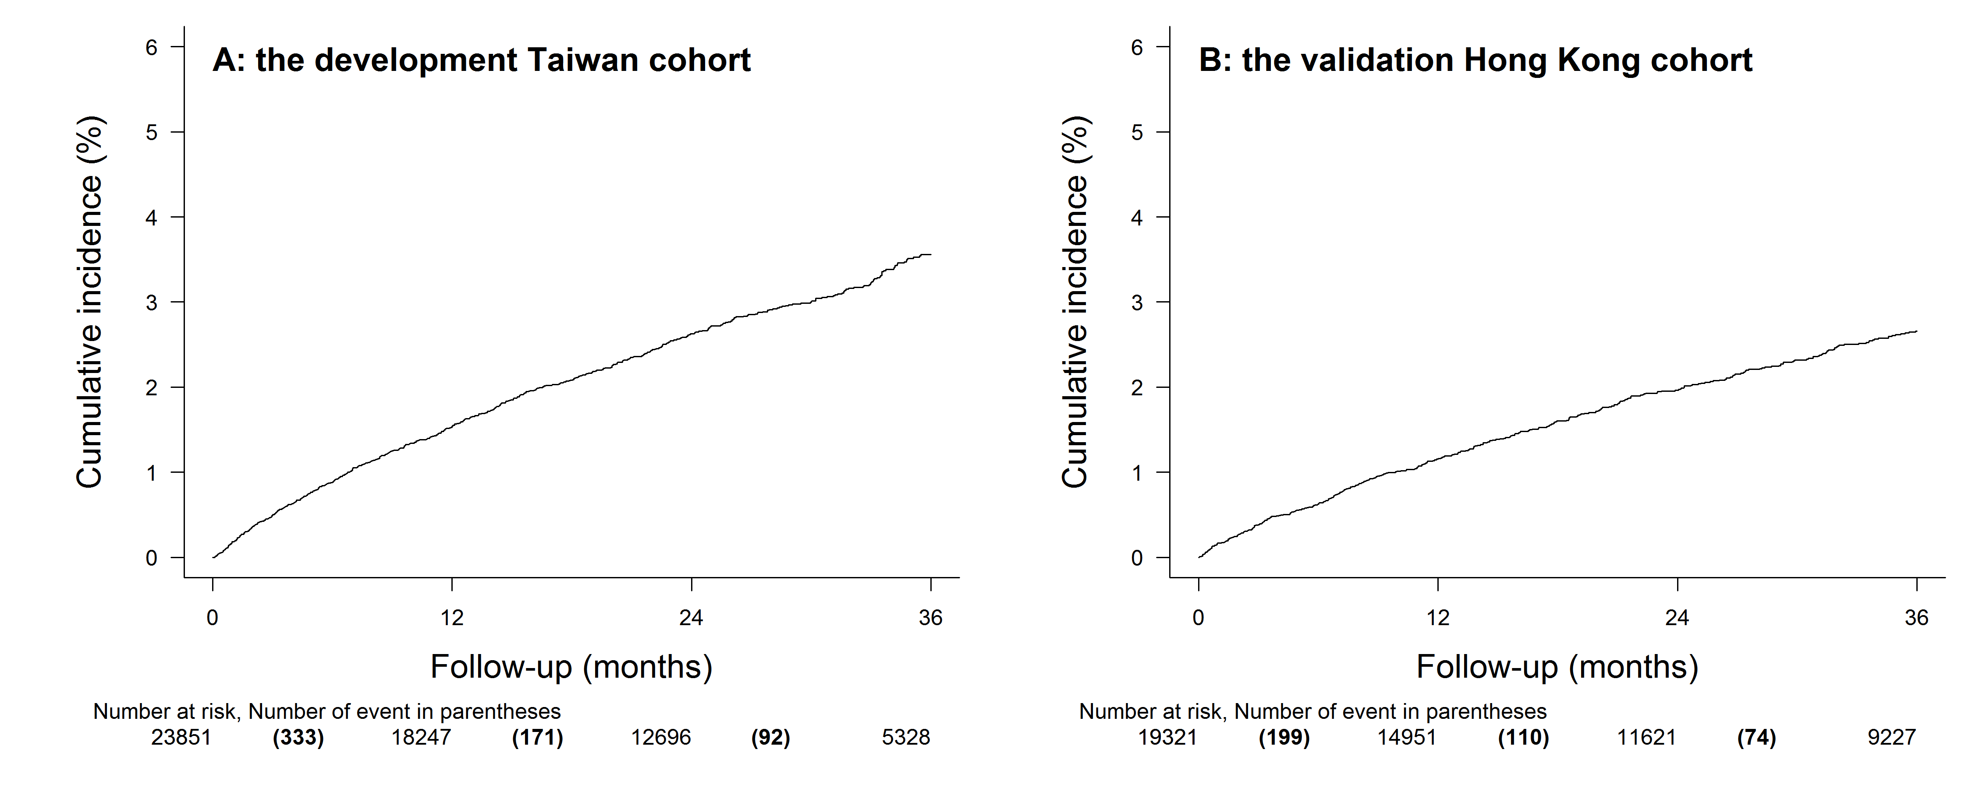
Figure 1. The cumulative incidences of hepatocellular carcinoma in the development Taiwan cohort (panel A) and the validation Hong Kong cohort (panel B).

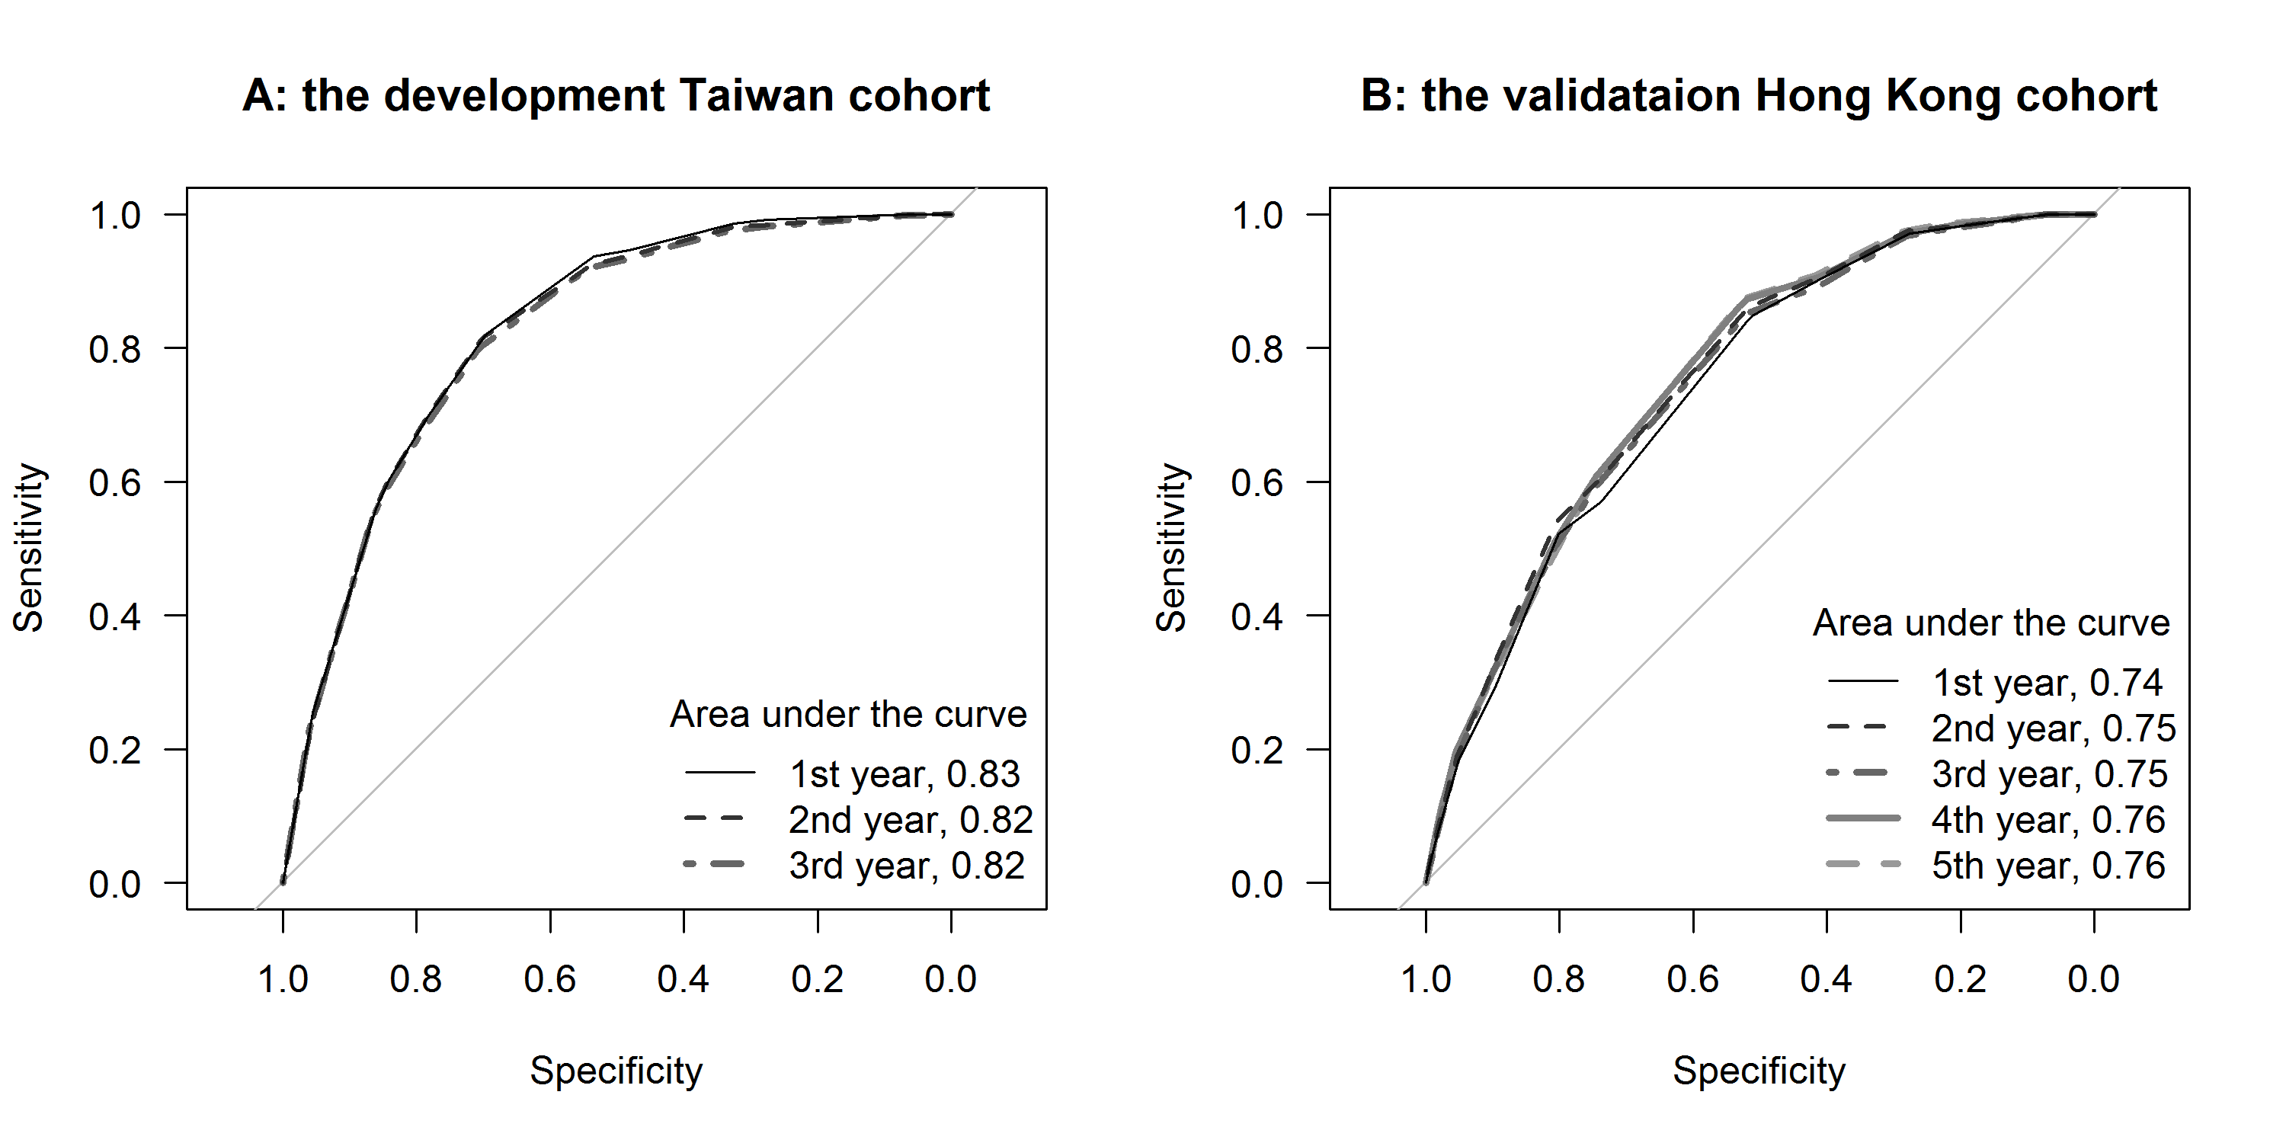
Figure 2. The receiver operating characteristic curves of the CAMD score to predict hepatocellular carcinoma during the first 3 years on therapy in the development cohort (panel A); the prediction was extrapolated to 5 years in the validation cohort (panel B).

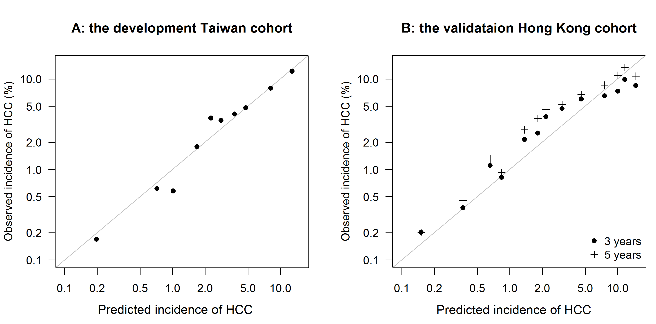
Figure 3. The predicted incidence of hepatocellular carcinoma according to the CAMD score was calibrated with the observed incidence as estimated by the Kaplan Meier method in the development (panel A) and the validation cohorts (panel B). The calibration was externally validated to 5 years in the validation cohort.

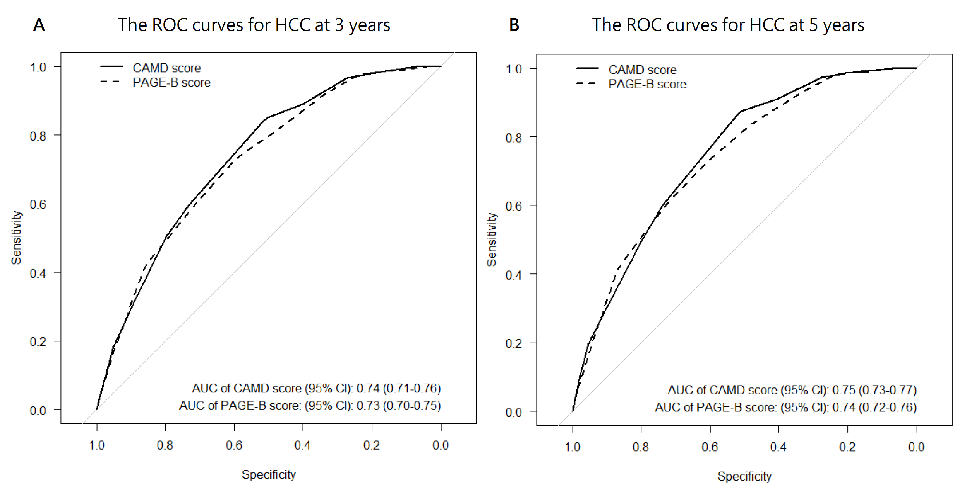
Figure 4. The receiver operating characteristic (ROC) curves of the CAMD and the PAGE-B scores to predict hepatocellular carcinoma (HCC) at 3 (panel A) and 5 years (panel B) during the entecavir or tenofovir therapy in 17,984 Hong Kong patients with platelet data available at baseline.

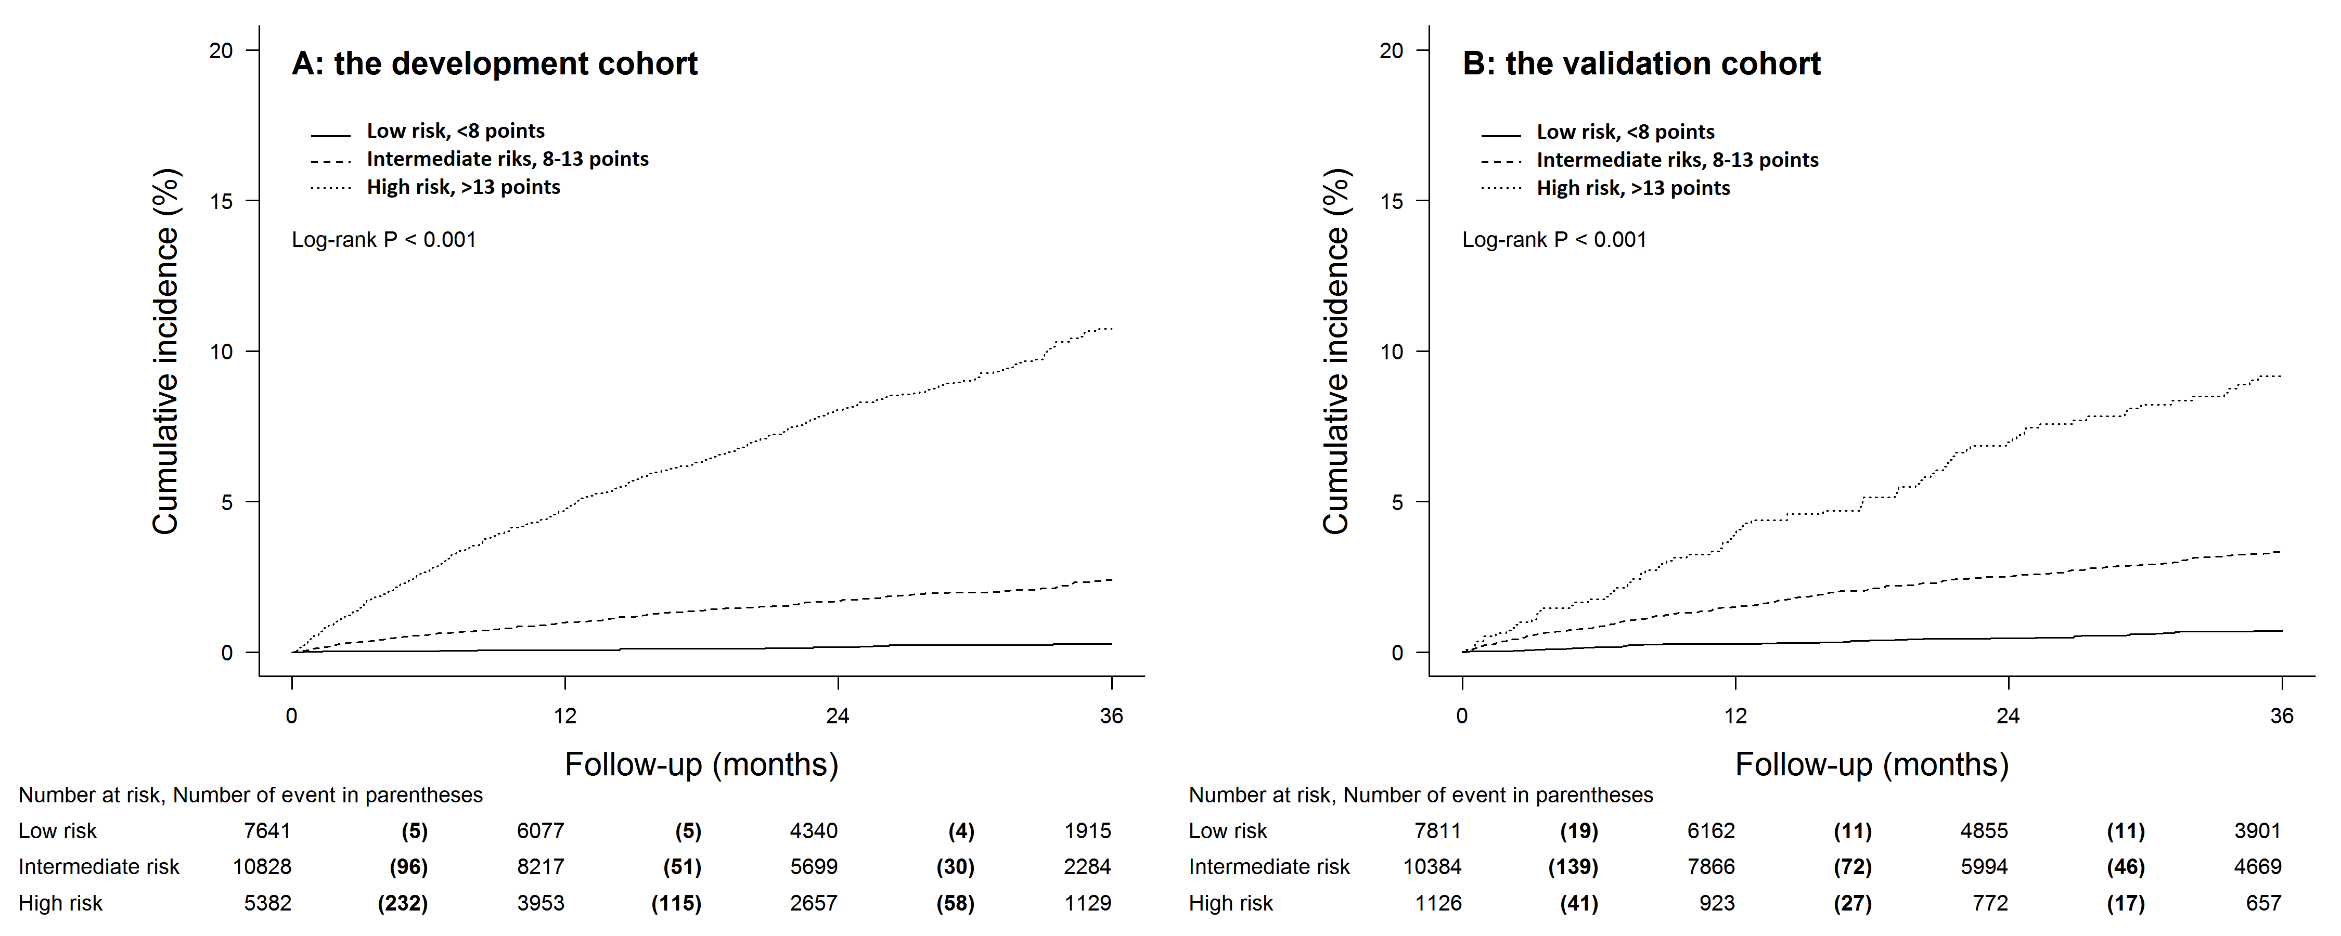
Figure 5. The CAMD score stratified patients in the development (panel A) and validation cohorts (panel B) into distinct subgroups at a low, intermediate, or high risk of hepatocellular carcinomoa during entecavir or tenofovir therapy. The log rank test was used for statistical comparison.

