財團法人明日醫學基金會補助專題研究計畫
成果報告 □期中進度報告

計畫名稱：
慢性B型肝炎患者接受抗病毒藥物後Mac-2結合蛋白糖基化異構體血清濃度的變化與後續肝癌風險的關係
Serial changes in serum M2BPGi level and risk of hepatocellular carcinoma after antiviral therapy in chronic hepatitis B

計畫類別： 個別型計畫 □ 整合型計畫
執行期間： 107 年 1 月 1 日起 至 107 年 12 月 31 日止

計畫主持人： 許耀峻
共同主持人：
計畫參與人員：

成果報告類型：□精簡報告 完整報告

處理方式：可公開查詢

執行單位：輔仁大學醫學系及附設醫院肝膽胃腸科

Serial changes in serum M2BPGi level and risk of hepatocellular carcinoma after antiviral therapy in chronic hepatitis B

Reported by Yao-Chun Hsu¹⁻³
¹School of Medicine, Fu Jen Catholic University, New Taipei, Taiwan
²Division of Gastroenterology, Fu Jen Catholic University Hospital, New Taipei, Taiwan
³Department of Medicine, E-Da Hospital/I-Shou University, Kaohsiung, Taiwan

This study was presented at the annual meeting of European Association for the Study of Liver Diseases (The International Liver Congress® 2018), Paris, France

The full-length article has been published in Aliment Pharmacol Ther. 2018; 48(10):1128-1137

Background: Mac-2 binding protein glycosylation isomer (M2BPGi) is an emerging biomarker for risk prediction of liver disease, but data remain sparse for patients with chronic hepatitis B (CHB) who are treated with nucleos(t)ide analogues (NA).
Aim: To clarify serial changes in M2BPGi and its association with subsequent hepatocellular carcinoma (HCC) development in NA-treated CHB patients.
Methods: We enrolled 384 previously untreated CHB patients who received NAs. Among them, 195 had baseline cirrhosis (n = 142:48:5 for Child A:B:C). Sera were collected at NA initiation, and after 1 and 2 years. Serum M2BPGi levels were measured and expressed as cut-off index (COI) at different time points. The association between M2BPGi and HCC was evaluated by the Cox proportional hazard model.
Results: The median M2BPGi levels significantly decreased from 1.68 COI at baseline, to 1.0 at year 1, and 0.88 at year 2. During median follow-up of 72.7 months, HCC occurred in 37 patients, 36 of whom had cirrhosis. In patients with cirrhosis, baseline M2BPGi level was associated with HCC risk (adjusted hazard ratio, 1.07 per COI; 95% CI, 1.01-1.14) on the multivariable Cox analysis, whereas levels at year 1 or 2 were not independently predictive. A risk score for HCC was developed using baseline M2BPGi, age and body mass index with c statistics of 0.77, 0.79 and 0.87 at 3, 5 and 10 years, respectively.
Conclusions: Serum M2BPGi level significantly decreases after NA treatment in CHB patients. Baseline level can be factored into the risk prediction of HCC in NA-treated patients with cirrhosis.

Keywords: HBV; M2BPGi; nucleos(t)ide analogues; risk prediction; HCC
Introduction
Mac-2 binding protein (M2BP) is a glycoprotein involved in intercellular adhesion and interactions with the extracellular matrix 1. M2BP is widely expressed in various human tissues, but a liver-specific glycosylation isomer (M2BPGi) can be determined and quantified using the Wisteria floribunda agglutinin immunoassay that is already commercially available in Japan 2. In the recent years, M2BPGi has emerged as a novel biomarker that correlates well with hepatic fibrosis in patients with chronic liver diseases 3. Recent literature also suggests that M2BPGi may correlate with hepatocellular carcinoma (HCC) development in patients with chronic viral hepatitis 4-8, though most have been conducted in patients with chronic hepatitis C (CHC) or untreated chronic hepatitis B (CHB) without serial measurements.

Indeed, the serum concentration of M2BPGi is not static and may change in a relatively short period of time, especially in the setting of antiviral therapies. This was well described by Nagata and colleagues in their recent study of CHC patients treated with either interferon-based or interferon-free direct acting antiviral therapies 9. However, data on the longitudinal effect of antiviral therapy on M2BPGi levels in treated CHB patients is still limited. While CHB patients treated with NA can expect significantly reduced risk of HCC, this risk remains, especially in patients with cirrhosis 10-12. Therefore, it is particularly important to evaluate the dynamic changes and predictive potential of novel biomarkers such as M2BPGi longitudinally and in relation to antiviral therapy because levels can change with treatment, treated patients may still develop HCC, and long-term suppressive treatment with nucleos(t)ide analogues (NAs) remains the primary therapeutic strategy in the management of active CHB 13-15. Moreover, a convenient and inexpensive serum marker to accurately estimate HCC risk remains unavailable for CHB patients treated with NAs.

In order to address the aforementioned gaps in the current literature, we conducted this multicenter cohort study of treatment-naïve patients who had pretreatment and serial blood collection after the initiation of NA therapies to evaluate the association of M2BPGi levels with future HCC development. In addition, to accurately estimate this risk, we used time-dependent analytic methods and performed stratified analyses by cirrhosis status, given that M2BPGi is well-known to strongly correlate with liver fibrosis/cirrhosis.

METHODS and MATERIALS
Study design and setting
This cohort study included an exposed cohort of CHB patients with serum samples prospectively collected prior to NA therapy (baseline sample) and serially at year 1 and year 2 after treatment initiation and an unexposed control cohort of CHB patients who did not receive NA therapy during study period. Patients were enrolled and observed at 2 teaching hospitals in Kaohsiung, Taiwan (Kaohsiung Medical University Hospital and E-Da Hospital) between end of January 2000 and end of September 2017. All patients gave written informed consents. The laboratory analysis for the serum samples was conducted at a single laboratory at the Department of Virology and Liver unit, Nagoya City University, Nagoya, Japan. Clinical and laboratory data were submitted to the data center at Stanford University Medical Center, Palo Alto, California, USA for data management and analysis. This study was approved by the institutional review board at each participating institution.

Patient population
Patients were eligible if they were 18 years or older, had CHB (positive hepatitis B virus [HBV] surface antigen [HBsAg] or HBV DNA and a documented history of chronic infection for 6 months or longer), were treatment-naïve at the time of the first serum collection (baseline level) and were subsequently treated with a commercially approved NA and had serum collection again at 1 year and/or 2 years after NA therapy initiation. Subjects with co-infection with hepatitis C virus or another cause of chronic liver disease, or any malignancy at the time of NA initiation were excluded. Those who developed HCC within one year of therapy were also excluded as HCC in this case may be prevalent instead of incident cases.

The indications of antiviral therapy principally followed the practice guidelines endorsed by the Asian Pacific Association for the Study of the Liver.14 In general, the manifestation of hepatic decompensation, severity of liver fibrosis, status of hepatitis B e antigen (HBeAg), serum levels of HBV DNA and alanine aminotransferase (ALT) were all taken into consideration.

The selection of untreated control patients followed the same eligibility criteria as described above, except for treatment status.

Data collection and M2BPGi measurement
Data including demographics, comorbid diseases, laboratory tests, and other pertinent radiological, pathological and clinical information at baseline and follow-up were extracted from each clinical centers and were recorded using the same data frame and variable definitions. One investigator reviewed the datasets and audited the accuracy. Cirrhosis was determined via histology or by clinical criteria mainly composed of radiological features (nodular hepatic surface, coarse echotexture, irregular vasculature, and splenomegaly) 16.

Noninvasive scores based on routinely available laboratory tests were also used to estimate levels of liver fibrosis and hepatic dysfunction. The scores of the aspartate aminotransferase (AST) to platelet ratio index (APRI), Fibrosis 4 (FIB-4), and MELD (model for end-stage liver disease) were calculated according to the following equations: [AST/38 (U/L) /platelet count (103/μL)] × 100, [AST (U/L) × Age (years)]/[ALT (U/L)1/2 × platelet count (103/μL)], and 3.78×ln[serum bilirubin (mg/dL)] + 11.2×ln[INR] + 9.57×ln[serum creatinine (mg/dL)] + 6.43, respectively 17-19.

Serum M2BPGi levels were measured using sera collected prior to NA initiation, at 1 year and at 2 years after the therapy. Archived sera from the 2 hospitals were sent to a single laboratory (Nagoya City University, Nagoya, Japan) for the measurement of M2BPGi. The protocol has been reported previously 20. In brief, it was measured by an automated analyzer applying the lectin-antibody sandwich immunoassay (HISCL-2000i; Sysmex Corporation, Hyogo, Japan). The quantity of M2BPGi that was conjugated to Wisteria floribunda agglutinin was expressed in cut-off index (COI) and calculated by the formula: (M2BPGisample – M2BPGinegative control) / (M2BPGipositive control – M2BPGinegative control). For the purpose of standardized calibration, the supplied solution of positive control would yield a COI of 1.0.

Longitudinal follow-up and outcome measure
The primary study outcome was the development of incident HCC. The surveillance for HCC was carried out by abdominal sonography in principle, whereas computed tomography or magnetic resonance image served as the second-line modality for diagnostic confirmation 21. Generally, the frequency of surveillance was every 6 months in patients without cirrhosis and 3 months in those with cirrhosis. Patients were censored at loss to follow-up, death, or end of the observation in the end of September 2017. HCC was diagnosed via histology, cytology, or noninvasive criteria using dynamic images as recommended by the American Association for the Study of Liver Diseases 21.

Statistical analysis
Continuous variables were expressed as medians and interquartile ranges (IQR) and categorical variables as percentages. Serial M2BPGi levels were first explored by the Skillings–Mack test which accounted for missing data in analysis with repeated measurements 22. The differences between the respective serum M2BPGi levels were further examined by the Wilcoxon signed-rank test in patients with available sera at all three time points.

The cumulative incidence of HCC was estimated by the Kaplan Meier method. We performed the Cox proportional hazard regression to evaluate the association between M2BPGi levels and subsequent development of HCC. The measurements of M2BPGi at different time points were examined individually and compared against each other for the association with HCC. M2BPGi levels were also analyzed as a time-varying variable in the model.

Next, we developed a risk score based on the most predictive M2BPGi for HCC as well as other risk factors significantly associated with HCC in the multivariable Cox model. The model examined all potential predictors regardless of the results in the univariable analyses and was determined by stepwise elimination to remove insignificant factors. The predictive factors in the risk score were weighted according to their regression coefficients. We constructed time-dependent receiver operating characteristic (ROC) curves for censored survival data to appraise the risk score that included M2BPGi as an explanatory variable.

All data analysis was performed using either the Stata software (13.0 version, College Station, Texas) or the R program (version 3.4.0). All statistical tests were two-tailed and a p value less 0.05 defined statistical significance.

Results
Characteristics of the study cohorts
We enrolled a total of 384 eligible patients who received NA therapy and 122 untreated controls. (Table 1 and Supplemental Table 1). For the treated cohort (Table 1), approximately three fourths were male (n=282), one half (n=195) had liver cirrhosis, and slightly over half (n=224) were treated with entecavir. One third (n=139) used older generations of NAs and the M2BPGi levels did no differ according to the regimens (Supplementary Table 2). The median follow-up for this cohort was 72.73 (IQR, 44.33, 103.75) months. During this period, 36 (9.38%) patients developed HCC and all but one occurred in patients with cirrhosis at baseline.

Median baseline serum M2BPGi (prior to NA therapy, available in all 384 patients) was 1.68 (IQR, 0.78, 4.40) COI. At year 1 and year 2 after the NA treatment, the measurements were available in 314 and 282 patients, respectively, with the medians of 1.0 (IQR, 0.61, 1.83) and 0.88 (95% CI, 0.58, 1.75), respectively. The distributions of M2BPGi were significantly skewed to the right (Supplementary Figure 1). The correlation between baseline M2BPGi level and FIB-4 index was significant but modest (Supplementary Figure 2A; Spearman’s ρ=0.6, p<0.0001), and the M2BPGi levels varied considerably within the same FIB-4 category (Supplementary Figure 2B).

Serial changes of M2BPGi during the antiviral therapy
The three measurements of M2BPGi significantly differed. In view of the difference between patients with and those without liver cirrhosis, the analysis was stratified by cirrhosis to confirm that M2BPGi levels decreased after NA treatment regardless of baseline cirrhosis status (Table 2).

In the paired comparison among 274 patients with all 3 measurements, the baseline M2BPGi measurement (median, 1.83; IQR, 0.97, 4.66) was significantly higher than those measured one year (median, 0.99; IQR, 0.61, 1.77) and two years (median, 0.87; IQR, 0.55, 1.71) afterwards (p<0.0001 for both comparisons, Wilcoxon signed-rank test). The trend of decline was significant over time (p_{trend}<0.0001) among both the cirrhotic and non-cirrhotic subgroups but the difference was much more pronounced in the first year (pretreatment to year 1 post-treatment level: median, 0.57; IQR, 0.07, 2.07) while the difference during the second year (between year 1 to year 2 post-treatment) was only modest (median, 0.08; IQR, -0.18, 0.40) (Table 3).

Serial M2BPGi levels in the untreated patients
Baseline M2BPGi were available in all 122 untreated patients. Of these, 91and 60 patients remained untreated and had serum collection at one and two years later, respectively; 59 patients had all three serum collections (Supplementary Table 3). There was no difference in serial measurements of M2BPGi in the untreated controls overall (p=0.17, Skillings–Mack test). Similarly, no difference was noted among the 59 untreated patients with all 3 paired sera (p=0.25, Friedman's test). Because only one untreated patient had cirrhosis, the analysis was not further stratified.

Association between pretreatment or on-therapy M2BPGi levels and risk of HCC
HCC occurred in 36 patients (35 in patients with cirrhosis) with a cumulative incidence of 19.8% (95% CI, 13.7-28.2%) at 15 years (Figure 1A). Because HCC almost exclusively occurred in the 195 patients with cirrhosis (Figure 1B), the analysis to identify risk factors of HCC was performed only in the cirrhosis subgroup.

In univariable Cox proportional hazard model (Table 4), the baseline M2BPGi level was significantly associated with the development of HCC (crude HR, 1.10 per COI; 95% CI, 1.05-1.16). With regard to M2BPGi levels at year 1 and 2 after treatment, the associations with subsequent occurrence of HCC did not reach the predefined level of statistical significance. The multivariable Cox model revealed that only the baseline M2BPGi level was significantly associated with HCC (adjusted HR, 1.07, 95% CI, 1.01-1.14) after adjustment for age and body mass index, which were the other two independent risk factors. The serial change of M2BPGi was further analyzed as a single variable that varied with time in the time-dependent Cox model. Time-varying M2BPGi level was associated with subsequent HCC development in the univariable Cox proportional hazard model (crude HR, 1.09 per COI, 95% CI, 1.01-1.18), but it was not an independent risk factor in the adjusted multivariable analysis (adjusted HR, 1.08 per COI, 95% CI, 0.98-1.196; p=0.10) (Table 4).

Development of a risk score using baseline M2BPGi to predict HCC risks in patients with cirrhosis
The regression coefficients for the three variables included in the final multivariable Cox model (Model I) were 0.08 per year for age, 0.07 per COI for baseline M2BPGi, and 0.10 per Kg/m² for body mass index (Supplementary Table 4), and were used to generate a risk score with the following formula: 8*age (year) + 7*baseline M2BPGi (COI) + 10*body mass index (Kg/m²). The score was calculable in 171 patients with cirrhosis with a median of 652.5 (IQR, 581.3, 709.4) points. Twenty nine patients among them developed HCC. The performance of the score to predict HCC was illustrated by the time-dependent ROC curves in Figure 2. The areas under the curves were 0.77, 0.79, and 0.87 at year 3, 5, and 10, respectively (Figure 2A). The new M2BPGi-based risk score outperformed both the PAGE-B and CAMD scores in this cohort of patients with cirrhosis at 5 and 10 years,though not at 3 years (Figures 2B, C and D). To illustrate the potential for clinical application, the median of the scores (652.5) was used to categorize patients into higher or lower risks ²⁷. The two risk subgroups significantly differed in the 15-year cumulative incidence of HCC (67.2% with 95% CI of 34.9-94.5% versus 15.8% with 95% CI of 6.2 -36.8%; Figure 3). The sensitivity, specificity, positive and negative predictive values for HCC were also appended (Supplementary Table 5).

DISCUSSION
Our study demonstrates that (1) serum M2BPGi levels were significantly higher in CHB patients with cirrhosis compared to those without cirrhosis regardless of treatment status; (2) serum level of M2BPGi significantly decreased after NA treatment while serial changes were not observed in untreated patients; (3) the decline in NA-treated patients occurred mostly during the first year of therapy, when more than half of the treated patients experienced a decrease of at least 0.5 COI, a finding that was consistent in cirrhotic as well as non-cirrhotic patients, while the changes between year 1 and year 2 were less appreciable; (4) baseline M2BPGi level was independently associated with the risk of HCC in patients with cirrhosis but not post-treatment or time-varying levels; and (5) a risk score including baseline M2BPGi and physiologic variables such as age and body mass index can predict long-term HCC risk in NA-treated CHB patients with cirrhosis. Collectively, these findings illustrated how serum M2BPGi level would change serially after NA therapy in CHB patients and identified baseline M2BPGi as the most significant level for the risk prediction of HCC in NA-treated patients.

M2BPGi is secreted by hepatic stellate cells ²⁸ and have been shown to correlate with liver fibrosis in a variety of chronic liver diseases including viral hepatitis ^{29,30}, non-alcoholic fatty liver disease ³¹, biliary cirrhosis ³², and autoimmune hepatitis ³³. Consistent with prior studies, our study also showed that M2BPGi levels were higher in CHB patients with cirrhosis than those without. However, our findings further suggested that serum M2BPGi level represented something more than just liver fibrosis because the rapid drop of M2BPGi within one year could not be entirely attributable to changes in the fibrosis status. Presumably, it was accounted for by the amelioration of hepatocellular injury that preceded the regression of fibrosis which would likely take a few years or longer. This result was consistent with recent studies that reported rapid decrease in serum M2BPGi levels among HCV-infected patients who cleared the virus and those who recovered from acute liver injury^{33,34}. These lines of evidence suggested that M2BPGi levels might also reflect liver inflammation, hepatocellular necrosis or regeneration. Therefore, the ability of M2BPGi measurement to predict long-term outcomes such as HCC should be interpreted in the clinical context which the levels were derived from, such as liver etiology, disease activity, fibrosis stages, and antiviral treatment status.

Previous studies of treated CHB patients have reported decreased in M2BPGi levels after NA therapy but few have evaluated serial levels between the first and second years after NA initiation in patients with CHB. One recent study observed that the median levels of M2BPGi at baseline and at 48 weeks were 1.22 and 0.77 COI in patients who did not develop HCC, and higher at 1.48 and 1.34 COI in those who later developed HCC, respectively; but this study did not investigate post-treatment M2BPGi levels beyond week 48.⁸ In another recent study, serial M2BPGi levels after therapy were examined. The mean M2BPGi also decreased from 3.1 COI at baseline to 1.9 COI at 48 weeks and 1.5 COI at 96 weeks ²⁹; however, this study only included 89 patients with serial serum samples, analyzed patients with and those without cirrhosis together, and did not evaluate correlation between M2BPGi with HCC development.

Besides its association with fibrosis, M2BPGi has also been studied as a marker of future HCC development in untreated CHB patients ³⁵. Data on M2BPGi as a predictor for HCC for NA-treated patients are much more limited by small sample size, lack of stratified analysis by cirrhosis which is a major confounder, and insufficient account for the time-dependent nature of the association of M2BPGi levels and HCC development. Shinkai and colleagues observed 234 CHB NA-treated patients (37 with cirrhosis) and reported that M2BPGi level measured at week 48 after NA initiation was predictive of subsequent occurrence of HCC rather than baseline levels as seen in our study; however, this result was not drawn from stratified analysis by cirrhosis and multivariate analysis did not control for fibrosis or cirrhosis limiting its conclusions.⁸ On the other hand, another recent study of NA-treated CHB patients (57 HCC cases and 57 non-HCC controls) found significant differences in pre-treatment M2BPGi levels between cases and controls, but not post-treatment levels, a finding similar to ours ⁷. This study also provided data for stratified analysis by cirrhosis, but its case control design did not allow for time-to-event analysis and evaluation of M2BPGi as a predictor of future HCC.

Patients with CHB remained at risk of HCC while on NA therapy.¹¹ Previous studies have found age, cirrhosis, platelet count, liver stiffness, severity of hepatic dysfunction, alfa-fetoprotein, male sex, and diabetes mellitus to be predictive of HCC in NA-treated patients.^{25,26,36-38} Whereas we explicitly set out to explore the serial changes of M2BPGi and how it might be associated with subsequent HCC, it was beyond our scope to compare this biomarker with other predictive tools such as liver elastography,³⁹ which has been shown to be predictive of HCC in both treated and untreated patients.^{37,40} Neither did the current study aim to conclude an exact cutoff of M2BPGi or establish an “optimal model” ready for clinical application. Accordingly, we chose the stepwise regression instead of criterion-based methods for variable selection in the multivariable Cox model, and applied the median split to illustrate how M2BPGi might be incorporated into a predictive score while deliberately avoiding the “optimal cutoff” approach that could raise the concern of multiple comparisons.²⁷

In addition to a larger sample size of 384 NA-treated patients (195 with cirrhosis) drawn from two clinical centers and a long duration of observation, our study also has the following strengths. First, an untreated cohort with serial serum collections served as a reference to contrast the rapid decrease seen in treated patients. This finding addressed the paucity of data in serial M2BPGi measurements in untreated CHB patients, although the study was not specifically designed to directly compare treated and untreated patients, as these two populations were expected to differ with the untreated one less likely to have advanced disease. Moreover, we performed stratified analysis by cirrhosis which is well-known to be one of the strongest factors associated with both M2BPGi level and HCC risk, thus removing cirrhosis from affecting our results as a potential confounder. Lastly, our conclusions were based on the consistent results from different angles of analyses using non-parametric methods, paired comparison, and time-dependent approaches.

There are some limitations that require attention. First, only one patient without baseline cirrhosis developed HCC in our study; therefore, we could not investigate the association between M2BPGi and HCC in the non-cirrhotic population. This issue required further research. Second, older generations of antiviral agents were still included to reflect the heterogeneous composition in the real-world practice. However, changes in M2BPGi levels appeared similar in patients receiving first-line agents vs older generations in the analysis (Supplementary Table 2). We did not find the type of NA was a significant HCC risk determinant, either (Table 4), in accordance with recent studies.³⁷ Third, as a result of incomplete or missing data, our analysis could not be fully adjusted for some potential confounders such as viral genotype, HBeAg status, and family history; however, previous studies have shown that these factors are not significant predictors for HCC in NA-treated CHB patients ^{36,41}. Fourth, although we found body mass index to be associated with HCC, this study could not examine if fatty liver was an independent risk factor of HCC in NA-treated CHB patients because there was no standardized measurement of fatty liver in this cohort, but this important issue should be further studied. Finally, limitations in generalizability are recognized: all participants are Taiwanese and our results may not be generalizable for other Asian and non-Asian ethnicities. In addition, the untreated cohort inevitably included mostly patients with inactive or less severe diseases. Otherwise, treatment would have been indicated. Therefore, our untreated patient data could not be extrapolated to all untreated patients, particularly those with liver cirrhosis. As most of our treated patients with cirrhosis also had Child-A disease, caution is advised before generalizing our data to treated patients with decompensated cirrhosis.

In summary, our findings demonstrate a significant drop of serum M2BPGi after NA treatment in patients with CHB during the first year of therapy and less pronounced afterwards; it is the pre-treatment baseline level that is most significantly associated with future HCC occurrence on long-term follow-up. Our study also demonstrates a risk score using the baseline M2BPGi level to predict HCC occurrence up to 10 years later in CHB patients with cirrhosis. External validation of this risk score is needed.

REFERENCES
1. Sasaki T, Brakebusch C, Engel J, Timpl R. Mac-2 binding protein is a cell-adhesive protein of the extracellular matrix which self-assembles into ring-like structures and binds beta1 integrins, collagens and fibronectin. EMBO J. 1998;17(6):1606-1613.
2. Narimatsu H. Development of M2BPGi: a novel fibrosis serum glyco-biomarker for chronic hepatitis/cirrhosis diagnostics. Expert Rev Proteomics. 2015;12(6):683-693.
3. Shirabe K, Bekki Y, Gantumur D, et al. Mac-2 binding protein glycan isomer (M2BPGi) is a new serum biomarker for assessing liver fibrosis: more than a biomarker of liver fibrosis. J Gastroenterol. 2018.
4. Yamasaki K, Tateyama M, Abiru S, et al. Elevated serum levels of Wisteria floribunda agglutinin-positive human Mac-2 binding protein predict the development of hepatocellular carcinoma in hepatitis C patients. Hepatology. 2014;60(5):1563-1570.
5. Sasaki R, Yamasaki K, Abiru S, et al. Serum Wisteria Floribunda Agglutinin-Positive Mac-2 Binding Protein Values Predict the Development of Hepatocellular Carcinoma among Patients with Chronic Hepatitis C after Sustained Virological Response. PLoS One. 2015;10(6):e0129053.
6. Kim SU, Heo JY, Kim BK, et al. Wisteria floribunda agglutinin-positive human Mac-2 binding protein predicts the risk of HBV-related liver cancer development. Liver Int. 2017;37(6):879-887.
7. Cheung KS, Seto WK, Wong DK, Mak LY, Lai CL, Yuen MF. Wisteria floribunda agglutinin-positive human Mac-2 binding protein predicts liver cancer development in chronic hepatitis B patients under antiviral treatment. Oncotarget. 2017;8(29):47507-47517.
8. Shinkai N, Nojima M, Iio E, et al. High levels of serum Mac-2-binding protein glycosylation isomer (M2BPGi) predict the development of hepatocellular carcinoma in hepatitis B patients treated with nucleot(s)ide analogues. J Gastroenterol. 2017.
9. Nagata H, Nakagawa M, Nishimura-Sakurai Y, et al. Serial measurement of Wisteria floribunda agglutinin positive Mac-2-binding protein is useful for predicting liver fibrosis and the development of hepatocellular carcinoma in chronic hepatitis C patients treated with IFN-based and IFN-free therapy. Hepatol Int. 2016;10(6):956-964.
10. Hsu YC, Ho HJ, Lee TY, et al. Temporal trend and risk determinants of hepatocellular carcinoma in chronic hepatitis B patients on entecavir or tenofovir. J Viral Hepat. 2017.
11. Lok AS, McMahon BJ, Brown RS, Jr., et al. Antiviral therapy for chronic hepatitis B viral infection in adults: A systematic review and meta-analysis. Hepatology. 2016;63(1):284-306.
12. Papatheodoridis GV, Idilman R, Dalekos GN, et al. The risk of hepatocellular carcinoma decreases after the first 5 years of entecavir or tenofovir in Caucasians with chronic hepatitis B. Hepatology. 2017;66(5):1444-1453.
13. European Association for the Study of the Liver. Electronic address eee, European Association for the Study of the L. EASL 2017 Clinical Practice Guidelines on the management of hepatitis B virus infection. J Hepatol. 2017;67(2):370-398.
14. Sarin SK, Kumar M, Lau GK, et al. Asian-Pacific clinical practice guidelines on the management of hepatitis B: a 2015 update. Hepatol Int. 2016;10(1):1-98.
15. Terrault NA, Bzowej NH, Chang KM, et al. AASLD guidelines for treatment of chronic hepatitis B. Hepatology. 2016;63(1):261-283.
16. Hung CH, Lu SN, Wang JH, et al. Correlation between ultrasonographic and pathologic diagnoses of hepatitis B and C virus-related cirrhosis. J Gastroenterol. 2003;38(2):153-157.
17. Wai CT, Greenson JK, Fontana RJ, et al. A simple noninvasive index can predict both significant fibrosis and cirrhosis in patients with chronic hepatitis C. Hepatology. 2003;38(2):518-526.
18. Vallet-Pichard A, Mallet V, Nalpas B, et al. FIB-4: an inexpensive and accurate marker of fibrosis in HCV infection. comparison with liver biopsy and fibrotest. Hepatology. 2007;46(1):32-36.
19. Kamath PS, Wiesner RH, Malinchoc M, et al. A model to predict survival in patients with end-stage liver disease. Hepatology. 2001;33(2):464-470.
20. Kuno A, Sato T, Shimazaki H, et al. Reconstruction of a robust glycodiagnostic agent supported by multiple lectin-assisted glycan profiling. Proteomics Clin Appl. 2013;7(9-10):642-647.
21. Heimbach JK, Kulik LM, Finn RS, et al. AASLD guidelines for the treatment of hepatocellular carcinoma. Hepatology. 2018;67(1):358-380.
22. Chatfield M, Mander A. The Skillings-Mack test (Friedman test when there are missing data). Stata J. 2009;9(2):299-305.
1. Sasaki T, Brakebusch C, Engel J, Timpl R. Mac-2 binding protein is a cell-adhesive protein of the extracellular matrix which self-assembles into ring-like structures and binds beta1 integrins, collagens and fibronectin. EMBO J. 1998;17(6):1606-1613.
2. Narimatsu H. Development of M2BPGi: a novel fibrosis serum glyco-biomarker for chronic hepatitis/cirrhosis diagnostics. Expert Rev Proteomics. 2015;12(6):683-693.
3. Shirabe K, Bekki Y, Gantumur D, et al. Mac-2 binding protein glycan isomer (M2BPGi) is a new serum biomarker for assessing liver fibrosis: more than a biomarker of liver fibrosis. J Gastroenterol. 2018.
4. Yamasaki K, Tateyama M, Abiru S, et al. Elevated serum levels of Wisteria floribunda agglutinin-positive human Mac-2 binding protein predict the development of hepatocellular carcinoma in hepatitis C patients. Hepatology. 2014;60(5):1563-1570.
5. Sasaki R, Yamasaki K, Abiru S, et al. Serum Wisteria Floribunda Agglutinin-Positive Mac-2 Binding Protein Values Predict the Development of Hepatocellular Carcinoma among Patients with Chronic Hepatitis C after Sustained Virological Response. PLoS One. 2015;10(6):e0129053.
6. Kim SU, Heo JY, Kim BK, et al. Wisteria floribunda agglutinin-positive human Mac-2 binding protein predicts the risk of HBV-related liver cancer development. Liver Int. 2017;37(6):879-887.
7. Cheung KS, Seto WK, Wong DK, Mak LY, Lai CL, Yuen MF. Wisteria floribunda agglutinin-positive human Mac-2 binding protein predicts liver cancer development in chronic hepatitis B patients under antiviral treatment. Oncotarget. 2017;8(29):47507-47517.
8. Shinkai N, Nojima M, Iio E, et al. High levels of serum Mac-2-binding protein glycosylation isomer (M2BPGi) predict the development of hepatocellular carcinoma in hepatitis B patients treated with nucleot(s)ide analogues. Journal of gastroenterology. 2018;53(7):883-889.
9. Nagata H, Nakagawa M, Nishimura-Sakurai Y, et al. Serial measurement of Wisteria floribunda agglutinin positive Mac-2-binding protein is useful for predicting liver fibrosis and the development of hepatocellular carcinoma in chronic hepatitis C patients treated with IFN-based and IFN-free therapy. Hepatol Int. 2016;10(6):956-964.
10. Papatheodoridis GV, Idilman R, Dalekos GN, et al. The risk of hepatocellular carcinoma decreases after the first 5 years of entecavir or tenofovir in Caucasians with chronic hepatitis B. Hepatology. 2017;66(5):1444-1453.
11. Ahn J, Lee HM, Lim JK, et al. Entecavir safety and effectiveness in a national cohort of treatment-naive chronic hepatitis B patients in the US - the ENUMERATE study. Alimentary pharmacology & therapeutics. 2016;43(1):134-144.
12. European Association for the Study of the Liver. Electronic address eee, European Association for the Study of the L. EASL 2017 Clinical Practice Guidelines on the management of hepatitis B virus infection. J Hepatol. 2017;67(2):370-398.
13. Terrault NA, Bzowej NH, Chang KM, et al. AASLD guidelines for treatment of chronic hepatitis B. Hepatology. 2016;63(1):261-283.
14. Lin D, Yang HI, Nguyen N, et al. Reduction of chronic hepatitis B-related hepatocellular carcinoma with anti-viral therapy, including low risk patients. Alimentary pharmacology & therapeutics. 2016;44(8):846-855.
15. Sheu JC, Sung JL, Chen DS, et al. Growth rate of asymptomatic hepatocellular carcinoma and its clinical implications. Gastroenterology. 1985;89(2):259-266.
16. Sarin SK, Kumar M, Lau GK, et al. Asian-Pacific clinical practice guidelines on the management of hepatitis B: a 2015 update. Hepatol Int. 2016;10(1):1-98.
17. Hung CH, Lu SN, Wang JH, et al. Correlation between ultrasonographic and pathologic diagnoses of hepatitis B and C virus-related cirrhosis. Journal of gastroenterology. 2003;38(2):153-157.
18. Wai CT, Greenson JK, Fontana RJ, et al. A simple noninvasive index can predict both significant fibrosis and cirrhosis in patients with chronic hepatitis C. Hepatology. 2003;38(2):518-526.
19. Vallet-Pichard A, Mallet V, Nalpas B, et al. FIB-4: an inexpensive and accurate marker of fibrosis in HCV infection. comparison with liver biopsy and fibrotest. Hepatology. 2007;46(1):32-36.
20. Kamath PS, Wiesner RH, Malinchoc M, et al. A model to predict survival in patients with end-stage liver disease. Hepatology. 2001;33(2):464-470.
21. Kuno A, Sato T, Shimazaki H, et al. Reconstruction of a robust glycodiagnostic agent supported by multiple lectin-assisted glycan profiling. Proteomics Clin Appl. 2013;7(9-10):642-647.
22. Heimbach JK, Kulik LM, Finn RS, et al. AASLD guidelines for the treatment of hepatocellular carcinoma. Hepatology. 2018;67(1):358-380.
23. Chatfield M, Mander A. The Skillings-Mack test (Friedman test when there are missing data). Stata J. 2009;9(2):299-305.
24. Heagerty PJ, Zheng Y. Survival model predictive accuracy and ROC curves. Biometrics. 2005;61(1):92-105.
25. Papatheodoridis G, Dalekos G, Sypsa V, et al. PAGE-B predicts the risk of developing hepatocellular carcinoma in Caucasians with chronic hepatitis B on 5-year antiviral therapy. Journal of hepatology. 2016;64(4):800-806.
26. Hsu YC, Yip TC, Ho HJ, et al. Development of a scoring system to predict hepatocellular carcinoma in Asians on antivirals for chronic hepatitis B. Journal of hepatology. 2018;69(2):278-285.
27. Altman DG, Royston P. The cost of dichotomising continuous variables. BMJ. 2006;332(7549):1080.
28. Bekki Y, Yoshizumi T, Shimoda S, et al. Hepatic stellate cells secreting WFA(+) -M2BP: Its role in biological interactions with Kupffer cells. J Gastroenterol Hepatol. 2017;32(7):1387-1393.
29. Zou X, Zhu MY, Yu DM, et al. Serum WFA(+) -M2BP levels for evaluation of early stages of liver fibrosis in patients with chronic hepatitis B virus infection. Liver Int. 2017;37(1):35-44.
30. Kuno A, Ikehara Y, Tanaka Y, et al. A serum "sweet-doughnut" protein facilitates fibrosis evaluation and therapy assessment in patients with viral hepatitis. Sci Rep. 2013;3:1065.
31. Abe M, Miyake T, Kuno A, et al. Association between Wisteria floribunda agglutinin-positive Mac-2 binding protein and the fibrosis stage of non-alcoholic fatty liver disease. J Gastroenterol. 2015;50(7):776-784.
32. Umemura T, Joshita S, Sekiguchi T, et al. Serum Wisteria floribunda Agglutinin-Positive Mac-2-Binding Protein Level Predicts Liver Fibrosis and Prognosis in Primary Biliary Cirrhosis. Am J Gastroenterol. 2015;110(6):857-864.
33. Nishikawa H, Enomoto H, Iwata Y, et al. Clinical significance of serum Wisteria floribunda agglutinin positive Mac-2-binding protein level and high-sensitivity C-reactive protein concentration in autoimmune hepatitis. Hepatol Res. 2016;46(7):613-621.
34. Morio K, Imamura M, Daijo K, et al. Wisteria floribunda agglutinin positive Mac-2-binding protein level increases in patients with acute liver injury. Journal of gastroenterology. 2017;52(12):1252-1257.
35. Liu J, Hu HH, Lee MH, et al. Serum Levels of M2BPGi as Short-Term Predictors of Hepatocellular Carcinoma in Untreated Chronic Hepatitis B Patients. Sci Rep. 2017;7(1):14352.
36. Hsu YC, Wu CY, Lane HY, et al. Determinants of hepatocellular carcinoma in cirrhotic patients treated with nucleos(t)ide analogues for chronic hepatitis B. The Journal of antimicrobial chemotherapy. 2014;69(7):1920-1927.
37. Kim HS, Kim BK, Kim SU, et al. Association Between Level of Fibrosis, Rather Than Antiviral Regimen, and Outcomes of Patients With Chronic Hepatitis B. Clinical gastroenterology and hepatology : the official clinical practice journal of the American Gastroenterological Association. 2016;14(11):1647-1656 e1646.
38. Wong GL, Chan HL, Tse YK, et al. On-treatment alpha-fetoprotein is a specific tumor marker for hepatocellular carcinoma in patients with chronic hepatitis B receiving entecavir. Hepatology. 2014;59(3):986-995.
39. Kim SU, Seo YS, Cheong JY, et al. Factors that affect the diagnostic accuracy of liver fibrosis measurement by Fibroscan in patients with chronic hepatitis B. Alimentary pharmacology & therapeutics. 2010;32(3):498-505.
40. Wong GL, Chan HL, Wong CK, et al. Liver stiffness-based optimization of hepatocellular carcinoma risk score in patients with chronic hepatitis B. Journal of hepatology. 2014;60(2):339-345.
41. Papatheodoridis GV, Dalekos GN, Yurdaydin C, et al. Incidence and predictors of hepatocellular carcinoma in Caucasian chronic hepatitis B patients receiving entecavir or tenofovir. Journal of hepatology. 2015;62(2):363-370.

Table 1. Baseline characteristics of the treated study cohort
Characteristics | No HCC (n=348) | HCC (n=36) | P*
Age, years | 46 [36-55] | 56 [52-61] | <0.001
Male gender, n (%) | 256 (73.56%) | 26 (72.22%) | 0.85
BMI, kg/m² | 24.5 [22.4-27.0] | 25.7 [22.6-29.8] | 0.14
DM, n (%) | 45 (12.93%) | 10 (27.78%) | 0.02
Cirrhosis, n (%) | 160 (45.98%) | 35 (97.22%) | <0.001
Child A, n (%) | 120 (75.0%) | 22 (62.86%) | 0.04
Child B, n (%) | 38 (23.75%) | 10 (28.57%)
Child C, n (%) | 2 (1.25%) | 3 (8.57%)
Antiviral regimen |  |  | 0.2
Lamivudine, n (%) | 86 (24.71%) | 12 (33.33%)
Adefovir, n (%) | 2 (0.57%) | 1 (2.78%)
Telbivudine, n (%) | 35 (10.06%) | 3 (8.33%)
Entecavir, n (%) | 204 (58.62%) | 20 (55.56%)
Tenofovir, n (%) | 21 (6.03%) | 0
HBeAg-positive, n (%) | 150/333 (45.05%) | 8/33 (24.24%) | 0.03
HBV DNA, log IU/mL | 6.45 [4.96-7.64] | 5.98 [4.85-7.25] | 0.18
AST, U/L | 82 [53-172] | 87 [50-150] | 0.99
ALT, U/L | 116 [65-274] | 83 [46.5-193.5] | 0.06
Alfa-fetoprotein, ng/ml | 6.87 [3.9-18.1] | 11.8 [6.3-22.3] | 0.02
Albumin, g/dL | 4.0 [3.5-4.4] | 3.5 [2.96-3.96] | <0.001
Creatinine, mg/dL | 0.98 [0.81-1.11] | 0.86 [0.72-1.07] | 0.04
Platelet count, 10³/μL | 162 [107-210] | 80 [70-122] | <0.001
Bilirubin, mg/dL | 1.3 [0.87-2.1] | 1.3 [0.95-3.2] | 0.3
INR | 1.08 [1.01-1.2] | 1.09 [1.18-1.35] | <0.001
FIB-4 | 2.22 [1.27-5.11] | 5.77 [3.77-11.15] | <0.001
APRI | 1.47 [0.81-2.94] | 2.48 [1.38-5.20] | 0.009
MELD | 8.35 [5.88-11.06] | 8.26 [6.87-14.41] | 0.24
Follow-up until HCC | 74.2 [45.5-104.7] | 59.2 [37.0-92.0] | 0.06
Baseline M2BPGi, COI | 1.57 [0.76-3.8] | 3.88 [1.78-10.66] | <0.001
Year 1 M2BPGi, COI# | 0.96 [0.6-1.63] | 2.57 [1.35-4.0] | 0.002
Year 2 M2BPGi, COI# | 0.84 [0.53-1.52] | 2.23 [1.28-5.20] | <0.001
ALT, alanine aminotransferase; APRI, aspartate aminotransferase-to-platelet ratio index; AST, aspartate aminotransferase; BMI, body mass index; DM, diabetes mellitus; FIB-4, fibrosis-4; HCC, hepatocellular carcinoma; INR, international normalized ratio; M2BPGi, mac-2 binding protein glycan isomer; MELD, model for end-stage liver disease; # M2BPGi was measured in 314 and 282 patients after one and two years of therapy, respectively; *compared between patients with and without HCC events

Table 2. Serum levels of M2BPGi from the baseline to two years after treatment in all 384 patients with baseline measurements*
 | Baseline** | First year** | Second year**
Cirrhosis | - [1.18, 7.25]¹  N=195 | 1.52 [0.85, 4.13]²  N=168 | 1.47 [0.81, 3.58]³  N=156
No cirrhosis | 1.11 [0.65, 2.08]¹  N=189 | 0.71 [0.51, 1.05]²  N=146 | 0.71 [0.46, 0.88]³  N=126
*Analysis adjusted for missing samples at year 1 and 2 by Skillings-Mack test; M2BPGi levels presented as median and interquartile ranges.
** p<0.0001 for the comparisons among the 3 measurements at different time points in all patients, the subgroup with cirrhosis, as well as the subgroup without cirrhosis (Skillings-Mack test)
^{1,2,3} p<0.0001 for all comparisons between cases with cirrhosis and without cirrhosis at the three time points (Wilcox rank sum test).

Table 3. Decline of M2BPGi after initiation of antiviral therapy in 274 patients with all three measurements
 | Decline during the 1st year | Decline during the 2nd year | P*
All patients | 0.57 [0.07, 2.07] | 0.08 [-0.18, 0.4] | <0.0001
Cirrhosis (n=148) | 0.55 [-0.14, 2.74] | 0.16 [-0.32, 0.74] | <0.0001
No cirrhosis (n=126) | 0.57 [0.17, 1.5] | 0.05 [-0.15, 0.2] | <0.0001
Notes: Data presented as median and interquartile range; *examined by the Wilcoxon signed-rank test

Table 4: The Cox proportional hazard model for the development of hepatocellular carcinoma in patients with liver cirrhosis
 | Univariable analysis |  |  | Multivariable analysis I |  |  | Multivariable analysis II
 | HR | 95 % CI | P | Adjusted HR | 95% CI | P | Adjusted HR | 95% CI | P
Age, year | 1.08 | 1.03-1.13 | 0.001 | 1.08 | 1.03-1.14 | 0.003 | 1.09 | 1.03-1.14 | 0.002
Male gender | 1.01 | 0.48-2.12 | 0.97
Body mass index, kg/m² | 1.14 | 1.03-1.27 | 0.01 | 1.11 | 1.00-1.22 | 0.05 | 1.10 | 0.99-1.22 | 0.09
Diabetes mellitus | 2.17 | 1.04-4.54 | 0.04
Child class B or C | 1.69 | 0.85-3.36 | 0.13
Less preferred NA regimen* | 0.58 | 0.28-1.18 | 0.13
HBV DNA, log IU/mL | 1.03 | 0.82-1.29 | 0.81
HBeAg-positive# | 0.32 | 0.14-0.72 | 0.01
AST, U/L | 1.0 | 0.999-1.001 | 0.71
ALT, U/L | 1.0 | 0.999-1.001 | 0.90
Alpha-fetoprotein, ng/ml | 0.998 | 0.991-1.004 | 0.49
Albumin, g/dL | 0.53 | 0.30-0.93 | 0.03
Creatinine, mg/dL | 1.49 | 0.83-2.69 | 0.18
Platelet count, 10³/μL | 0.99 | 0.98-1.0 | 0.04
Bilirubin, mg/dL | 1.04 | 0.97-1.11 | 0.27
INR | 1.91 | 0.78-4.64 | 0.16
FIB4 | 1.02 | 0.99-1.06 | 0.13
APRI | 1.01 | 0.96-1.06 | 0.70
MELD score | 1.08 | 1.01-1.15 | 0.02
M2BPGi at baseline, COI | 1.10 | 1.05-1.16 | <0.001 | 1.07 | 1.01-1.14 | 0.02
M2BPGi at year 1, COI | 1.09 | 1.0-1.18 | 0.05
M2BPGi at year 2, COI | 1.10 | 1.0-1.22 | 0.06
Time-varying M2BPGi, COI | 1.09 | 1.01-1.18 | 0.03 |  |  |  | 1.08 | 0.98-1.20 | 0.10
Notes: all the listed factors were examined with stepwise regression in the multivariable model. The M2BPGi levels at baseline, at year 1, and 2 were tested one by one in the model I. The serial measurement of M2BPGi was managed as a single time-varying variable in the model II. ALT, Alanine aminotransferase; APRI, aspartate aminotransferase-to-platelet ratio index; AST, aspartate aminotransferase; CI, confidence interval; FIB-4, fibrosis-4; HBV; hepatitis B virus; HR, hazard ratio; INR, international normalized ratio; M2BPGi, mac-2 binding protein glycan isomer; MELD, model for end-stage liver disease. # Data of HBeAg status was available in 366 patients.

Figure 1. The cumulative incidence of hepatocellular carcinoma up to 15 years after the initiation of NA therapy in the overall treated study cohort (A) and the subgroups stratified by liver cirrhosis (B).
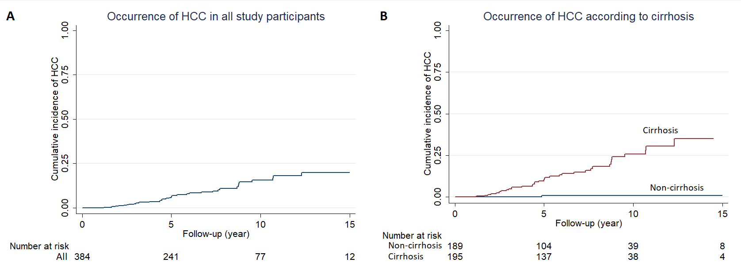

Figure 2. The receiver operating characteristic curves of the risk score based on age, body mass index, and baseline M2BPGi level to predict hepatocellular carcinoma in patients with cirrhosis. Areas under the curves at 3, 5, and 10 years were 0.77, 0.79, and 0.87, respectively (A). The newly developed M2BPGi-based score, PAGE-B, and CAMD score were similar in the area under the receiver operating characteristic curves at 3 years (B), but the M2BPGi-based score outperformed the other two scores at 5 and 10 years of follow-up (CD); AUC, area under the curve (comparison was carried out by bootstrapping).
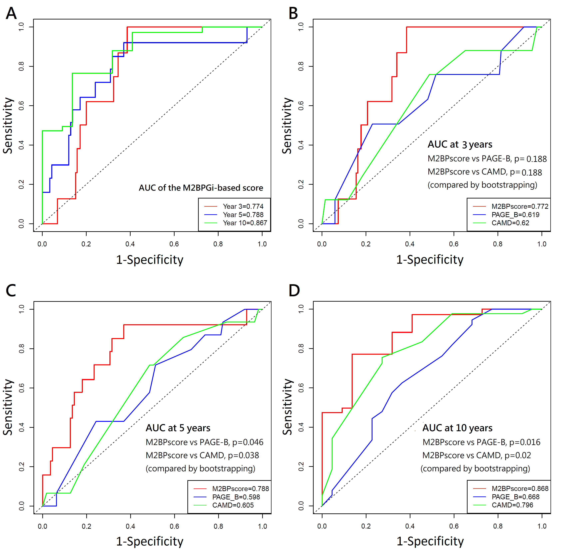

Figure 3. Using the median of the risk score to stratify patients at different risks for hepatocellular carcinoma, the cumulative incidences at 15 years were 67.2% (95% CI, 34.9-94.5%) for the higher-risk and 15.8% (95% CI of 6.2 -36.8%) for the lower-risk patients.
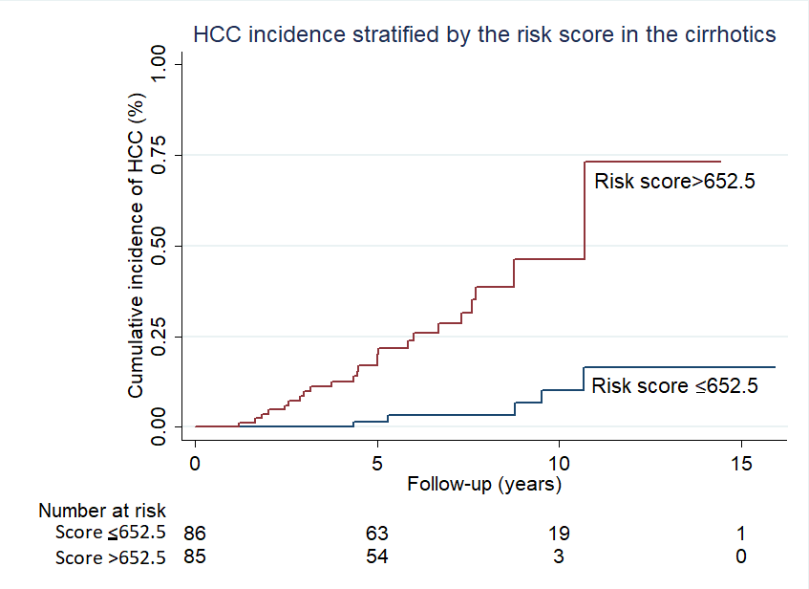

Supplementary Figure 1.
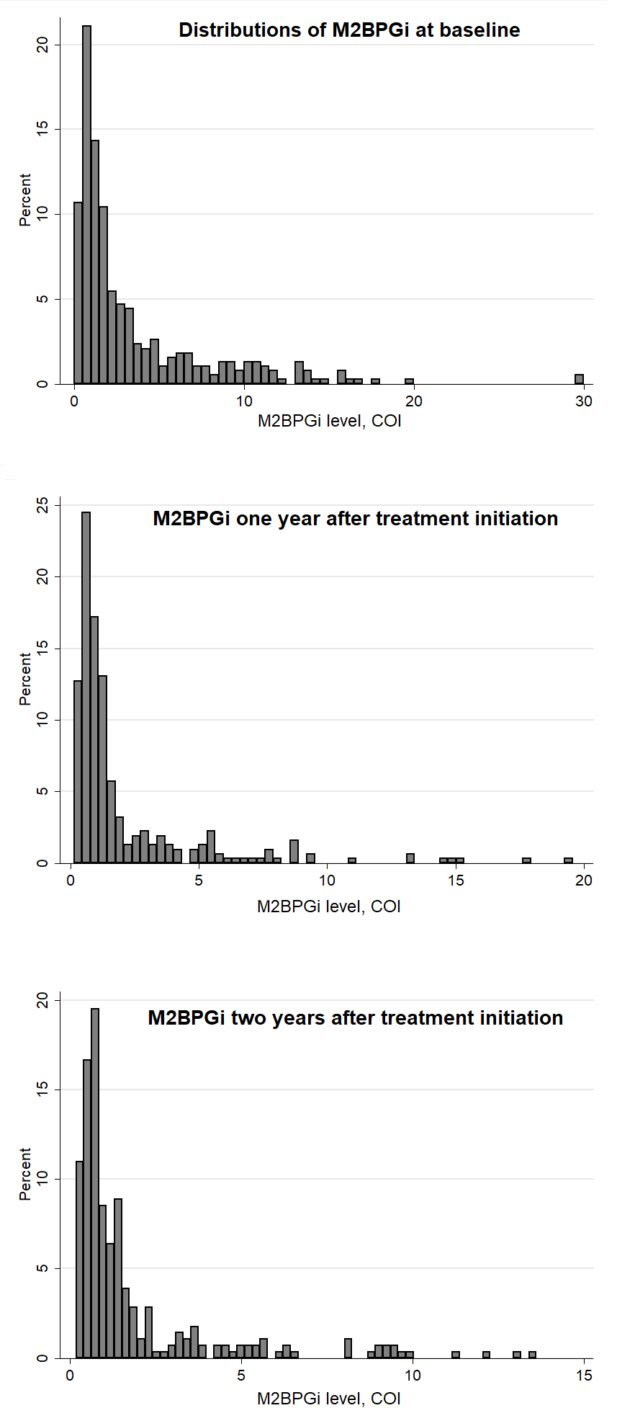

Supplementary Figure 2.
