研究計畫申請書
計畫類別 | ■ (A)一般型 □ (B)鼓勵啟發型 □ (C)資深研究人員型  □ (D)任務導向整合型
計畫歸屬 | □基礎科學■基礎醫學□生物醫學□生物電子□臨床醫學□醫學工程  □生物資訊□醫院管理□衛生政策□醫學倫理□整合性醫學研究
本計畫名稱 | （中文）甘草酸預防全靜脈營養引起肝細胞型態和功能上之改變
本計畫名稱 | （英文）Glycyrrhizin Prevents Total Parenteral Nutrition Associated Changes to Hepatocyte Phenotype and Function
本計畫主持人 | 姓名： 蔡佳珍 | 機關：國立陽明大學附設醫院
本計畫主持人 | 職稱： 主治醫師 | 單位： 教研部
通訊地址  聯絡電話 | 宜蘭市新民路152號國立陽明大學附設醫院教研部
通訊地址  聯絡電話 | 0953385640 | E-mail:jjthsai@yahoo.com.tw
計畫執行期限 | 自 100 年 1 月1 日起至 101年1 月 1日止
第 頁

第 頁
二、計畫中文摘要：
關鍵詞: 甘草酸,淤膽型肝炎
背景：全靜脈營養引起膽汁淤積型肝功能異常是常見併發症。從我們先前研究得知，大鼠經全靜脈營養注射後會造成肝組織纖維化和ALP上升。此外大鼠基礎肝細胞與全靜脈營養液反應後，會被破壞細胞間緊閉功能。臨床上目前無特殊治療方法。甘草酸，是甘草的一個主要組成成份，已經知道有抗發炎,肝臟保護作用,抗氧化等作用。本研究是探討甘草酸對全靜脈營養引起肝功能異常之保護機制。
目的:本研究是探討甘草酸對全靜脈營養引起肝功能異常之保護機制。
方法：分離雄性Sprague-Dawley大鼠的基礎肝細胞。將肝細胞實驗分成三組。控制組、全靜脈營養引起肝細胞功能異常組及甘草酸治療全靜脈營養引起肝細胞功能異常組 。利用非侵入性自動化即時偵測細胞行為系統觀察肝細胞的阻抗值變化，可分析細胞行為與型態上變化。利用RT-PCR和西方點漬法分析甘草酸的作用機制。動物實驗方面，將雄性Sprague-Dawley大鼠重200 至250克，隨機分為三組。控制組（老鼠12隻）、全靜脈營養引起肝功能異常組（老鼠12隻）及甘草酸治療全靜脈營養引起肝功能異常組（老鼠12隻）組使用全靜脈營養二小時。其中控制組老鼠使用標準生理食鹽水注射約兩小時。全靜脈營養引起肝功能異常組使用全靜脈營養注射約兩小時。所有組的老鼠每日1750kcal-1850kcal的熱量攝取。而甘草酸治療脂肪肝組老鼠在給予甘草酸20毫克/每公斤靜脈注射.三組老鼠兩小時後，評估肝臟病理學檢查及膽汁排出量比較。測量肝臟中及血液中脂質過氧化水平生物標誌物：Malondildehyde，肝臟中DNA斷裂試驗，氧化激酶（超氧化物歧化酶，穀胱甘肽過氧化物酶，過氧化氫和一氧化氮合酶）和生化參數（血清ALT /穀草轉氨酶，血糖，白蛋白）的變化。利用酵素免疫結合法分析細胞激素的狀況並比較三組有無差異。
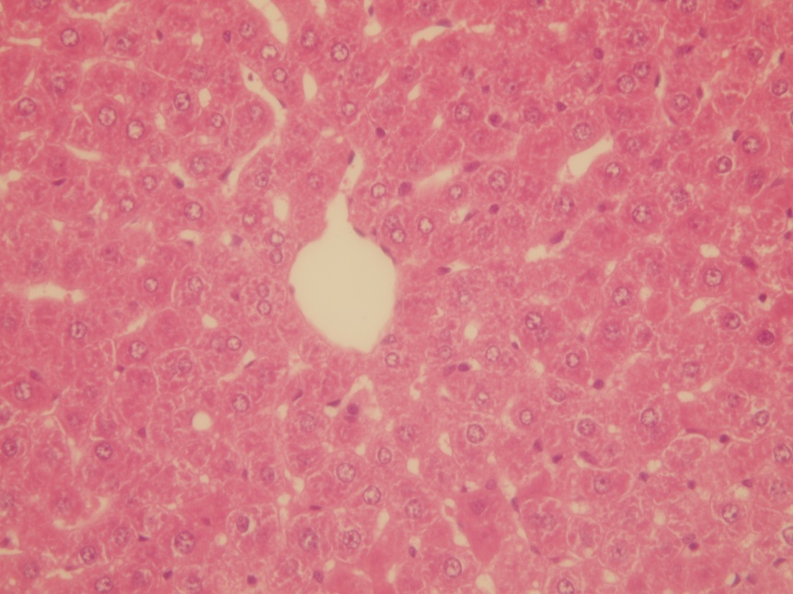
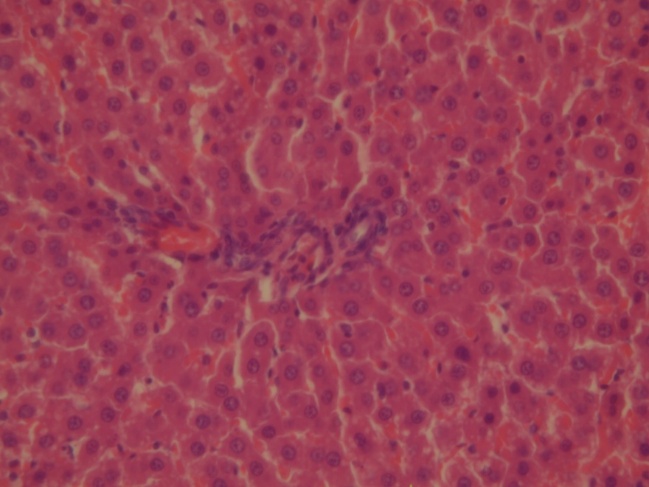
A B

Fig 1大鼠肝組織H&E化學染色。(A)控制組。靜脈注射saline兩小時。(B)TPN注射組。靜脈注射TPN兩小時，黑色方框處呈細胞聚集纖維化。
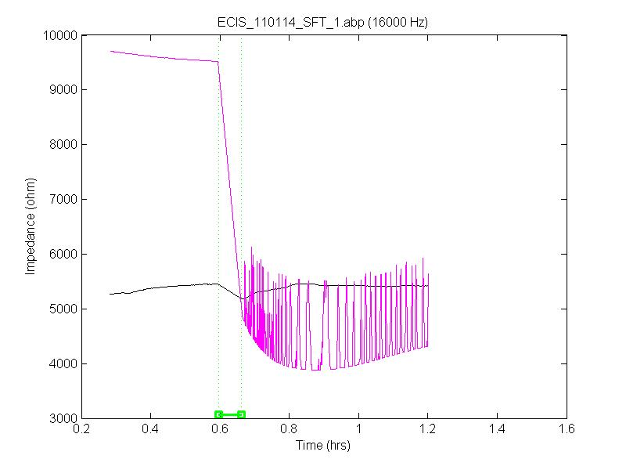
Fig 2 大鼠肝細胞阻抗分析。粉紅線代表肝細胞與TPN反應後阻抗數值變化。黑線代表肝細胞與PBS反應後阻抗數值變化。粉紅線呈阻抗值下降趨勢，於0.6小時後更換TPN為PBS後，曲線呈鋸齒狀。
第 頁
三、計畫英文摘要：
Key Word: Glycyrrhizin, cholestasis hepatitis
Background: Total parenteral nutrition (TPN) is often complicated by cholestatic hepatitis. In the previous studies, rat will generate the liver fibrosis and increase total serum ALP after TPN injection. Besides, barrier function of rat hepatocyte was destoryed by TPN treatment.The mechanism is unknown till now and no definite therapeutic method clinically .Glycyrrhizin, one major constituent of Licorce(Glycyrrhizae radix), have been known to effect of anti-infalmmatory ,antihepatotoxic, and antioxisative activity. The aim of this study was to investigate protective effect of glycyrrhizin on choletsasis hepatitis resulting from total parenteral nutrition.

Methods: Rat hepatocytes were isolated from 200-250 g male Sprague-Dawley rats into three groups. The control test was given PBS treatment. The TPN test was given TPN treatment. The glycyrrhizin test was given PBS and TPN. To use a non-invasive biophysical approach to monitor living rat hepatocyte of cell behavior and morphology. To study the mechanism of glycyrrhizin protection by RT-PCR and Western blot assays. Male Sprague-Dawley rats weighting 200-250g were randomized into three groups. A control ground (n=12) was given saline infusion for 2 hours . The total parenteral nutrition group was administered total parenteral solution for 2 hours. All groups daily total energy was ranged from 1750-1850kcal/d. Rats in the glycyrrhizin ground were given glycyrrhizin 20 mg/kg by intravenous administration.All rats were killed at 2 hours and assessed for liver pathology examination and bile output amount . Levels of lipid peroxidation level biomarker: Malondildehyde in serum and liver, hepatic DNA fragmentation assay, oxidative stress( superoxide dismutase, glutathione peroxidase,catalase and nitric oxide synthase) and biochemical parameters (serum ALT/AST,Glucose,albumin) were measured.

第 頁
四、本研究計畫之背景、目的及重要性：
Cholestatic hepatitis and Nonalcoholic steatohepatitis were common complication resulting from total parenteral nurtiion usage. The exact mechanism is still unclear and no definite therapeutic method clinically.
Nonalcoholic steatohepatitis (NASH) is a condition that causes inflammation and accumulation of fat and fibrous tissue in the liver.⁽¹⁾ Although a similar condition can occur in people who abuse alcohol, NASH occurs in those who do drink little to no alcohol. The exact cause of NASH is unknown. However, it is seen more frequently in people with certain medical conditions such as diabetes, obesity, and insulin resistance.It is not clear how many people have NASH because it causes no symptoms. However, NASH is diagnosed in about 7 to 9 percent of people in the United States who have a liver biopsy. Most people are between the ages of 40 and 60 years, although the condition can also occur in children over the age of 10 years. NASH is seen more often in women than in men.⁽²⁾The cause of NASH is not clear, although research is ongoing in an attempt to find effective treatments.⁽³⁾ At the present time, treatment of NASH focuses on controlling some of the medical conditions associated with it (such as diabetes and obesity) and monitoring for progression.⁽⁴⁾
Glycyrrhizin is one active compound of Licorice and have anti-inflammatory, antihepatotoxic, interferon-inducing , and antioxidative effect. Previous study described that high-fat component induces insulin resistance, down-regulates genes for antioxidant enzymes, and further aggravates the steatohepatitis.⁽⁵⁾
Our purpose was to investigate whether glycyrrhizin decreased choloestasis hepatitis in an animal model resulting from total parenteral nutrition, and whether this therapeutic approach resulted in a decreased in tumor necrosis factor α( TNF-α) production, lipid peroxidation and oxidative stress.
Reference:
- Powell, EE, Cooksley, WG, Hanson, R, et al. The natural history of nonalcoholic steatohepatitis: A follow up study of forty-two patients for up to 21 years. Hepatology 1990; 11:74.
- Chitturi, S, Farrell, GC, Hashimoto, E, et al. Non-alcoholic fatty liver disease in the Asia-Pacific region: Definitions and overview of proposed guidelines. J Gastroenterol Hepatol 2007; 22:778.
- Marchesini, G, Bugianesi, E, Forlani, G, et al. Nonalcoholic fatty liver, steatohepatitis, and the metabolic syndrome. Hepatology 2003; 37:917.
- Angelico, F, Burattin, M, Alessandri, C, et al. Drugs improving insulin resistance for non-alcoholic fatty liver disease and/or non-alcoholic steatohepatitis. Cochrane Database Syst Rev 2007; :CD005166.
5. Matsuzawa N, Takamura T, Kurita S, et al. Lipid-induced oxidative stress causes steatohepatitis in mice fed an atherogenic diet. Hepatology. 2007 Nov;46(5):1392-403.

第 頁
五、研究方法及進行步驟：
The study will be approved by the Institutional Animal Care and Use Committee (IACUC) of National Yang-Ming University.Male Sprague-Dawley Rats (200-250g) were obtained from the Laboratory Animal Center at the National Yang-Ming Medical College. These animals were specifically pathogen fee and kept in stable environmentally controlled quarters (temperature maintained at 24±1℃ and a light-dart cycle of 7:00-19:00) for at least three weeks before use. All grounps dayily total energy was ranged from 1750-1850kcal/d.
The total parenteral nutrition group was administered total parenteral solution for 2 hours. All groups daily total energy was ranged from 1750-1850kcal/d. Rats in the glycyrrhizin ground were given glycyrrhizin 20 mg/kg by intravenous administration.All rats were killed at 2 hours and assessed for liver pathology examination and bile output amount . Levels of lipid peroxidation level biomarker: Malondildehyde in serum and liver,hepatic DNA fragmentation assay, oxidative stress( superoxide dismutase, glutathione peroxidase,catalase and nitric oxide synthase) and biochemical parameters (serum ALT/AST,Glucose,albumin) were measured.
Rat hepatocytes were isolated from 200-250 g male Sprague-Dawley rats after perfusion of the liver with collagenase type IV (Sigma Chemical Co., St. Louis, MO). Cells were suspended in medium consisting of Waymouth’s 752/1 (Gibco BRL,Gaithersburg, MD) containing 25 mM HEPES, pH 7.2, 5%
heat-inactivated fetal bovine serum, 1.7 mM additional CaCl2, 5 mg/ml bovine insulin, 100 i.u./ml penicillin and 0.1 mg streptomycin . Approximately 1.5´106 cells in 3 ml of medium were placed in 60 mm Lux culture dishes and cultured in 5% CO2 atmosphere at 37°C. Approximately 2 hours later, medium was changed and cells were cultured for 16-18 hours.Cell viability was determined to be greater than 90% as judged by exclusion of trypan blue.
Measurement of barrier function of cell layers in tissue culture via ECIS has proven to be a significant and rapidly growing use of this technology. The utilization of ECIS to monitor barrier function was first demonstrated in 1992 using bovine pulmonary endothelial cells exposed to thrombin.
A histological study was performed following a midline laparotomy to remove the liver. Liver was weighted, and liver tissue samples taken at the time the rat was killed were immediately placed in 10% buffered formalin and subsequently embedded in pararffin. Liver sections were stained with hematoxylin and eosin using standard techniques. Sections were viewed without knowing the treatment ground to which each animal belonged. Biopsies were classified into four grades depending on fat accumulation using the Brunt et al.(Brunt EM,Janney CG,Di Biscegile AM, et al. Nonalcoholic steatohepatitis: a proposal for grading and staging the histological lesions. Am J Gastroenterol 1999, 94(9):2467-2474).
Levels of lipid peroxidation level biomarker: Malondildehyde in serum and liver,hepatic DNA fragmentation assay, oxidative stress( superoxide dismutase, glutathione peroxidase,catalase and nitric oxide synthase) and biochemical parameters (serum ALT/AST,Glucose,albumin) were measured.
All data are expressed as the mean±SD statiscal analysis was performed with non-parametric Mann-Whitney test.Standard calculations were performed using SPSS version 17.0. Results were considered statistically significant at P<0.05.

第 頁

六、預期完成之工作項目及具體成果：
1.To find the protective effect of glycyrrhizin cholestasis hepatitis resulting from total parenteral nutrition
2.To find the possible treatment of cholestasis hepatitis resulting from total parenteral nutrition

第 頁
七、預定進度甘梯圖(Gantt Chart)：
1. 本表作為進度控制及檢討之依據。
2.工作項目：請視計畫性質及需要自行訂定，預定進度以粗線標示其起迄月份。
3.預定進度累計百分比：係為配合追蹤考核作業所需，請視工作性質就以下因素擇一估計訂定：
(1)工作天數，(2)經費之分配，(3)工作之比重，(4)擬達成目標之具體數字。
月 次  工作項目 |  | 第  1  月 |  | 第  2  月 |  | 第  3  月 |  | 第  4  月 |  | 第  5  月 |  | 第  6  月 |  | 第  7  月 | 第  8  月 | 第  9  月 | 第  10  月 | 第  11  月 | 第  12  月 | 備 註
文獻回顧
設備請購
IACUC申請
先驅試驗
研究進行
統計分析
論文寫作
結案報告
投稿發表
預定進度累進百分比
第 頁
八、預算：(請按(1)人事費(2)業務費(3)材料費(4)旅運費(5)其他費用 之順序分項填寫,並請說明）
項 目 | 名 稱 | 數 量 | 單 價 | 總 價 | 備 註
(1) 人事費
(2) 業務費 | IACUC審查費 | 1
 | 印刷、海報費、文具、紙張 |  | 2000
(3) 材料費 | 老鼠、飼料、代養費及相關動物費 |  | 30000
 | 病理檢查相關費用 |  | 8000
 | 動物實驗用試劑相關費用 |  | 10000
 | 細胞培養藥劑相關費用 |  | 40000
 | 細胞實驗用試劑相關費用 |  | 60000
(4) 旅運費
(5) 其他費用
合 計 |  |  |  | 150000
第 頁
九、計畫主持人個人資料：
姓名：蔡佳珍 | 出生日期：民國 65年10 月14日 | 身分證字號：Q222261487
單位：教研部 | 職稱：主治醫師 | 電話：0953385640
住址：宜蘭市新民路152號
學歷(學校名稱、主修系科、學位、起迄年月)
慈濟大學、醫學系、醫學士、1995.6-2002.6
陽明大學 傳統醫藥研究所博士班 2009.6-
經歷(服務機構、部門、職稱、起迄年月)
台北榮民總醫院、內科部、住院醫師、2003.9-2007.7
台北榮民總醫院、腸胃科、總醫師、 2007.7-2009.8
陽明大學附設醫院、教研部、主治醫師 2009.8-

主持之研究計畫(近五年內主持計畫之名稱、補助機構、起迄年月，若篇幅不夠另紙填寫)
著作(近五年內已發表著作之題目、刊物名稱、起迄頁次、刊出年份、若篇幅不夠可另紙填寫)
1. Oral or intravenous proton pump inhibitor in patients with peptic ulcer bleeding after successful endoscopic epinephrine injection. Br J Clin Pharmacol. Accepted 4 December 2008, Jai-Jen Tsai, Yao-Chun Hsu, Chin-lin Perng, Hwai-Jeng Lin
2. Hepatocellular carcinoma with invasion into right atrium. Tsai JJ, Su CW, Lin HC.Clin Gastroenterol Hepatol. 2008 Oct;6(10):e39-40.
3. Diarrhoea after every feeding. Tsai JJ, Tseng CW, Su CW, Lin HJ. Gut. 2008 Dec;57(12):1665-1720.
4. Clinical manifestations and management of buried bumper syndrome in patients with percutaneous endoscopic gastrostomy. Gastrointestinal Endoscopy
Ref:GIE-D-08-01204. Jai-Jen Tsai, M.D. , Hwai-Jeng Lin, M.D., FACG
9. Massive Gastrointestinal Bleeding Associated with Contralateral Mucosal Abrasion by Percutaneous Endoscopic Gastrostomy Tube . Endoscopy. Jai-Jen Tsai, M.D. , Hwai-Jeng Lin, M.D
10. Gastric volvulus: A rare cause of postprandial vomiting. J Gastroenterol Hepatol Ms: JGH-01147-2008, Jai-Jen Tsai, Tseng CW
11. Double pylorus: an unusual complication of peptic ulcer disease (with video)..Clin Gastroenterol Hepatol. 2008 Oct;6(10):e38. Tseng CW, Tsai JJ, Lin HJ
12. Abdominal aortitis associated with autoimmune pancreatitis. Clin Gastroenterol Hepatol. 2009 Jan;7(1):Tseng CW, Tsai JJ, Chen CC.
13. Skeptical that pantoprazole dose can prevent bleeding. Lin HJ, Tsai JJ. Am J Crit Care. 2008 Sep;17(5):404; author reply 404-5.
- Intermittent intravenous pantoprazole and continuous cimetidine infusion: effect on gastric pH control in critically ill patients at risk of developing stressed related mucosal disease.Tsai JJ, Lin HJ. J Trauma. 2008 Nov;65(5):1203-4.9
- Intragastric pH with oral versus intravenous bolus plus infusion proton pump inhibitor therapy in patients with bleeding ulcers.Lin HJ, Tsai JJ. Gastroenterology. 2008 Nov;135(5):1804-5.9
16. Hemoperitoneum: a Problem in PD Patients with Hepatic Tumors. Perit Dial Int. 2009 Mar-Apr;29(2):236-7.Tseng CW, Tsai JJ, Chen CC, Su CW, Lin HC.

第 頁

